The Present Continuous Use
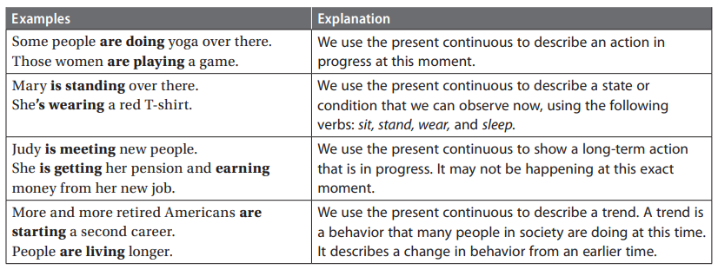

Exercise 1: Fill in the blanks with the present continuous form of one of the verbs from the box.
retire return work discover start volunteer live spend

1. More and more older people are working at second careers these days.
2. Many people _________________________ at a younger age.
3. They _________________________ time doing interesting things.
4. Some people _________________________ new careers.
5. Other people _________________________ . They are helping others without pay.
6. People _________________________ longer and healthier lives.
7. Some people _________________________ new talents and abilities.
8. Some older women _________________________ to work after raising a family.

Questions With The Present Continuous
Compare statements, yes/no questions, short answers, and wh- questions.
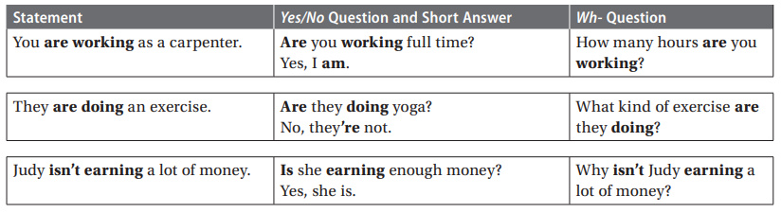
Exercise 2: Use the words given to make a yes/no question. Fill in the second blank to complete the short answer.
1. those/men play
A: _____ Are those men_____ playing checkers?
B: No, they _____ aren’t_____. They’re playing chess.
2. you/consider
A: ___________________________ this retirement home?
B: Yes, I ___________________________. I’m considering it now that my wife is gone.
3. Marge/design
A: ___________________________ a website?
B: Yes, she ___________________________. She’s designing a website with pictures of her
vacations.
4. Marge/take
A: ___________________________ pictures now?
B: No, she ___________________________. She’s putting her pictures on her website.
5. your wife/do
A: ___________________________ something now?
B: No, ___________________________ . She’s just relaxing.
6. Betty and Charles/take
A: ___________________________ art classes?
B: Yes, they ___________________________ . They love art.

7. I/ask
A: ___________________________ too many questions?
B: No, ___________________________. You can ask as many questions as you want.
8. you/write
A: ___________________________ down this information?
B: No, ___________________________. I can check your website later.

