MATERIAL INFORMATION

6. ORGANIC MATERIALS

It's been used since the existence of mankind. Depending on the development of technology, these materials have been improved. Improvements include measures such as the directional devotion of wood material – isotope removal, filling gaps with resin – and protection against impregnated external influences. While improvements and improvements in these natural organic materials were made, artificial organic materials – polymers or plastics have increased rapidly with the developments in organic chemistry and have become used in all fields today.

6.1. Polymer – Plastic Materials

Polymers form a group of artificial organic materials. They have a wide range of uses due to their easy processing and acclaimed properties.

6.1.1. General features

Their superiority;

- They are obtained in the desired color with coloring substances.
- Some are transparent and can be used instead of glass.
- Their density is low.
- It can be used as an insulator.
- They are resistant to acid, base and salt solutions.
- It's easy to clean and maintain.

Drawbacks;
- Most of them have biological hazards.
- Their surface is soft and they have little resistance to scratching.
- They wear out in the air over time.
- They are affected by factors such as ultraviolet rays and radiation.

6.1.2. Molecular structure of plastics

As with all organic matter, they contain carbon as an important element. They are made up of chains with large molecules. By synthesizing these large chains of molecules, they are obtained artificially.

The starting substances consist of relatively few atomic molecules (for example, ethylene consists of carbon andhydrogen). These are called monomers. Thousands of these monomers form a chain with a chemical synthesis method. These are called polymers.

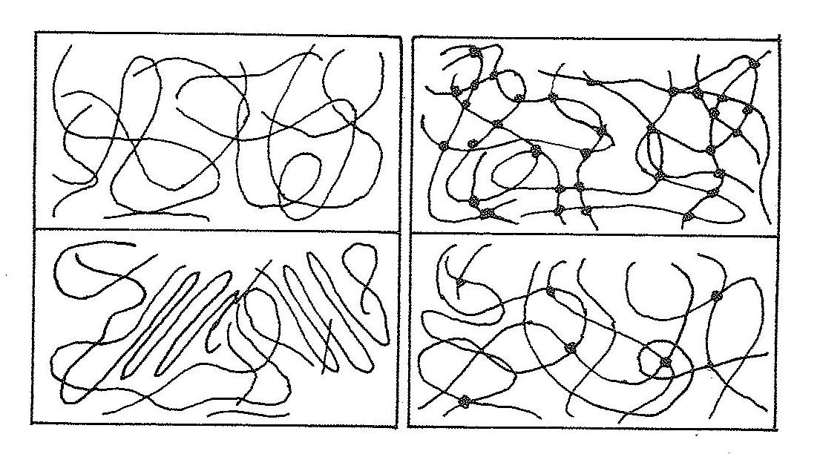

Figure 6.1. Types of structures in plastic materials

According to the polymerization, polycondensation and polyadition synthesis method applied, three types of plastic materials are obtained (Figure 6.1).

In polymerization, string or chain-shaped molecules are weakly connected to each other in the case of amorphous. This bond is weakened by heating. The materials obtained by this method are called thermoplasms. Their general characteristics become plastic in the heat and solidify when they cool down.

By polycondensation synthesis method, tightly connected structures are formed in small structure of the mesh eye. Materials of this structure are called duroplasts – thermostrettes. Materials with large mesh eye obtained by polyadication synthesis method are called elastomers.

6.1.3. Types of plastics

6.1.3.1. Thermoplasty materials

These materials are easy to process, with very few water absorptions and low friction coefficients. When heated, they soften, when cooled, they harden.

Thermoplasty materials, which are common to use, are given below.

Polyethylene (PE) is the most commonly used thermoplasty. Low light permeability, high UV resistance. There are no physiological harms. They are also used as packaging material and electrical insulation material in the construction of bottles, cans, containers and utensils.

Polyvinylchloride (PVC) is one of the cheapest plastic materials used a lot. Light permeability is good. Suitable for under-cover cultivation. In addition, insulation material is used in the construction of rain gutters.

Polypropylene (PP) is low strength. Chemical resistance is a well expensive material. They are used in the construction of products such as packaging material, boxes, bottles.

Polystyren (PS) optical properties are good. It is used as heat and sound insulation in foam form.

Polycarbonate (PC) are materials with good light permeability and high resistance to impact and temperature. They are used to make utensils.

Polyamide (PA) is a material also known as nylon. These materials, which have good mechanical properties, are used in the construction of products such as bearings and gears.

Polythetrafloetylene (PTFE) is a material with a low friction coefficient. Sintering – teflon is made on the surface of metals in powder form.

Polymetymmetahrila (PMMA) light and UV permeability are good. They are used in the construction of safety glasses, in milking plants, in the construction of transparent milking pipes.
6.1.3.2. Duroplat – thermoetting materials

They are usually obtained by pressing resins together with additives.

Here are some commonly used duroplasts.

Epoxy resin has very good electrical, thermal and chemical resistance. They are used in the field of electricity and electronics.

Phenol resin – they have mechanical, thermal and chemical resistance. They are used to make electrical materials.

Polyester resin thermal and electrical resistance is good. Those reinforced with glass fiber are used in the construction of bodywork, boats.

6.1.3.3. Elastomer – rubber materials

They are materials with high elastic form change capability. This behavior in tire elasticity is achieved by loose-wide networking of chain molecules. In this network form production, natural or artificial rubber is processed with sulfur-vulcanization is obtained.

It is obtained by evaporating the sap of the natural rubber rubber tree called latex. This substance is vulcanized at a certain pressure and temperature by mixing with sulfur with fillers and color substances. Hard, soft and foam rubber is obtained according to the sulfur ratio.

Hard rubber is used in the automotive industry to make wheel tires, gaskets, etc.

Since synthetic rubber is obtained artificially and in different compositions, it is known by names such as S, Buna A, Neoprene, silicone.

5.1.3.4. Plastics converted from natural materials

Examples of thermoplastic materials converted from cellulose-based natural substances include vulcanfiber, celluloid and synthetic horns. Silions, whose main ingredient is silicon and oxygen, are converted duroplasts.

6.2. Natural Organic Materials

It is the oldest group of materials. Wood, vegetable fibers, animal skin and bristles are the most used.

6.2.1. Wood materials

They are materials that are not homogeneous but easy to process. Wooden materials are obtained from coniferous and broad-leaved trees.

6.2.2. Plant fibers
Fibers obtained from various plants are used as reinforcement material in weaving, rope and rope making, belt etc. materials. Self and hemp can be used in the manufacture of filter weaving.

8.2.3. Animal hair

Sheep are obtained by shearing the hairs of animals such as goats. They are used as filter elements in the chemical industry. It is also turned into a rope.

6.2.4. Animal skins

They are obtained by drying and tanning animal skin by swimming. For technical purposes, herbal tanning agent (tann) and chrome screed are used.

