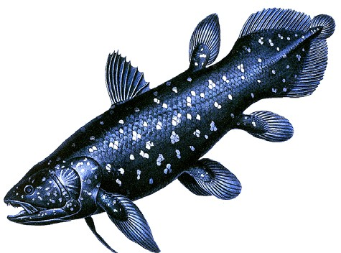
Evolution And Population Genetics
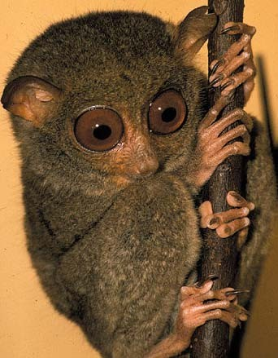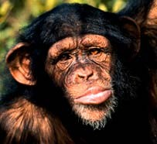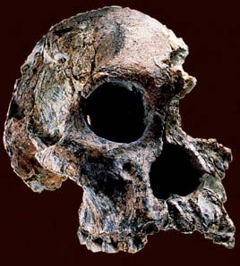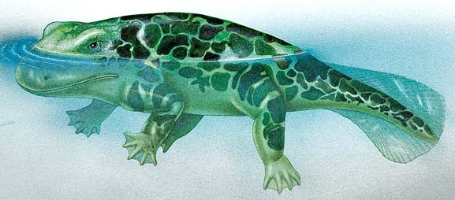
Evolution is a genetic process. A change in the genetic structure of a single population, or the formation of new genetic
lineages. 1

Evolution has two components:
Anagenesis - change in a genetic lineage through time - A small or large change can be considered evolution. A slight increase or decrease in the frequency of a particular blood type for example could be considered evolution.
Cladogenesis - the origin of new genetic lineages (new species). Although evolution occurs within lineages, two populations of a single species can become so different that they no longer belong to the same genetic lineage.
Anagenesis is the more commonly appreciated component of evolution.
Since evolution is a property of populations and it is a genetic phenomenon, understanding evolution requires an understanding of how genes behave in populations.
2

The fundamental principle of population genetics is the Hardy- Weinberg Principle:
If the individuals in a large population mate randomly, and there is no mutational change in the frequency of alleles in the population, and there is no influx of genes from other populations, and there is no difference in the survival and reproductive potential of different genotypes, then the frequency of genotypes in the population will be a binomial distribution derived from the frequency of the two alleles.
If the frequency of A = p = 0.5, and the frequency of a = q = 0.5, then the frequency of the genotypes will be:

f(AA) = p2 = 0.5*0.5 = 0.25 f(Aa) = 2pq = 2*0.5*0.5 = 0.5 f(aa) = q2 = 0.5*0.5 = 0.25
And, so long as the conditions stated above hold, the frequencies will not change from generation to generation.
3

Finding the frequency of an allele in a population, and finding the HW genotypic frequencies.
If there are two alleles B and b, then there are three genotypes BB, Bb, and bb.
If f(BB) = D, if f(Bb) = H, and f(bb) = R then f(B) = D + 1/2 H = p, and f(b) = R + 1/2 H = q
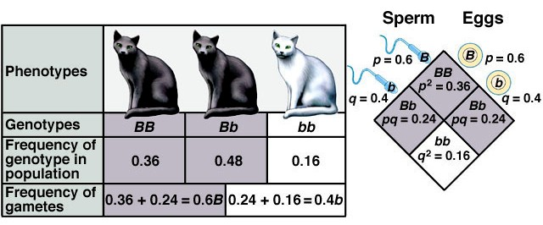
HW frequencies are f(BB) = p2, f(Bb) = 2pq, f(aa) = q2

4

Example: Frequency of cystic fibrosis
The allele that causes cystic fibrosis is recessive, and its frequency in Caucasian Americans is 0.022. Assuming there is only one allele that is dominant to the cystic fibrosis allele, then:
f(c) = q = 0.022 f(C) = p = 1-q = 0.978
What is the expected frequency of the different genotypes among Caucasian Americans?
f(CC) = 0.978 * 0.978 = 0.956
f(Cc) = 2 * 0.978 * 0.022 = 0.043
f(cc) = 0.022 * 0.022 = .0005
About 5 in 10,000 births among Caucasian Americans should have cystic fibrosis, and about 4.3% of the same group should be
carriers of cystic fibrosis. 5

Evolution is the product of factors, conditions, and forces that change allele frequencies
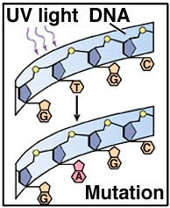
Mutation - change of one allele to another
A → a
Mutation can change allele frequencies, but the rate of mutation is normally so low (on average about 1 mutation in a given gene in every 1,000,000 gametes) that the effect of mutation is not measurable and it usually has a negligible effect on the frequency of alleles.
Mutation does create new alleles that can become common as a result of other causes of evolution.
6

Immigration - the influx of alleles from other populations - also called gene flow.
If members of one population regularly enter another population the frequency of alleles in the receiving population may change to become more like the source population.
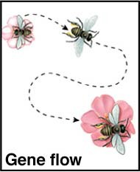
Gene flow tends to homogenize populations
- to make them more similar genetically. Only small numbers of individuals need to be exchanged for the two populations to become genetically indistinguishable in a short period of time.
Gene flow can be a powerful force for evolutionary change, and gene flow can sometimes oppose other forces of
evolutionary change. 7

Nonrandom mating - also known as assortative mating - results in deviations from the Hardy-Weinberg expected ratios.
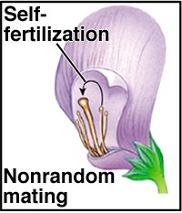
Inbreeding (mating among close relatives), or self-fertilization, or like mating with like all lead to a reduction in the frequency of heterozygotes in a population, and an increase in the frequency of homozygotes.
Inbreeding results in a higher frequency of homozygotes for deleterious alleles and can interact with selection to reduce the frequency of deleterious alleles in a population.

8

Small population size can lead to genetic drift - chance change in frequency of alleles in a population.
If a population remains small, then in each generation chance factors may result in some genotypes not mating in the proportions expected. As a result, some genotypes may increase in frequency quickly while other decrease in frequency.
Even if a population is large, if few individuals produce the next generation, the alleles those individuals have will be more highly represented.
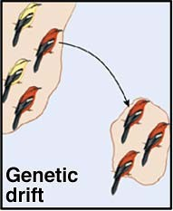
One type of event that causes genetic drift is the founding of new populations by a few individuals. If the founding individuals are somehow genetically different from the parent population then the result is called a founder

effect.
9

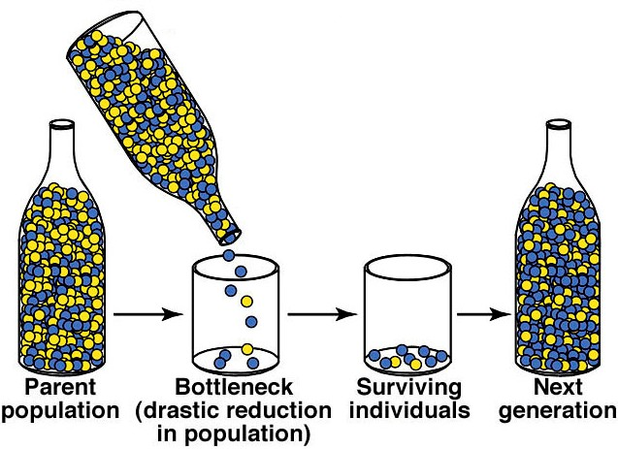
Genetic drift can also occur when large populations are reduced to small sizes. The chance change in genetic composition of a population as a result of a great reduction in size is called the bottleneck effect.

Genetic drift, due to persistent small population sizes, founder effects, or bottleneck effects, can result in large change in the genetic composition of a population and commonly results in the loss of alleles from a population. It can also result in populations that have lost variation that may be important for long-term survival.

Genetic drift can be a potent force for evolutionary change. 10

Selection - differences in survival and reproductive potential that result in differences in reproductive success. If some individuals in a population produce more offspring than others, either because they are better able to survive to adulthood, or are more efficient at producing offspring, their offspring will be represented in greater frequency in the next generation than other members of the population.

Selection ≠ Evolution
Selection (like genetic drift, or mutation) is a process. Evolution is a potential outcome of several different processes.
For selection to produce evolution there must be variation in the population, the variation results in some individuals having better survival or reproductive abilities than others, and the variation must be heritable (due to underlying genetic differences).

11

The evolution of long necks in giraffes (a hypothesis).
Ancestors of the giraffe had shorter necks than modern giraffes and browsed on tree leaves and shrubs of the African Savannah.
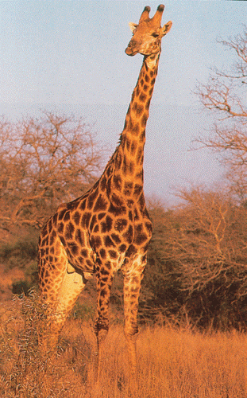
Some had longer necks than others and were able to reach higher branches than others. In times of food shortage, those with the longest necks had a survival advantage. If so, selection has occurred.
If neck length variation was not genetically based, then the next generation would not have necks any longer than the average in the previous generation. No evolution would have occurred.
If neck length was due to genetic variation, then the genes for having a long neck would have increased in the population. The new generation would be different from the prior generation, and better suited to survive in their environment - due to their neck
length. This is an adaptation. 12

The power of selection to produce change is clear in the development of different breeds or varieties of domestic plants and animals. For example, all of the breeds of domestic dog have been produced from a single ancestral genetic population through the action of humans preserving some characteristics and eliminating others during the development of a breed.
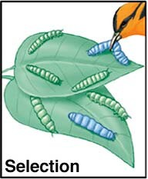
When humans are the source of selection we call it artificial selection. When natural events result in differences in survival or reproductive success we call it natural selection.
Predators can choose different phenotypes preferentially, because they stand out or because they are in some way more
attractive. 13

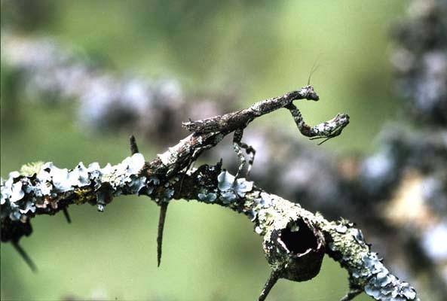
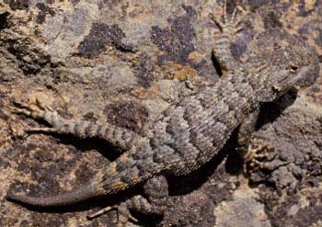
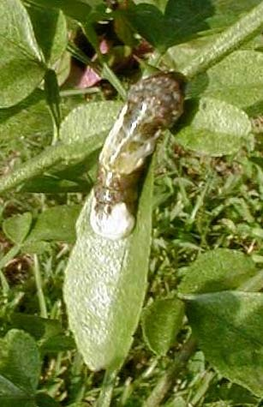
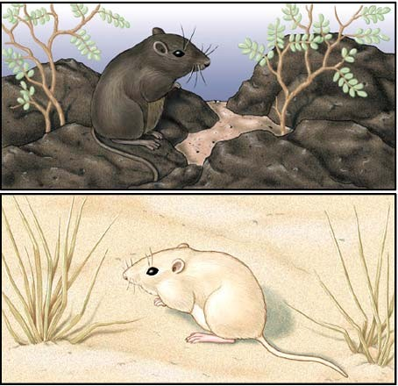
Crypsis (camouflage coloration) in prey species is the product of natural selection by predators

14

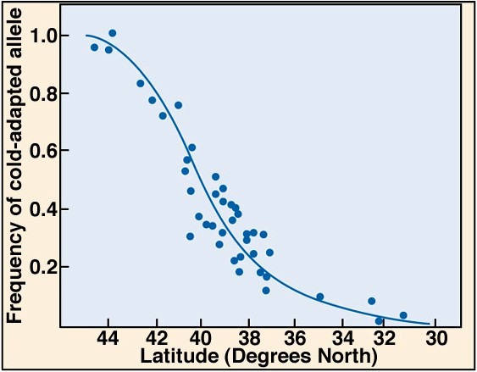
Many different aspects of the environment select for or against some types of phenotypic variation and the genes that result in the different phenotypes.
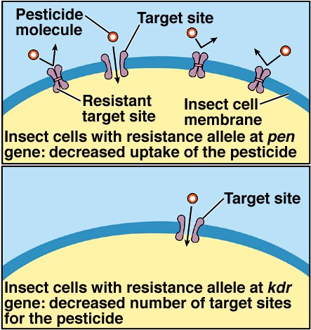
Cold-adapted and warm-adapted organisms are selected at different latitudes

The application of pesticides in agriculture produces pests that are resistant to specific pesticides.
Similar selection occurs in human pathogens through the application of antibiotics.

15

Differences in survival and reproductive ability are commonly called differences in fitness. So, natural selection is the result of differences in fitness that are associated with different phenotypes. Evolution by natural selection is the result of fitness differences that are associated with phenotypic differences that have a genetic basis.
Natural selection is often defined as “survival of the fittest.” There are problems with this definition:
- Even if every individual was genetically and phenotypically identical (no fitness differences), some would, by chance, survive and reproduce while others would not. In such cases there is no selection even though some survive and others do not.
- It is a tautology - a truism - a statement that is always true. Who survives? Who are the fittest? The answers are circular. Natural selection is best defined as the process of differences in
survival or reproductive ability among different phenotypes. 16

Example: Selection among different genotypes in humans
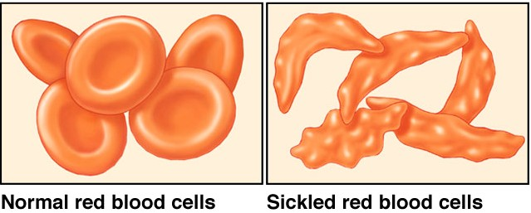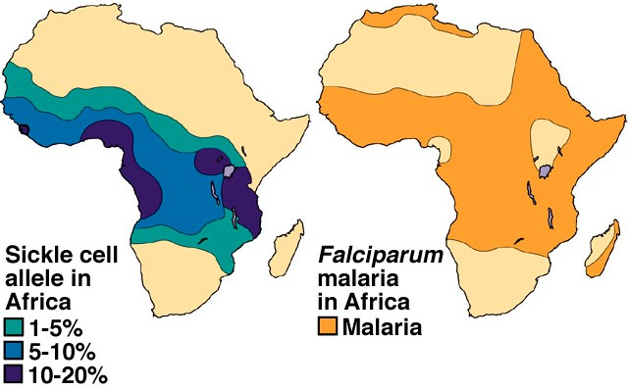Sickle cell anemia is due to a single base pair change in β-Hb. Without the aid of modern medicine, the sickle cell homozygote dies very young. So, why isn’t the sickle cell allele removed from the human population?
17

The sickle cell allele and sickle cell anemia are both most common in areas of the world where malaria is or was formerly common.

Malaria is caused by a protozoan blood parasite (Plasmodium falciparum) that is spread by Anophales mosquitoes.
The three human genotypes have different fitness where malaria is common
The non-sickle cell homozygote (SS) is susceptible to malaria, about 20% of the SS individuals die of malaria where malaria is common.
The sickle cell homozygote (ss) is resistant to malaria but 100% die to the complications from sickle cell anemia
The sickle cell heterozygote (Ss) is resistant to malaria and does not have the problems associated with sickle cell anemia
The sickle cell allele is maintained at relatively high frequencies in areas where malaria is common because of heterozygote advantage.
18

Types of selection
Selection can be classified based on its effects on a distribution of phenotypes.

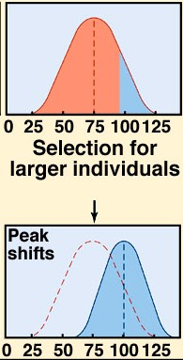
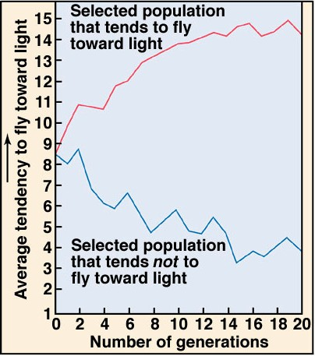
Directional selection - occurs when fitness is highest among individuals with extreme phenotypes. If there is a genetic basis for the fitness differences, the result will be a shift in the distribution of phenotypes.
19

Stabilizing selection - selection against the extremes, or selection favoring the middle, of a distribution. Stabilizing selection tends to reduce the frequency of extreme phenotypes.
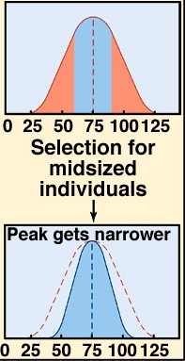
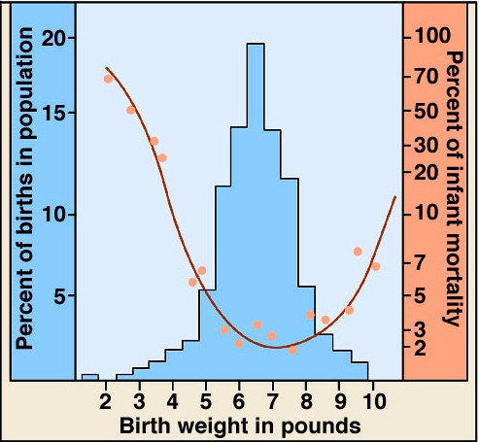
20

Example: Skin color selection in humans
Why does human skin color vary among indigenous peoples over the surface of the globe? Darker in equatorial zones and lighter toward the poles.
Human skin color is controlled by 5 to 8 genes, each with small effects on the phenotype. They add to, or subtract from, the production of melanin.
The amount of melanin in the skin influences several aspects of health.
Melanin is natural sunscreen - dark skinned humans are more resistant to the damaging effects of ultraviolet radiation. UV light causes mutations and skin cancer. UV light also destroys the vitamin, folic acid. Low folic acid concentrations in mothers results in birth defects.
UV light is necessary for vitamin D production. Low vitamin D
production results in skeletal abnormalities. 21

Light skinned peoples are more susceptible to the sunlight induced cancers and to folic acid deficiencies
Dark skinned peoples are more susceptible to vitamin D deficiencies.
In the tropics - dark skinned people have higher fitness due to resistance to the damaging effects of sunlight (directional selection)
Toward the poles - lighter skinned people have higher fitness due to sufficient vitamin D production. (directional selection)
In temperate zones - intermediate skinned people are favored, due to the problems of sunlight damage on the very light skinned, and vitamin D deficiencies in the very dark skinned. (stabilizing selection)
This example illustrates that fitness depends on the environmental context, and that high fitness is often the result of a compromise22.

Disruptive selection - selection that favors the extremes of a distribution.
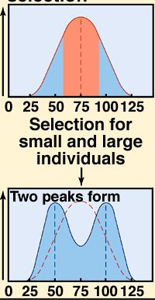
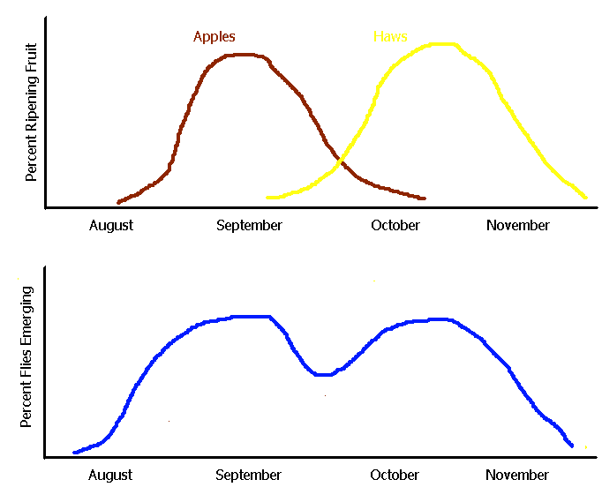
Disruptive selection the Apple Maggot Fly.
23

Sexual Selection - selection due to differential ability to obtain mates - because of preference by members of one sex for certain phenotypes in the other, or because of competition among members of one sex for access to members of the other sex.
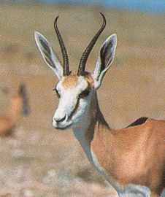
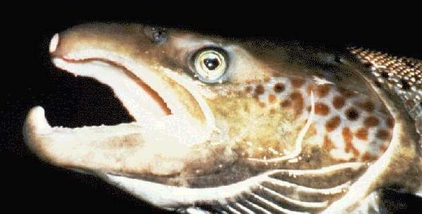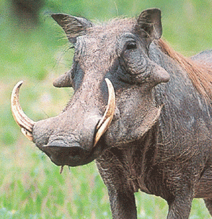Competition usually occurs among males of a species. Selection favors traits that aid the male in his ability to battle rivals - horns, antlers, large canines, large body size.

24

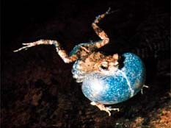
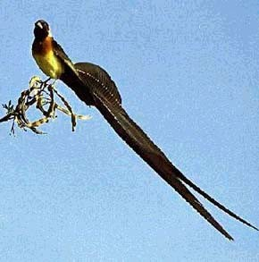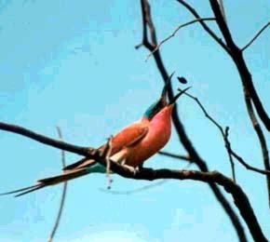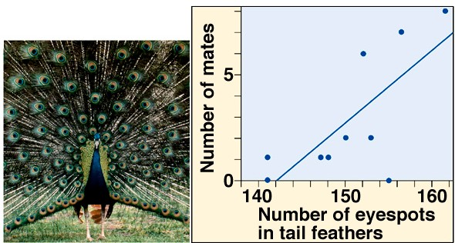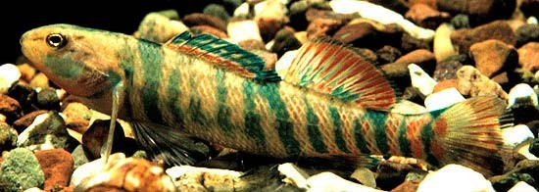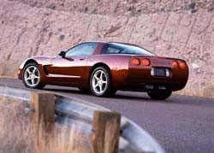Sexual selection by mate choice usually occurs due to female choice of males with certain characteristics

Females choose distinctive traits in males like bright colors and loud calls.
25

Why should females be the choosier sex?

Why choose bright colors, loud calls, etc?

26
Reference: https://www.nicholls.edu/biol-ds/biol155/Lectures/Population%20Genetics.pdf

