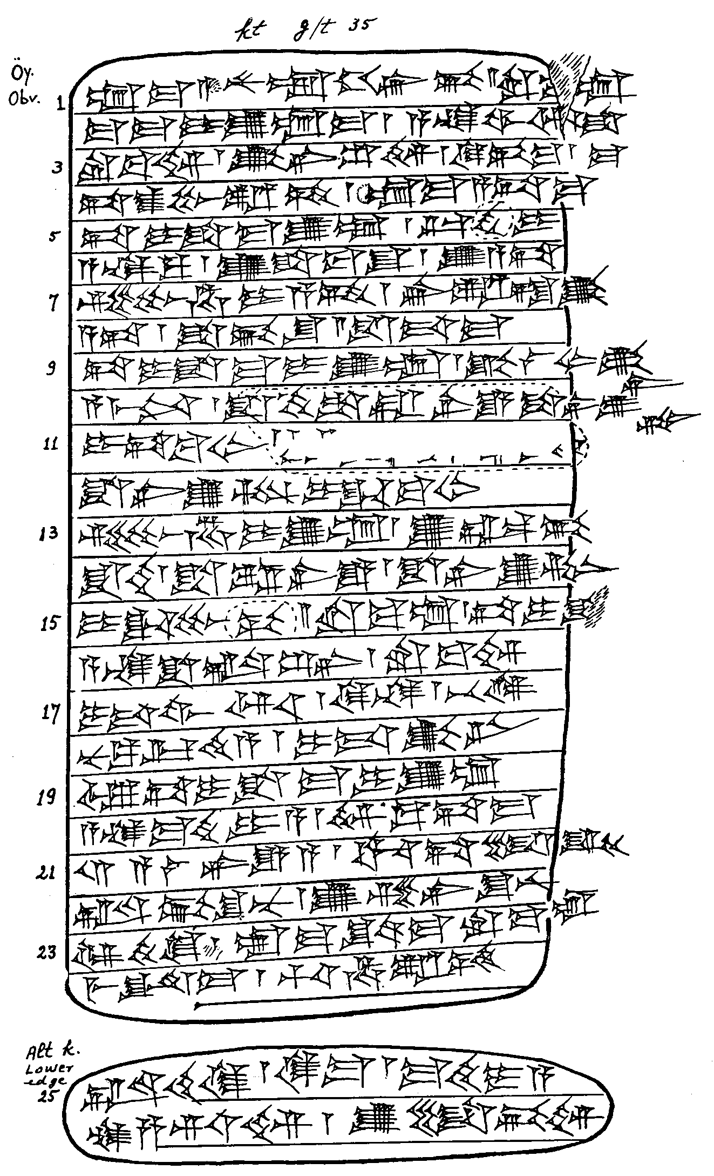

Kt g/t 35

1 um-ma A-nu-um-hi-ir-bi // ru-ba-um
ma-ma-i-u2-um-ma / a-na Wa-ar-s^a=ma
ru-ba-im / ka3-ni-s^i2-im / qi2-bi-ma /
ta-as^2-pu-ra-am / um-ma a-ta-ma
5 ta-i-s^a-ma-<i>-u2-um / ur-di2-i
a-na-ku / u2-s^a-pa2-s^u / u2 a-ta
Si2-bu-ha-i-a-am / IRø{ra-ad}-ka3
a-ta / s^a-pi2-s^u // is^-tu3-ma
ta-i-s^a-ma-i-u2-um / ka3-la2-ab2-ka3=ni
10 a-mi3-nim / is^-ti2 s^a-ra-ne2-e s^a-ni-u2=tim
i-da2-ba-ab2 (Ras.)
<<s^a-ni-u2-tim i-da-ba-ab2>>
si2-bu-ha-i-u2-um / ka3-al-bi
is^-ti2 / s^a-ra-ne2-e / s^a-ni-u2-tim
15 i-da-bu-ub // ru-ba-um / ta-i-s^[a-ma-i-u2-um]
a-na s^a-al-s^i2-ni / ru-ba-im
i-tu3-wa-ar / ke-na / be-el {NB: Balkan emendiert zu ki-ma}
nu-ku-ur-ti2-a / i-du-ka3-ni
u3 ta-i-s^a-ma-i-u2-um
20 a-na ma-ti2-i-a / im-qu2-ta-ma
12 a-la2-ne2-e-a / uh3-ta-li-iq
al-pi2-s^u-nu / u2 s,e2-ni-s^u-nu
il5-te2-qe2 / um-ma s^u-ut-ma ru-ba-um
me-et-ma / hu-ha-ra-am
25 al-te2-qe2 / ki-ma / ma-ti2-i-a
na-s,a-ri-im / u2 li-bi-im

