Edwin Arlington Robinson (1869-1935)

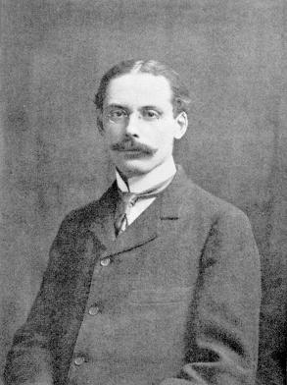

- Robinson is one of the earliest representatives of the true American poetry.
- He is traditional to some degree in form but he is the authentic voice of the Twentieth Century American vernecular.
- He is sympathetic with his fellow American citizen even in his semi-satirical works like “Miniver Cheevy”.
- He is known to say he was “born with his skin inside out”. He displays this sensitivity to his characters.
- He is known to say he was “born with his skin inside out”. He displays this sensitivity to his characters.
- He produced a great volume of poetry but most of his works are forgotton. He is known for only a number of poems.
- It is right to see him as a protomodernist that paved the way to modernism.

