The indigenous religion of Japan, Shintō, coexists with various sects of Buddhism, Christianity, and some ancient shamanistic practices, as well as a number of “new religions” (shinkō shukyō) that have emerged since the 19th century. Not one of the religions is dominant, and each is affected by the others. Thus, it is typical for one person or family to believe in several Shintō gods and at the same time belong to a Buddhist sect. Intense religious feelings are generally lacking except among the adherents of some of the new religions. Japanese children usually do not receive formal religious training. On the other hand, many Japanese homes contain a Buddhist altar (butsudan), at which various rituals—some on a daily basis—commemorate deceased family members.
Shintō is a polytheistic religion. People, commonly major historical figures, as well as natural objects have been enshrined as gods. Some of the Hindu gods and Chinese spirits were also introduced and Japanized. Each rural settlement has at least one shrine of its own, and there are several shrines of national significance, the most important of which is the Grand Shrine of Ise in Mie prefecture. Many of the ceremonies associated with the birth of a child and the rites of passage to adulthood are associated with Shintō. After the Meiji Restoration (1868), Shintō was restructured as a state-supported religion, but this institution was abolished after World War II.
Buddhism, which claims the largest number of adherents after Shintō, was officially introduced into the imperial court from Korea in the mid-6th century ce. Direct contact with central China was maintained, and several sects were introduced. In the 8th century Buddhism was adopted as the national religion, and national and provincial temples, nunneries, and monasteries were built throughout the country. The Tendai (Tiantai) and Shingon sects were founded in the early 9th century, and they have continued to exert profound influence in some parts of Japan. Zen Buddhism, the development of which dates to the late 12th century, has maintained a large following. Most of the major Buddhist sects of modern Japan, however, have descended from those that were modified in the 13th century by monks such as Shinran, who established an offshoot of Pure Land (Jōdo) Buddhism called the True Pure Land sect (Jōdo Shinshū), and Nichiren, who founded Nichiren Buddhism.
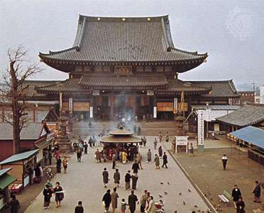
Kawasaki, Japan: templeKawasaki Daishi (or Heigen) Temple, Kawasaki, Kanagawa prefecture, Japan.Photos Pack
Christianity was introduced into Japan by first Jesuit and then Franciscan missionaries in the mid- to late 16th century. It initially was well received, both as a religion and as a symbol of European culture. After the establishment of the Tokugawa shogunate (1603), Christians were persecuted, and Christianity was totally banned in the 1630s. Inaccessible and isolated islands and the peninsula of western Kyushu continued to harbour “hiding Christian” villages until the ban was lifted by the Meiji government in 1873. Christianity was reintroduced by Western missionaries, who established a number of Russian Orthodox, Roman Catholic, and Protestant congregations. Practicing Christians account for only a tiny fraction of the total population.
The great majority of what are now called the “new religions” were founded after the mid-19th century. Most have their roots in Shintō and shamanism, but they also were influenced by Buddhism, Neo-Confucianism, and Christianity. One of the largest, the Sōka Gakkai (“Value Creation Society”), is based on a sect of Nichiren Buddhism. Another new Nichiren sect to attract a large following is the Risshō Kōsei-kai. New Shintō cults include Tenrikyō and Konkōkyō.
KAYNAK: https://www.britannica.com/place/Japan/Religion
PDF DOSYA İÇİN KAYNAK:
https://www.pewresearch.org/wp-content/uploads/sites/7/2017/11/Religion20171117.pdf

