Definition of Biology
Biology is the science that studies life. What exactly is life? Although this question sounds silly and has an obvious answer, it is as such not easy to make the definition of life. For example, a sub discipline of biology called virology studies viruses, which exhibit some of the characteristics of living entities but lack of others. It turns out that although viruses can attack living organisms, cause diseases, and even reproduce, they do not full fill the criteria that biologists use to define life.
From its earliest beginnings, biology has dwelled on four main subjects: What are the common properties that make something “alive”? How do those various living things function? When faced with the enormous diversity of life, how do we classify the different kinds of organisms so that we can better understand them? And, finally—what biologists ultimately seek to understand—how did this diversity arise and how is it continuing? As new organisms are discovered every day, biologists continue to seek answers to these and other questions.

Properties of Life
All groups of living organisms share several key characteristics or functions: order, sensitivity or response to stimuli, reproduction, adaptation, growth and development, regulation, homeostasis, and energy processing. When examined together, these eight characteristics serve to define life.

1- Order
Organisms are highly organized structures that consist of one or more cells. Even very simple, single-celled organisms such as bacteria and unicellular protists are remarkably complex. Inside each cell, atoms make up molecules. These in turn make up cell components or organelles. Multicellular organisms, which may consist of millions of individual cells, have an advantage over single-celled organisms in that their cells can be specialized to perform specific functions, and even sacrificed in certain situations for the good of the organism as a whole. These specialized cells come together to form organs such as the heart, lung, or skin in some animals and and leaves, stem and root in certain plants.
2- Sensitivity or Response to Stimuli
Organisms respond to diverse stimuli. For example, plants can bend toward a source of light or respond to touch. Even tiny bacteria can move toward or away from chemicals (a process called chemotaxis) or light (phototaxis). Movement toward a stimulus is considered a positive response, while movement away from a stimulus is considered a negative response.
3- Reproduction
Single-celled organisms reproduce by first duplicating their DNA, which is the genetic material, and then dividing it equally as the cell prepares to divide to form two new cells. Many multicellular organisms (those made up of more than one cell) produce specialized reproductive cells that will form new individuals. When reproduction occurs, DNA containing genes is passed along to an organism’s offspring. These genes are the reason that the offspring will belong to the same species and will have characteristics similar to the parent, such as fur color and blood type.

4- Adaptation
All living organisms exhibit a “fit” to their environment. Biologists refer to this fit as adaptation and it is a consequence of evolution by natural selection, which operates in every lineage of reproducing organisms. Examples of adaptations are diverse and unique, from heat-resistant Archaea that live in boiling hot springs to the tongue length of a nectar-feeding moth that matches the size of the flower from which it feeds. All adaptations increase the reproductive potential of the individual exhibiting them, including their ability to survive to reproduce. Adaptations are not constant. As an environment changes, natural selection causes the characteristics of the individuals in a population to track those changes.

5- Growth and Development
Organisms grow and develop according to specific instructions coded for by their genes. These genes provide instructions that will direct cellular growth and development, ensuring that a species’ young will grow up to exhibit many of the same characteristics as its parents.
6- Regulation
Even the smallest organisms are complex and require multiple regulatory mechanisms to coordinate internal functions, such as the transport of nutrients, response to stimuli, and coping with environmental stresses. For example, organ systems such as the digestive or circulatory systems perform specific functions like carrying oxygen throughout the body, removing wastes, delivering nutrients to every cell, and cooling the body.

7- Homeostasis
To function properly, cells require appropriate conditions such as proper temperature, pH, and concentrations of diverse chemicals. These conditions may, however, change from one moment to the next. Organisms are able to maintain internal conditions within a narrow range almost constantly, despite environmental changes, through a process called homeostasis or “steady state”—the ability of an organism to maintain constant internal conditions. For example, many organisms regulate their body temperature in a process known as thermoregulation. Organisms that live in cold climates, such as the polar bear, have body structures that help them withstand low temperatures and conserve body heat. In hot climates, organisms have methods (such as perspiration in humans or panting in dogs) that help them to shed excess body heat.
8- Energy Processing
All organisms use a source of energy for their metabolic activities. Some organisms (photoautotrophs) capture energy from the sun and convert it into chemical energy in food; others (ex: heterotrophs) use chemical energy from molecules they take in.

Some Sub Disciplines of Biology

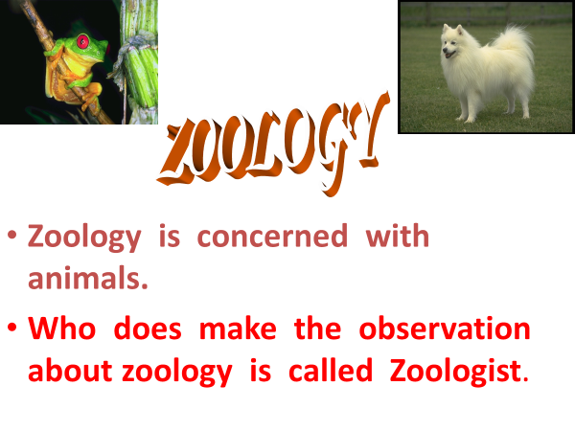
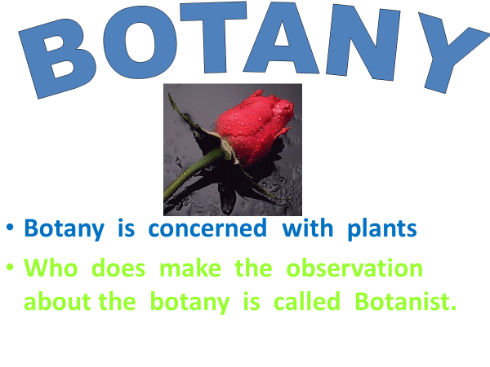
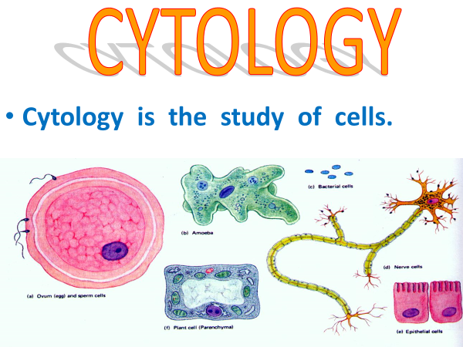

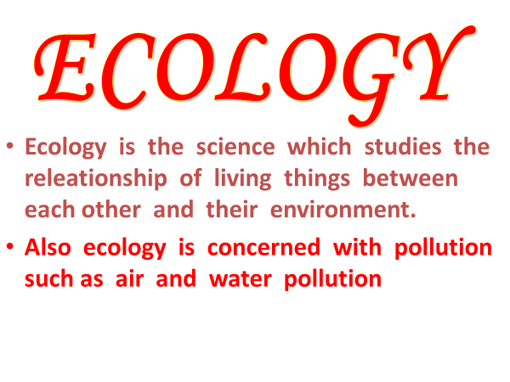
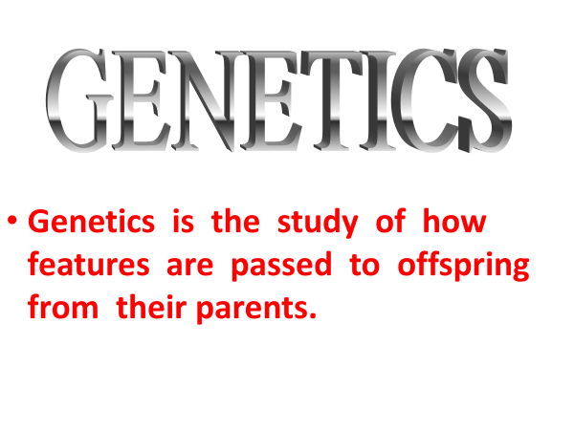

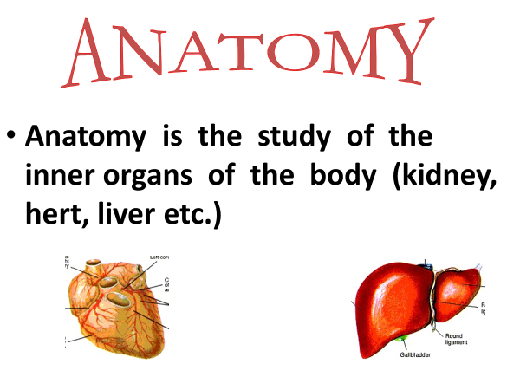
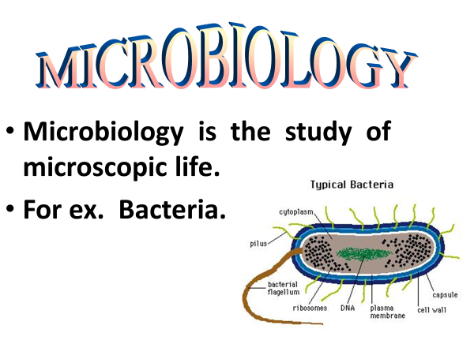

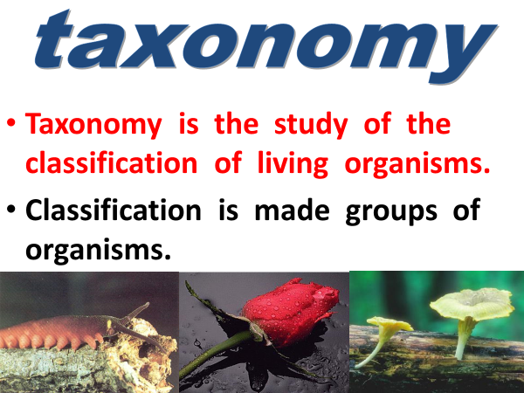
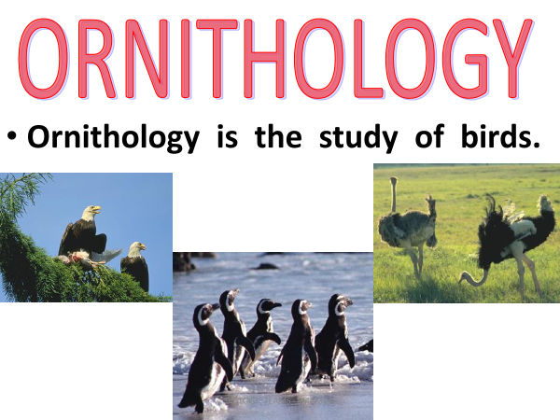
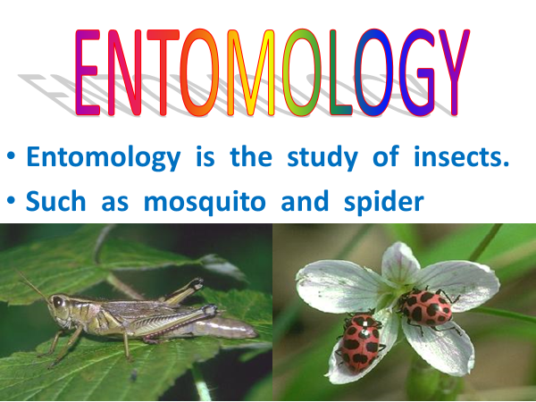
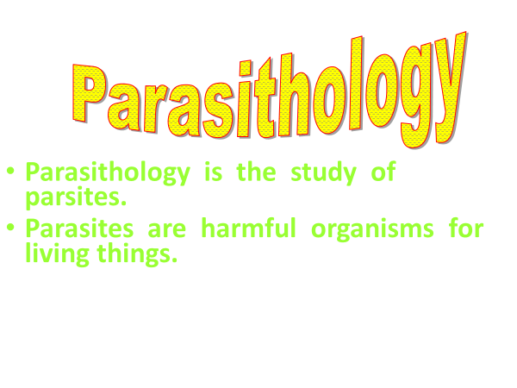
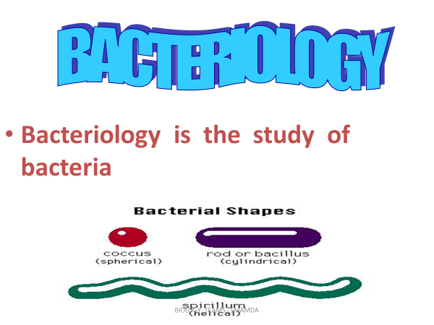
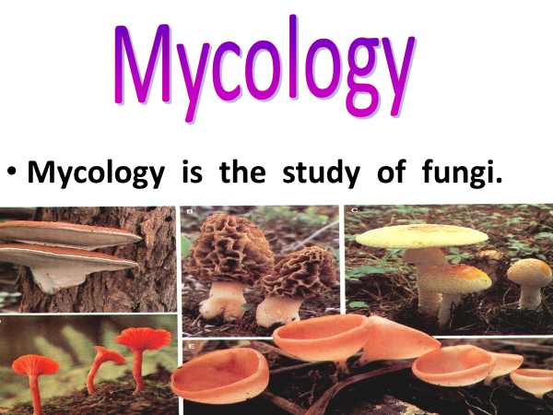
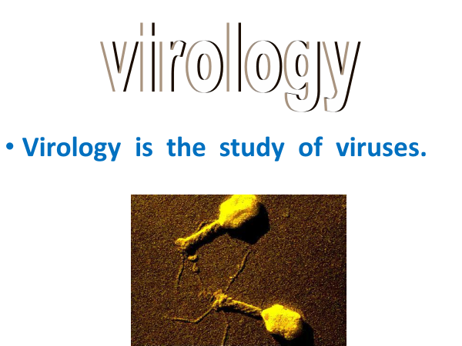
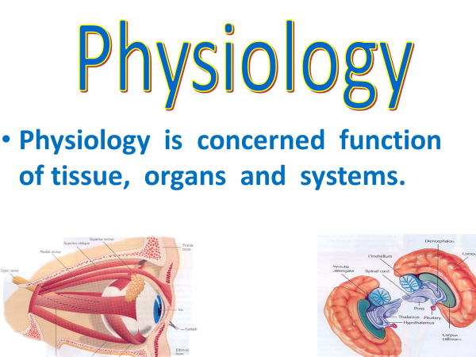
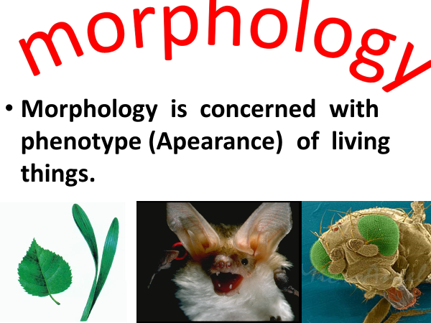
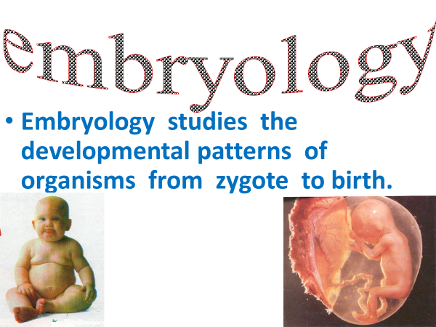

References:
Text adapted from: OpenStax, Concepts of Biology. OpenStax CNX. May 18, 2016
https://cnx.org/contents/s8Hh0oOc@9.10:Pj8cW7X1@4/Introduction

Photographic slides are used from : slideshare.net
https://slideplayer.com/slide/5255574/

