8.Hafta 22-24
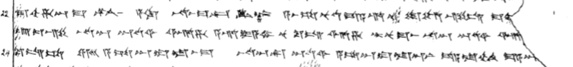
22 ma-ah-ha-an-ma ^{LÚ}KÚR a-ki na-as-ma-kan KIN-az a-as-sa-nu-ud-da-a-ri nu tu-uz-zi-is ma-a[h-ha-an MA-HAR ^{D}UTU^{SI}]
23 u-iz-zi na-an ^{D}UTU^{SI} ar-ha a-ri-ya-mi nu ku-is ar-ha tar-nu-ma-as na-an ^{D}UTU^{SI} ar-[ha tar-na-ah-hi]
24 ku-is-sa ERINMES a-sa-an-du-la-as-ma na-an-kan ^{D}UTU^{SI} a-sa-an-du-la-an-ni da-a-la-ah-hi ma-a-a[n]

