Phase Transitions and Equilibrium Criteria

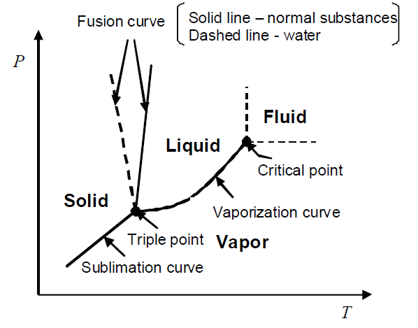
Phase diagrams in the P-T plane

Phase diagrams in the P-T plane

We will develop a number of useful equations to relate properties of pure substances in different phases that are at equilibrium. These relationships can be represented graphically by the phase diagrams. Different types of phase diagrams can be drawn such as P versus specific volume or pressure/temperature versus composition in case of binary systems but for today we will limit ourselves to those that relate pressure to temperature.

The main three curves that you can see in the diagram are called coexistence curves. These curves actually represent a boundary between the single phases solid, liquid and vapor. But what is a lot more important is that two bordering phases exist at equilibrium at any point on these curves. The curve representing a transition from either liquid to vapor or vice versa is called vaporization curve. The one seperating the phases, solid and gas is the sublimation and the last one which is boundary between liquid and solid is the melting or fusion curve.

And there is a point on the diagram which is intersection of these three curves which we call as triple point. It is the only point that all three phases exist in equilibrium. The number of degrees of freedom is being equal to zero. Let me remind you how we used to calculate degrees of freedom,

F=C-P+2, this relationship is referred as Gibbs Phase Rule.

Please always keep the significance of this rule in your minds which we use to find out the number of intensive variables such as, P, T and specific volume used to specify the state of a system.

So according to phase rule, F at triple point is equal to 1-3+2=0 , what about F at the coexistence curves

F is 1-2+2 is equal to 1 indicating one independent intensive variable should be enough to describe the state of the system.

You have two very steep fusion curves on the diagram. While solid line represents the normal substances, dashes one is representative of water. Well, it should not be difficult to describe why water has an unusual behaviour regarding its transition from liquid to solid compared to other substances. Since we all know that water will contract during melting in other words, it will expand during freezing.

Lastly, the steepness of the fusion curve tells us that the triple point of a majority of substainces is close to their melting points at atm pressure.

You can easily notice that there is no point of termination below triple point on the sublimation curve however we have a point called critical point above triple point on vaporization curve. This point is referred to as critical point. At this point the pressure and temprature are called critical pressure and critical temperature, respectively. At pressures and temps exceeding this point, we name the susbtances as supercritical fluids. They are observed to possess both gaseous (viscosity, diffusivity, surface tension) and liquid properties (density). Such that they are able to diffuse into substances easily and dissolve susbtances. Delta H, S and V, they all approach zero as the critical point is approached.

- The negative slope of fusion curve for water is crucial to support life in frozen lakes and rivers. How?
- The fusion curve has a very steep slope indicating the triple point of most substances is close to their melting temperature at atmospheric pressure.
- Critical point
- Substances exist in the fluid region above Tc and Pc, called supercritical fluids.
- Coexisting phases are indistinguishable.
- Both gaseous and liquid properties are observed in the supercritical region.
- ∆S ̃, ∆H ̃ and ∆V ̃ approach zero as the critical point is approached.

Now let’s have a look what type of information we can gather from these curves. Let’s say that alpha and beta are any phases that are in equilibrium According to the phase equilibrium criteria, the molar gibbs free energies of a pure substance at different phases will be equal to each other. Now, please remember how we used to write the differential form of gibbs free energy. I would like to derive quickly for you, you know this is the differential fundemental equation for enthalpy which I am not going to derive, I expect you to remember is dH= TdS+VdP, OK. When we put this into the fundemnatal eqn for gibbs free energy : G= H-TS, dG= dH-TdS-SdT, OK if we susbstitute this eqn in to this long differential eqn, we obtain, dG= TdS+VdP-TdS-SdT…..We finally have dG=VdP-SdT, I aasume , it is completely clear up to this point. So from this eqn. we can easly get the dP/dT.

Clapeyron equation relates the slope of the coexistence curve to the enthalpy and volume changes at a phase transition.

Reference:

Ismail Tosun, “The Thermodynamics of Phase and Reaction Equilibria”, 2012, Elsevier.

