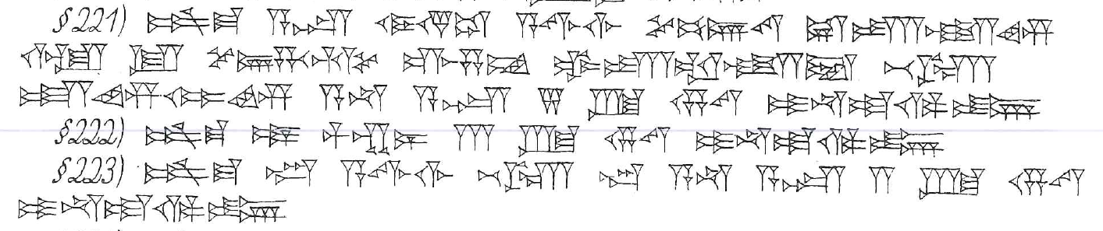
221. šum-ma asûm ( A.ZU) eṣemti ( GÌR.PAD.DU) a-wi-li-im še-bi-ir-tam uš-ta-li-im ù lu še-er-ha-nam mar-ṣa-am ub-ta-al-li-iṭ be-el si₂₀-im-mi-im a-na asîm ( A.ZU) 5 šiqil (GÍN) kaspam ( KÙ.BABBAR) i-na-ad-di-in
222. šum-ma mār ( DUMU) muškēnim ( MAŠ.EN.GAG) 3 šiqil ( GÍN) kaspam (KÙ.BABBAR) i-na-ad-di-in
223. šum-ma warad ( ÌR) a-wi-lim be-el wardim ( ÌR) a-na asîm ( A.ZU) 2 šiqil ( GÍN) kaspam ( KÙ.BABBAR) i-na-ad-di-in

