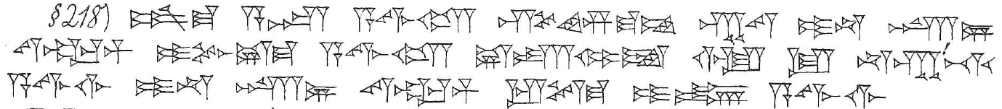
218. šum-ma asûm ( A.ZU) a-wi-lam sí-im-ma-am kab-tam i-na karz/ṣillim ( GÍR.Nİ/ZAL) siparrim ( ZABAR) i-pu-uš-ma a-wi-lam uš-ta-mi-it ù lu na-kap!-ti a-wi-lim i-na karz/ṣillim ( GÍR.Nİ/ZAL) siparrim ( ZABAR) ip-te-ma i-in a-wi-lim úh-tap-pí-id ritta ( KİŠİB.LÁ)-šu i-na-ki-su

