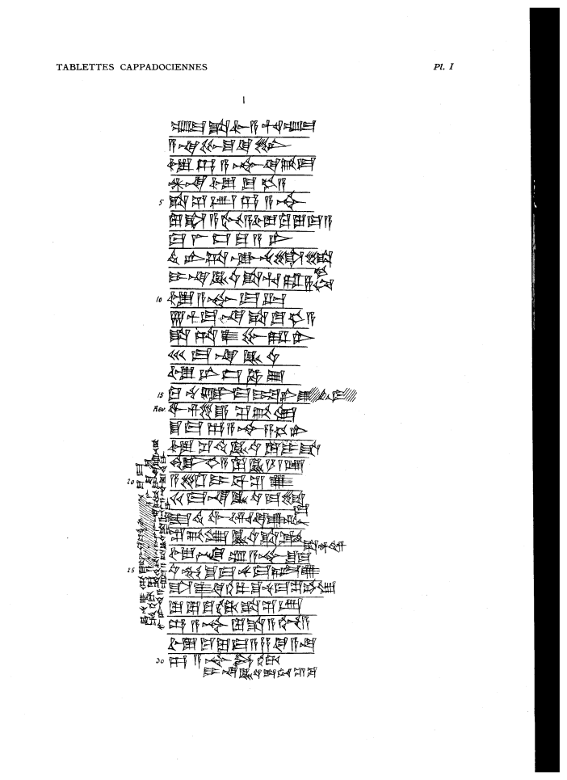

um-ma Ša-lim-a-hu-um-ma
a-na Pu-šu-ke-en₆
ù Dan-A-šur3 qí-bi-ma
AN.NA ù TÚG^{HI.A}
5 ša šé-ep Dan-A-šùr
lu ša A-gu-a ù Ku-lu-ma-a
ma-lá iz-ku-a-ni
té-er-ta-ak-nu li-li=kam
i-na KU3.BABBAR ša Hu-ra-ṣa-nim
10 ù A-šùr-ma-lik
7 1/2 ma-na ša TUG2.HI.A
ša ta-áš-pu-ra-ni
30 ma-na KÙ.BABBAR
ù ni-is-ha-sú
15 ku-nu-uk-ma i-pá-ni-ú-tí-ma
wa-s,e2-e s^e2-bi-lam
s^u-ma Dan-A-s^ur3 sa3-he-er
u3 s^i2-ti2 KU3.BABBAR lu i-s^a
ANS^E.HI.A lu KU3.BABBAR 1 GIN2
20 a-s^ar i-ba-s^i2-u2
20 ma-na KU3.BABBAR ma-li=ma
is^-ti2 wa-ar-ki-u2-tim
s^e2-bi4-lam KU3.BABBAR s^a Puzur4=d.Adad
u3 En-um-A-s^ur3 s^u-ma
25 u4-mu-s^u-<<ma>>-nu ma-al-u2
s^a-as^2-qi2-il5-s^u-nu-ma s^e2-bi-lam
lu lu-qu2-tam s^a s^e2-ep
Dan-A-s^ur3 lu s^a A-gu-a
u3 Ku-lu-ma-a za-ki <<a-na>>
30 Dan-A-s^ur t,ur4-dam
i-na KU3.BABBAR s^a tu3-s^i2-ba-<la-ni>
Ha-nu u2-ul Ka3?-la2?-pa2?-am x [x] x s^u-ma
am-tam2 Dan-A-s^[ur3 x x x] a-la2-qe2-[ma]_
la2 ir-de8-a-am li-bi4 i-la2-mi3-na-kum i-na t,up-pi3-ka3
35 um-ma a-te-<ma> KU3.BABBAR s^a A-pi3-la2 A-s^ur3-is^-ti2-kal2
i-s^a-qal

