Digital Natives and Digital Immigrants

They’re everywhere: in coffee shops, on the train, in restaurants, at work. They’re texting; they’re tweeting; they’re googling; they’re checking social media; they’re taking selfies; they’re listening to music. And yes, they’re even working. They’re always connected. These are the “digital natives.”
Born at the end of the twentieth century and the beginning of the twenty-first century, digital natives don’t know life without technology. The first generation of digital natives is now entering the workforce and changing the way we work. More and more younger people are working from home, in coffee shops, or anyplace. They’re bringing their personal equipment into the workplace too. They switch back and forth between their social and professional lives. They don’t see the need to separate the two.
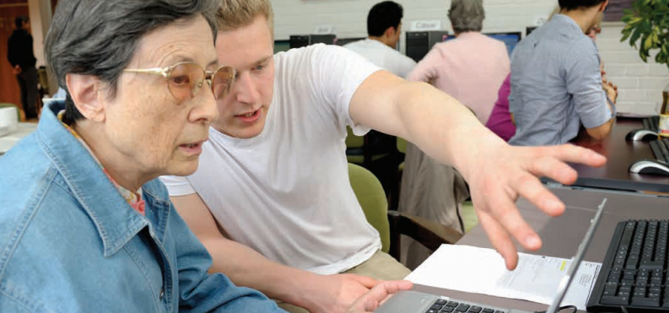
Some older people are adapting well to technology. Some people call them "digital immigrants." Others are having trouble. Some are refusing to use any new technology.
Older people often think that technology is growing too fast. Look at the older people around you. Do they have smartphones? Do they have earbuds in their ears? Are they texting? Many older people prefer to share information with a small group of friends. Digital natives share information globally.
The younger generations want high-tech devices that do everything: take pictures, send texts and photos, provide music and videos, and connect them with friends around the world. What does the older generation want from technology? In many cases, Grandma and Grandpa want a device that connects them to family and friends. They like to see pictures of grandchildren. Some even love to have a video chat with family.
As more and more technology is entering every aspect of our lives, the digital divide between generations is widening.

Comprehension Check: Based on the reading, tell if the statement is true (T) or false (F).
1. Many digital natives are always connected.
2. Seventy-five percent of older people use smartphones.
3. Digital immigrants usually want a device that does many things.

Contrasting the Simple Present and the Present Continuous
