Isothermal Reactor Design
C) Tubular Reactors: Gas-phase reactions are carried out mainly in tubular reactors where the flow is s generally turbulent. Fluid going through a tubular reactor may be modeled as flowing through the reactor as a series of infinite thin coherent "plugs", each with a uniform composition, traveling in the axial direction of the reactor, with each plug having a different composition from the ones before and after it. The key assumption is that there is no dispersion and there are no radial gradients in either temperature, velocity, or concentration.

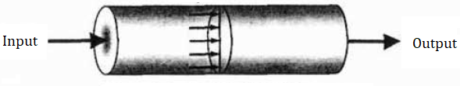
Figure 1. Tubular reactor
The differential form of the design equation derived for the tubular reactor (PFR):
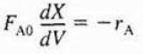
The volume necessary for a conversion within the tubular reactor can be calculated by integrating the given design equation from zero the desired value.
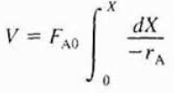
For the following reaction:
A → B
With a rate law of :
-r_{A} = k C_{A}²
If we consider the reaction to take place as a liquid-phase reaction:
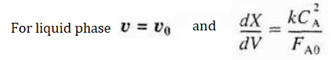
The concentration of the reactor effluent can be written in terms of the effluent conversion as following:
C_{A} = C_{A} (1 – X_{A})
If we insert the concentration relation into the design equation in integral form, we will obtain the following derivation:
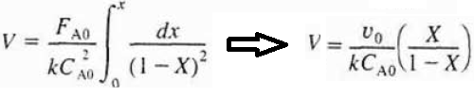
If we consider the reaction to take place as a gas-phase reaction at constant temperature and pressure, the concentration of the reactor effluent can be written as following:
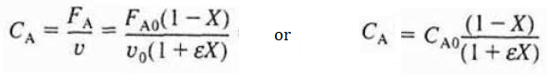
If we combine the mole balance equation and the rate law for the second order gas-phase reaction:
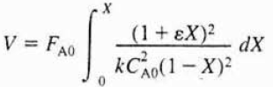
If we integrate the given design equation, we will obtain the following derivation:
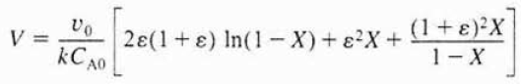
Pressure Drop in Reactors
The concentration of reactants and products is insignificantly affected by even relatively large changes in the total pressure. Hence, the effect of pressure drop on the rate of reaction can be ignored for the liquid-phase chemical reactors.
On the other hand, the concentration of the reacting species and the product species is proportional to the total pressure. Hence, it is needed to account of the effects of pressure drop on the reaction system.
The concentration of the reacting species and the product species can be written for an ideal gas as following:
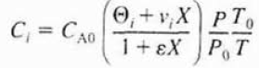
For a second order gas-phase reaction:
A → B + C
The differential form of the mole balance equation in terms of the reactor volume is:
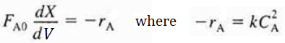
The rate law can be written for the gas-phase reaction as following:
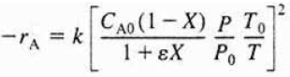
If we combine the design equation of PFR with the rate law :
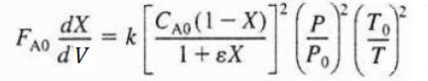
If we divide the given relation with the entering molar flow rate of A (for constant temperature condition):
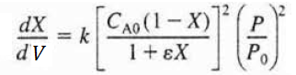
The differential form of the given equation is function of only conversion and pressure as following:
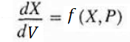
The differential form of the mole balance equation in terms of the catalyst weight is:
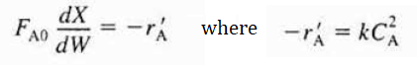
If we combine the design equation of PBR with the rate law given above :
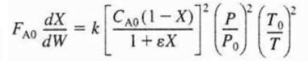
For isothermal operation, the right-hand side of the equation given above is function of only
conversion and pressure:
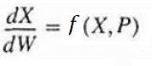

References:
- H. Scott Fogler, “Elements of Chemical Reaction Engineering”, Prentice Hall Professional Technical Reference, Fourth Edition.

