1.Hafta 1-4
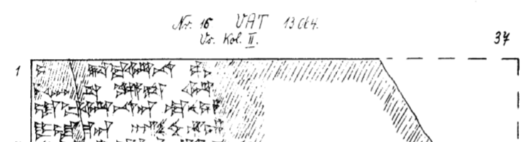
1 L[UGAL GAL] TA-BA-AR-NA pa-a[n-ga-u-i A-NA ^{LÚ.MEŠ}GAL.GAL-ya]
2 me-mi-i[s-t]a ka-a-sa ar-[ma-ni-ya-ah-ha-at nu-us-ma-as TUR-la-an]
3 la-ba-ar-na-an te-nu-un [a-pa-a-as-wa-as-sa-an e-sa-ru LUGAL-us-an-za]
4 DUMU-la-ma-an hal-zi-ih-hu-un [nu-us-si tág-ga-li-ya-nu-un pár-ga-nu-un-na-an]

