11.Hafta 32-35
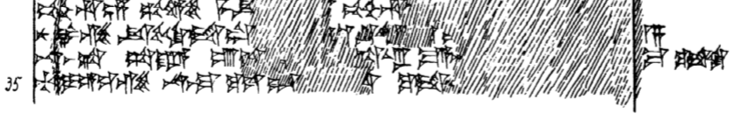
32 pé-eh-hu-un GUD^{HI.A}-se me-e[k-k]i pé-eh-hu-u[n UDU^{HI.A}-se me-ek-k]i pé-eh-hu-un
33 nu az-zi-ik-ki-id-du [a]k-ku-u[s-ki-i]d-d[u ma-a-na-as as-su-us]
34 na-as-ta sa-ra-a ú-is-ki-[i]t-ta-ru ma-a-a[n-ma-as pu-g-ga-a]n-za
35 ti-i-e-ez-zi na-as-ma ku-us-du-[wa-a-t]a ku-it-k[i na-as-ma har-nam]-ma ku-it-ki

