ANKARA UNIVERSITY
Computer Engineering Department
COM1002: Computer Programming II (Spring 2021-22)
Course Syllabus

Instructor: Dr. İrem Ülkü
Contact: irem.ulku@ankara.edu.tr

Reference Textbook: C: How to Program, Paul J. Deitel, Harvey Deitel, Pearson; 8th edition, ISBN: 978-0133976892
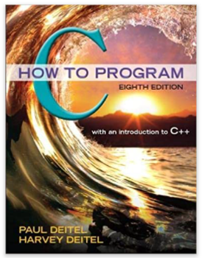
Lecture Notes: Will be available on the Moodle weekly.
Office Hours (OH): Will be arranged later.
Course Aim: This course aims to teach students the basic principles of the computer programming using C Programming Language. Students are expected to be able to use the C programming language to code, document, test, and implement a well-structured, robust computer program.
Course Content: This course includes Introduction to C Programming, Structured Program Development in C, C Program Control, C Functions, C Arrays, C Pointers, C Characters and Strings, C Formatted Input/Output, C Structures, Unions, Bit Manipulation and Enumerations, C File Processing and C Data Structures.
Weekly Schedule: This is a 5-credit course with 4 lecture hours and 2 laboratory hours each week. The students will be assessed weekly for the content that is covered in the class via laboratory exams. Laboratory attendance is important, a student should not miss more than 3 labs during the semester.

Course Outline:
WEEK | CONTENTS
1 | Introduction to C Programming
2 | Structured Program Development in C
3 | C Program Control
4 | C Functions
5 | C Functions
6 | C Arrays
7 | C Arrays
8 | Midterm
9 | C Pointers
10 | C Characters and Strings
11 | C Formatted Input/Output
12 | C Structures, Unions, Bit Manipulation and  Enumerations
13 | C File Processing
14 | C Data Structures

Grading:
Item | Weight
Laboratory* + Homework | %15
Midterm | %15
Final | %80
*Attendance constraints apply
Class Policies:
- The University Policy on attendance (at least %70 for lectures and at least %80 for laboratories) will be applied.
- Students who do not attend more than 3 laboratories will get F4 grade.
- If a student is absent during laboratories and quizzes, this student will get no credit for that particular requirement.
- Any form of cheating is strictly forbidden. Exchanging source codes or laboratory solutions is cheating and will be reported to the University. At least, you will fail the course.

