- BASIC CONCEPTS
Concepts or ideas, which are the basis of engineering and science, are chemical species, mass, momentum, and energy. Those concepts are all conserved quantities. A conserved quantity is one which might be transformed into another form. However, this transformation type does not change the total amount of the quantity. As an example, money can be transferred from a savings account to a checking account but this type of transfer does not alter the total assets.
For any type of quantity which is conserved, an inventory rate equation can be written to explain the transformation of the conserved quantity. Inventory of the conserved quantity is rely on a specified unit of time, which is given in the term, rate.

Basic ideas and concepts, upon which the technique for solving science and engineering problems is
based, are the rate equations for the:
- Conservation of momentum,
- Conservation of mass,
- Conservation of chemical species
- Conservation of energy.

- Characteristics of the Basic Concepts
The basic ideas and the concepts have specific characteristics that are always taken for granted
but seldom stated explicitly. The basic concepts are:
- Independent of the state of application,
- Independent of the coordinate system,
- Independent of the matter on which they are applied.

The basic concepts are applied both at the macroscopic and the microscopic levels as illustrated on Table 1.
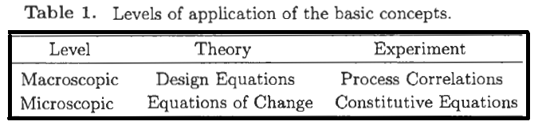
At the microscopic state, the basic ideas appear as partial differential equations in three independent space variables (x, y, z) and time (t). Basic concepts at the macroscopic state are called the equations of change, like conservation of momentum, energy, mass and chemical species.

- Basic Definitions
The functional notation
ϴ = ϴ (x, y, z, t)
illustrates that there are three independent space variables, which are x, y, z, and one independent time variable, t. The notation “ϴ” on the right side of the given equation indicates the functional form, and the notation “ϴ” on the left side of the equiation illustrates the value of the dependent variable, ϴ

  - Steady-State
The concept “steady-state” means that at a particular location in space, the dependent variable “ϴ” does not change with respect to time. It can be illustrated by using the dependent notation “ϴ” below.
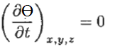
The partial derivative notation means that the dependent variable “ϴ” is a function of more than one independent variable, which are x, y and z. This equation indicates that the depedent variable “ϴ” is not a function of time, t.
When ordinary differential is used instead of partial derivatives, the meaning of this equation is quite different given before. The following equation (ordinary differential equation) means that the dependent variable is constant, not a function of any independent variable
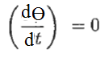
Example: A swimming pool is initially half full with water. The water is fed into the pool from the faucet and it leaves the pool from the bottom of the pool via a pump. The volumetric
flow rates of the faucet and the pumu are different from each other. The differential equation describing the time rate of change of the height of water in the pool is llustrated by the following equation:
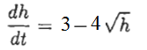
At which h is the height of water in meters. Calculate the height of water in the pol under steady conditions.

Solution: Under steady-state condition, dh/dt must be equal to zero. Then;
h = (3/4)^{1/2} = 0.5625 m

  - Uniform
The concept “uniform” means that at a particular instant in time, the dependent variable “ϴ” is not a function of position. This requires that all three of the partial derivatives with respect to position must be zero, as shown below:
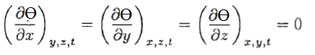

The variation of any kinds of a physical quantity with respect to position is called gradient. Hence, the gradient of a quantity should be zero for a uniform condition to exist with respect to that quantity.

  - Equilibrium
A system is in equilibrium if the system is both under steady-state and uniform conditions. An equilibrium system does not exhibit any variations with respect to time (t)and position (x, y and z).
The ideal gas law is an well-known example of a thermodynamic system under equilibrium condition.
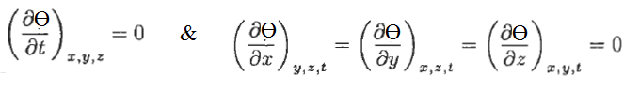
  - Flux
The flux of a certain quantity is defined by:
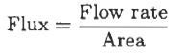
at which flow area is normal to the direction of flow.

References:
İ. Tosun, “MODELLING IN TRANSPORT PHENOMENA A Conceptual Approach”, Elsevier, 2002.

