Evaluation of Transfer Coefficients: Engineering Correlations

Most engineering problems do not have real solutions and most of engineering analysis is concerned with the experimental data which is usually expressed in terms of engineering correlatons. These correlations are limited only to a specific geometry and boundary conditions.Hence, the results obtained from correlations are not exact, which means that it is possible to obtain two different results from two different correlations for the same engineering condition.
Most of the engineering correlations are expressed in terms of dimensionless numbers. As an example, the correlations used to obtain the friction factor “f”, heat transfer coefficient “h”
and mass transfer coefficient “kc”are generally expressed in the form of :

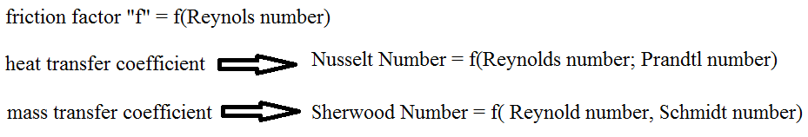

REFERENCE TEMPERATURE AND CONCENTRATION

In order to calculate the dimensionless numbers, appearing in the engineering correlations, we need to know the physical properties of the fluid. The physical properties of the fluid depend on temperature and concentration most of the times. In engineering problems, temperature and concentration vary as a function of positionif it is not uniform. Hence, it is required to determine reference temperature and concentration.

Bulk Temperature and Concentration: The bulk temperature or the bulk concentration at a particular location within a pipe or conduit is the average temperature or average concentration.
The bulk temperature and the bulk concentration is thought as the free stream temperature and free stream concentration if the objects are immersed in an infinite fluid.

Film Temperature and Concentration: The film temperature and the film concentration can be obtained from the arithmetic average of the surface value and the bulk value as shown below:
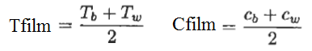

FLOW PAST A FLAT PLATE
If we suspend a flat plate into a uniform stream of velocity V, and temperature T, as shown in Figure 1.
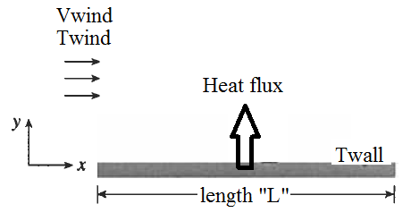
Figure 1. Wind flow over a flat plate at Twall

Average friction factor, average Nusselt number and average Sherwood number can be calculated for a variety of flow conditions as shown in Table 1.

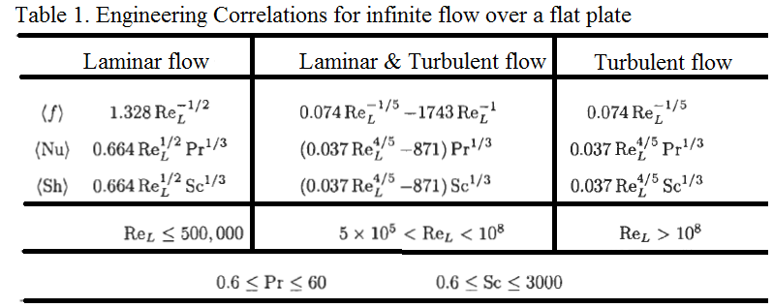

In order to calculate average values of friction factor, Nusselt number and Sherwood number from the stated engineering correlations, all physical properties of the fluid must be calculated at the film temperature.
Average values of the heat transfer coefficient and mass transfer coefficientcan be calculated from the average values of the Nusselt number and the Sherwood number.
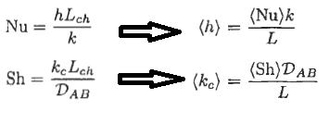
The rate of momentum transfer can be calculated using the friction factor and the following expression, given below:
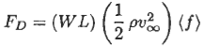
The rate of heat transfer can be calculated using average Nusselt number and the following expression, given below:
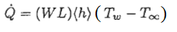
The rate of mass transfer can be calculated using average Sherwood number and the following expression, given below:
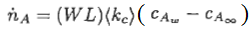
Engineering problems related with the infinite flow of a fluid over a flat plate can be classified as followings:
- In order to calculate the transfer rate (momentum, heat or mass); the physical properties of the fluid, and the dimensions of the plate needs to be known.
- In order to calculate the length of the plate in the direction of flow; the physical properties of the fluid need to be known.
- In order to calculate the fluid velocity; the transfer rate (momentum, heat or mass), and the physical properties of the fluid needs to known. In addition, the dimensions of the plate needs to be known.
References:
İ. Tosun, “MODELLING IN TRANSPORT PHENOMENA A Conceptual Approach”, Elsevier, 2002.

