Evaluation of Transfer Coefficients: Engineering Correlations
FLOW NORMAL TO A SINGLE CYLINDER

Example. A cylindrical object of 0.05 m outside diameter is covered with a thin layer of ethyl alcohol. Air at 303 K flows normal to the pipe with a velocity of 3 m/s. Determine the average mass transfer coeficient.

Solution:
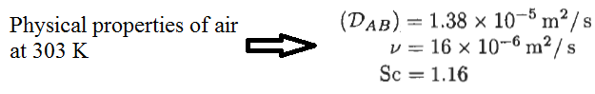
Assumptions:
- There is a steady-state condition,
- The system is also isothermal

The reynolds number can be calculated using the following correlation:
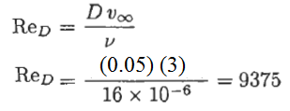
Bedingfield and Drew at 1950 proposed a correlation for mass transfer for cross-flow and parallel-flow of gases to the cylinder. When we used this correlation to calculate the Sherwood number:
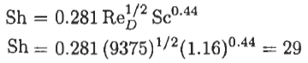
The average mass transfer coefficient can be calculated using the Sherwood correlation given below:
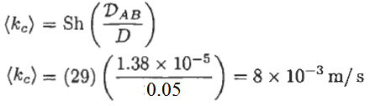
FLOW IN CIRCULAR PIPES
The rate of pump work “W” to transfer a fluid from a position to another position can be determined from the given correlation:
W = Q ΔP
where Q is the volumetric flow rate and ΔP is the pressure difference between two position along the pipe.
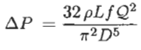
- Friction Factor Correlations
- Laminar flow correlation
For laminar flow in a circular pipe with the Reynolds number less than 2100, the friction factor can be calculated using the followig correlation:
f = 16/N_{RE}

- Turbulent flow correlation
Colebrook at 1938 proposed a correlation for turbulent flow in a circular pipe with the Reynolds number more than 2100. Hence, the friction factor can be calculated using the following corelation given below:
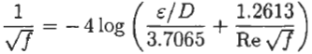
where Є is the surface roughness of the pipe wall in meters.

- Heat Transfer Correlations
Various correlations have been proposed depending on the flow conditions within the pipe.
A) Laminar flow correlation
For laminar heat flow in a circular pipe with the Reynolds number less than 2030, the average Nusselt number can be calculated using the followig correlation:
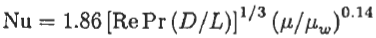
The physical properties except the viscosity at wall are evaluated at the mean bulk temperature. The proposed correlation is valid for the following condition:
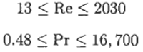
B) Turbulent flow correlation
Sieder and Tate at 1936 proposed a correlation for turbulent flow in a circular pipe with the Reynolds number more than 10000. Hence, the average Nusselt number can be calculated using the following corelation given below:
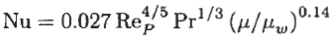
The given correlation is valid for the given condition below:
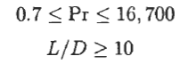
- Calculation of the heat transfer rate
After the average heat transfer coefficient is calculated using the given correlations above, the
rate of heat transferred needs to be calculated using the equation given below:
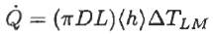
at which ΔT_{LM} is the log mean temperature difference within the pipe flow. ΔT_{LM} can be calculated as followings:
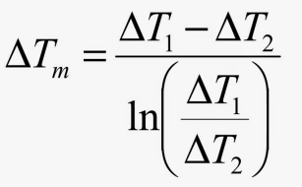
3) Mass Transfer Correlations
A) Laminar flow correlation
For laminar mass flow in a circular pipe with a constant wall concentration, the average Sherwood number can be calculated using the followig correlation:
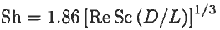
The given correlation is valid for the given condition below:
B) Turbulent flow correlation
Linton and Sherwood at 1950 proposed a correlation for turbulent flow in a circular pipe with the Reynolds number more than 2000. Hence, the average Sherwood number can be calculated using the following corelation given below:
The given correlation is valid for the given condition below:
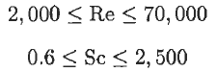
• Calculation of the mass transfer rate
After the average mass transfer coefficient is calculated using the given correlations above, the rate of mass transferred needs to be calculated using the equation given below:
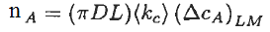
at which (ΔTCA)_{LM} is the log mean concentration difference within the pipe flow.

References:
İ. Tosun, “MODELLING IN TRANSPORT PHENOMENA A Conceptual Approach”, Elsevier, 2002.

