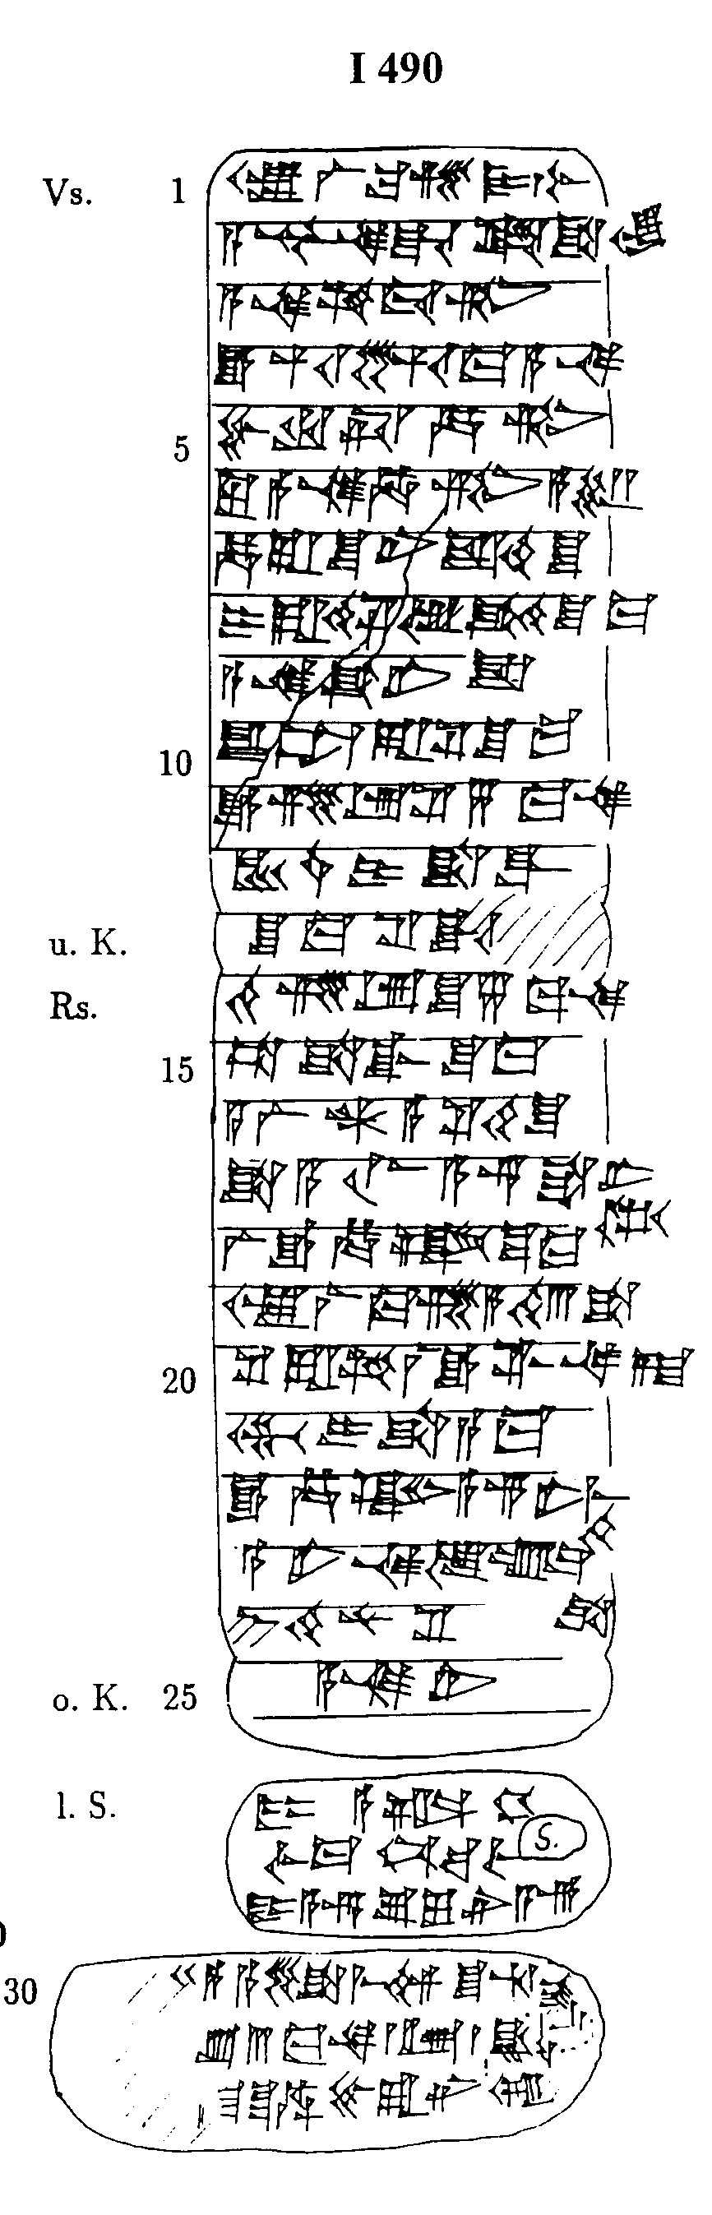
ICK 4, 490
{Vs.} 1 Is^tar-la2-ma-si2 DUMU.SAL
A-s^ur3-na-da Puzur4-Is^tar
a-na am-tu3-tim
e-hu-uz-ma a-na
5 Pu-ru-us^-ha-tim
lu a-na Ha-tim a-s^ar
ha-ra-s^u-ni is^-ti2-s^u
i-ra-de8-s^i2 u3 qa2-di2-s^u-ma
a-na Ka3-ni-is^
10 u2-ta-ra-s^i2 s^u-ma
e-zi-ib-s^i2 5 ma-na
KU3.BABBAR i-s^a-qal
{u.K.} s^u-ma s^i2-it-[ma]
{Rs.} te2-zi-ib-s^u 5 ma-na
15 ta-s^a-qal-s^u-ma
a-la2-an a-s^i2-ti2-s^u
s^a a-lim A-s^ur s^a-ni=tam2
la2 e-ha-az s^u-ma
Is^tar-la2-ma-si2 a-di2 3 s^a-na-at
20 s^e2-ra-am la2 e-mar
GEME2 i-s^a-a-ma
e-ha-az A-s^ur-ne2-me=di2
A-ni-na u3 um-ma=s^a
[i]_-di2-nu-s^i2
{o.K.}
25 [IGI] A-na-li2
{l.S.} DUMU A-al-DU10
IGI Ma-num-ba-lum2-A-s^ur
DUMU A-s^ur-s,u2-lu-li2

