6.Hafta 15-17
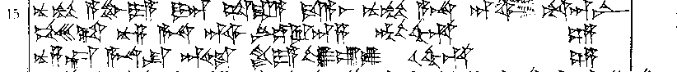

15 nu-mu A-BU-YA DUMU-an sa-ra-a da-a-as nu-mu A-NA DINGIR^{LIM} ARAD-an-ni
16 pe-es-ta nu-za A-NA DINGIR^{MES LÚ}SANGA-an-za BAL-ah-hu-un
17 nu-za-kán A-NA SU ^{D}ISTAR GASAN-YA lu-ú-lu u-uh-hu-un

