MATERIAL INFORMATION

9. IMPACT OF ENVIRONMENTAL CONDITIONS IN MATERIAL

The stability of a material explains its tendency to chemical and phase changes in its environment. Therefore, it is important to know the environmental conditions. Two important factors in environmental conditions are corrosion and radiation.

9.1. Corrosion

The chemical and electro-chemical effect of the environment and the damage or degradation it causes on the material are called corrosion.

9.1.1. Chemical corrosion

The occasional metal material creates a chemical compound without a vehicle (conductor or electrolyte), causing damage to the material. In other words, this corrosion is the damage of the material by gases, acids, bases and salts.

In practice, chemical corrosion is formed by the influence of normal air, industrial air and sea water. Corrosion generated by normal air is oxidation.

Chemical corrosion is mostly found in active metals. The rate of corrosion caused by oxidation of metals in normal air varies depending on the protective effect of the formed oxide layer. The oxide layer is fast in porous ones (Mg), and the protective ones (Cu, Fe, Ni) are slow and very slow in those that are very good preservatives (Al, Cr, Zn).

9.1.2. Electro-chemical corrosion

Electrochemical corrosion occurs in environments that allow the movement of ions. In other words, in order for electrochemical corrosion to occur, an environment where electric current can be born is required. This environment consists of an electrically transmitting electrolyte (acid base or salt melt) and two separate n metal electrodes.
Electro-chemical voltage sequence

Au +1.42
Ag +0.80
Cu +0.52
H 0
Pb -0.13
Sec -0.14
Ni -0.23
Cd -0.40
Fe -0.44
Cr -0.71
Zn -0.76
Take -1.66
Ti -1.75
Mg -2.40

It is arranged according to the normal potion of metals in electro-chemical voltage ranking. The potential varies with different pH values.

A simple example of electrochemical corrosion is a galvanic battery formed by a metal nail or wire and a drop of water that falls on steel hair covered with zinc. Since iron is more peeled here than zinc, zinc coating wears out and steel is released. The steel then rust by chemical corrosion.

9.1.3. Corrosion prevention methods

Corrosion prevention methods are grouped into four groups as follows.

In the design phase: It is aimed to design the materials that will create galvanic batteries in such a way that they do not touch each other. If you can't get out of here, a neutral layer should be placed between them.

Coating: Coating of metals with corrosion resistant metal or non-metal materials. Lubrication of the surface of a metal material is the simplest coating method. The common method in the industry is painting. In addition, galvanizing, tinning, chrome and nickel film coating can be listed as coating, oxidizing, phosphate and easing coating by spraying metal or plastic.
Protection of the material by cathode: The metal mass, which is intended to be protected from corrosion, is attached to the metal (usually Zn or Mg), which is less peeling than itself. Thus, this metal, which is turned into a cathode, is corroded. Groundwater pipes, water tanks, etc. are protected from this way. In a similar application, it is to cathode by giving current to the material to be protected. In this application, the end of the Battery (+) is connected to the material to be protected in this electrode (-) (Figure 9.1).

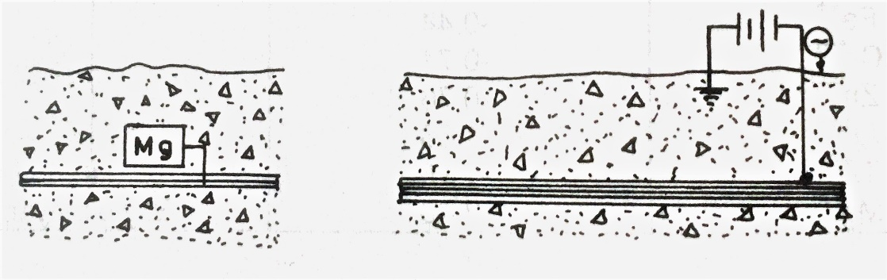
Figure 9.1. Cathodic protection of underground pipes

Using corrosion-resistant alloy: Non-alloy steels are corrosion resistant. Since pure metals contain homogeneous crystals, they always withstand corrosion more than their alloys.

9.1. Radiation

Radiation alters the mechanical, physical and chemical properties of materials. Important radiations are gamma rays and neutrons. Other alpha rays, beta rays and protons (Figure 9.2).

In practice, the effect of solar radiation on materials is important. Some chemical changes in the internal structure of materials should be taken into account. For example, alpha rays in ultraviolet rays are known to disrupt the atomic structure of organic materials in particular, causing aging and color changes. Metals are more resistant to radiation than plastic and ceramic materials.
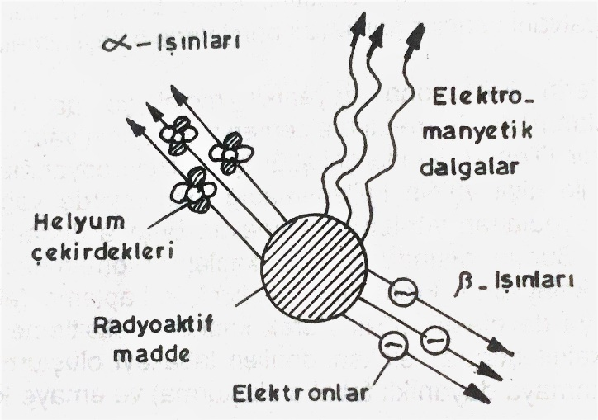
Figure 9.2. Radioactive rays

