Milk Production in Dairy Cows
Dairy Cow Lactation Process & Udder Anatomy

It all starts with eating…
Milk contains a large amount of essential nutrients and components for the diet of healthy animals. In order for dairy cows to produce milk, containing these components, they must first ingest the raw materials.
Through ingestion, rumination and digestion, plant material is broken down in the stomachs and moved to the small intestine where the necessary nutrients are absorbed into the blood stream.
These nutrients are delivered to the udder, along with other parts of the body, via the blood. The udder has a high supply of blood, in order to allow large volumes of milk to be produced.

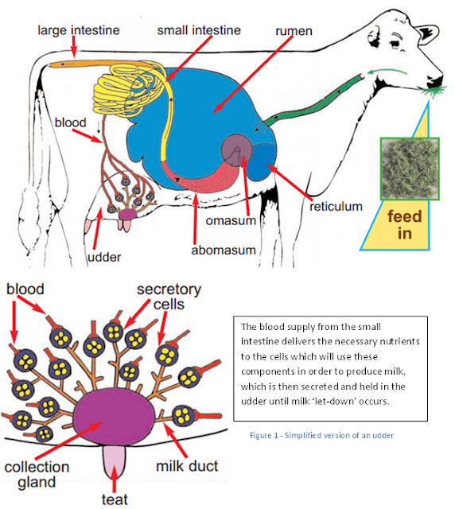

In the udder…
Once the blood supply containing the nutrients has reached the udder, the nutrients are used to produce milk.
The udder is to all intents a highly-developed and modified sweat gland, lined inside with a structure similar to skin. In cattle, it is composed of four individual glands, known as quarters.

The above photo shows one quarter of a cow, each cow has 4 of what is shown above.
The interior of each quarter of the udder is composed of a teat cistern, a gland cistern, milk ducts and glandular tissue. The glandular tissue deep within the udder contains millions of microscopic sacs called alveoli (the large amount of these tiny sacs increases the overall surface area : volume ratio meaning there is a greater capacity of milk producing cells in the udder); each alveolus is lined with milk-producing epithelial cells and is surrounded by muscle cells (myoepitheliad cells) that contract, squeezing milk from the alveolus into the milk ducts when the stimulus for milk let-down occurs during milking, or when a calf is suckling.

The nutrients found in milk area brought to each alveolus via the blood vessels, where epithelial cells convert them into milk. There is a large blood supply to the udder; in the order of 400 litres of blood pass through it just to produce a single litre of milk.
Between milking sessions, milk accumulates in the alveolar spaces, milk ducts, and cisterns; this is particularly more common in higher-yielding cows. During milking, this accumulation of milk is removed through the teat ducts.
There is no milk flow and very insignificant flow of blood between the four separate glands, but due to the large volume of blood needed for milk production this is why antibiotics injected into one quarter can find their way systemically into the cow’s bloodstream and be detectible in other quarters too.
There is also a strong, complex structure of ligaments attaching to the pelvic bone, the abdomen and the inner thigh, to support the udder and help it to hold its shape and allow expansion as milk collects between milking.
Through the teat…

Cow teat structure has evolved to allow for effective suckling by the calf but also to provide some protection against damage and infection from mastitis-causing pathogens.
The teat has a large mass of interconnecting blood vessels at is base, called the erectile venous plexus. This structure makes the teat become more rigid when milk let-down is stimulated, in order for a calf to suckle or milk to be collected by milking equipment, without the teat collapsing on itself.
The teat is also well-serviced with nervous tissues, allowing the stimulus required to initiate milk-let down to be transmitted to the brain. This explains why sore and damaged teats appear to be particularly painful.
Teats vary in size and shape; the more cylindrically-shaped teats are alleged to be less-susceptible to mastitis.
The outer layer of thick, hairless skin is called the epidermis; it contains a thick layer of keratin and therefore has a much more rugged structure in order to cope with the demands of being suckled and milked. It has no sweat or sebaceous glands to lubricate it like normal skin, so is more prone to becoming dry and cracked. The epidermis also has a large number of nerve endings.
The dermis is the second layer of the teat wall and carries the nerves and blood vessels.
There is a layer of muscle, giving the teat strength and structure and a circular sphincter muscle around the teat canal.
The teat cistern is lined with epithelial cells, which are square-shaped and are able to move apart, allowing white blood cells to enter the cistern as part of immune system response to bacterial infection.
The teat canal is approximately 9mm in length and has a lining comprised of folded epidermal tissue (similar to skin, but containing more keratin), covered by a thin lipidised film; which is hydrophobic (repels water). There is also a structure known as the rosette of Furstenberg, which has an important role in detecting bacterial infection and initiating an immune response.

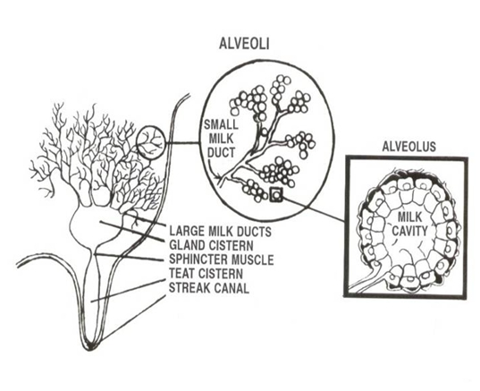

Summary:
· The necessary nutrients and substances are absorbed from digested material in the small intestine. Via the blood these nutrients, along with components from other parts of the body, are transported to the blood vessels which supply the udder.
· In the glandular tissue of the udder, these blood vessels supply alveoli, which consist of epithelial cells, which use the nutrients provided to produce milk.
· The milk is secreted into the alveoli, the milk ducts and the gland cistern; all of these areas fill up with milk throughout the day.

How the milk leaves the udder…

The process of milk leaving the udder via the teat is initiated by milk let-down.
It is important to understand the let-down of milk, in order to create an efficient routine to milk cows as quickly and efficiently as possible, minimising any possibility of ‘over milking’.
Milk let-down is controlled by unconditioned factors, most notably the response to tactile stimuli provided by a calf rubbing the udder or tea when suckling, or a similar stimulus provided by the milker when fore-milking the quarter or otherwise preparing it for being milked. Also, conditioned factors, such as particular sounds, smells or routine the cow experiences around milking time will also contribute to milk let-down.
All of these above stimuli result in the release of the hormone Oxytocin. This is released from the cow’s pituitary gland in the brain, into the bloodstream. Once in the blood stream it takes effect in the udder, causing several important processes to occur…
Oxytocin acting in the udder causes the mass of interconnecting blood vessels in the teat to fill with blood, making the teat more erect and allowing milk to enter it from higher in the udder.
Oxytocin also encourages muscles throughout the udder to release milk – this is done by initiating the myoepitheliad cells to contract, which force the milk out of the alveoli in the glandular tissue, and into the gland cistern and through to the teat cistern, where it can exit the teat through the streak canal.
The effects of oxytocin can be reduced/counteracted by the release of adrenaline, therefore during milking the amount of stress put onto the cattle should be minimised in order to avoid the release of adrenaline, which would reduce milk let-down efficiency.
Lag time…
The average time between beginning to prepare the cow for milking (by fore-milking or washing the teats) and the resultant let down of milk is roughly 60-90s. This period is known as ‘lag time’.
During the period in between milking (e.g. after morning milking and before evening milking), milk will have already collected in the udder and teat cisterns and will be released almost immediately upon attachment of the milking equipment. The amount of time taken for the milk from higher up in the udder (in the glandular tissue) to be released into the lower parts of the udder and through the teat, is the lag time. Essentially it is the time taken for oxytocin to take effect.

Over-milking…

This can occur when a high pressure vacuum is acting on an udder with a very low volume of milk, or no milk at all. This can cause significant damage to the teat end and increase susceptibility of cows to mastitis.
If the milk let-down is not timed correctly and the milking machine is put onto the cow too early, a short period of over-milking can occur, where the milk is still being processed higher up in the udder and is not yet at the teat cistern.

After milking…

Once the milking process has finished, the teat sphincter closes and the folds of skin around the opening close around one another, creating a tight seal and the lipidised film around the sphincter stops a column of milk forming through which bacterial entry could occur. A way keratin seal begins to form in the teat canal to protect against bacterial entry.

However, the sphincter muscle can take around 20-30mins to close and it is during this time that the risk of bacterial entry is greatly increased. This is why spraying with iodine is essential after milking and why lying down should be avoided for the half an hour after milking.

