ANKARA UNIVERSITY
Computer Engineering Department
COM1001: Computer Programming I (Fall 2022-23)
Course Syllabus

Instructor: Dr. İrem Ülkü
Contact: irem.ulku@ankara.edu.tr
Reference Textbook: An Introduction to Programming Using Python, David I. Schneider, Pearson; 1st edition, ISBN: 978-1292103433
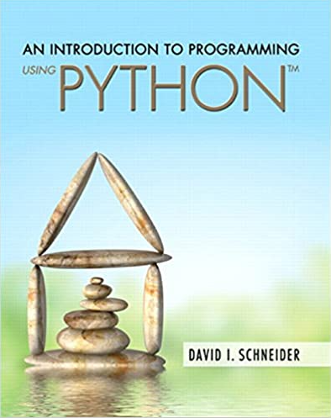
Supplementary Textbook: Learning Python, Mark Lutz, O'Reilly Media; Fifth edition, ISBN: 978-1449355739
Lecture Notes: Will be available on the Moodle weekly.
Office Hours (OH): Will be arranged later.
Course Aim: This course aims to teach students the basic principles of the computer programming using Python Programming Language. Students are expected to be able to use the Python programming language, apply various data types and control structures and understand the object-oriented program design.
Course Content: This course includes built-in types, lists, tuples, dictionaries, operators, expressions, statements, I/O and file operations, control flow statements, loops, functions, recursion, classes, object-oriented programming concepts (inheritance, polymorphism and operator overloading), errors, exceptions, modules, packages, debugging, testing and graphical user interface all based on Python programming language. All of these topics will be supported with laboratory applications.
Weekly Schedule: This is a 5-credit course with 4 lecture hours and 2 laboratory hours each week. The students will be assessed weekly for the content that is covered in the class via laboratory exams. Laboratory attendance is important, a student should not miss more than 3 labs during the semester.
Course Outline:
WEEK | CONTENTS
1 | An Introduction to Computing, Problem Solving and Python
2 | Core Objects, Variables, Input, Output, Strings
3 | Lists, Tuples, Dictionaries and Files
4 | File Operations
5 | Structures that Control Flow
6 | Functions
7 | Processing Data
8 | Midterm
9 | Exception Handling, Random Values, Turtle Graphics
10 | Recursion
11 | Class
12 | Inheritance, Polymorphism and Operator Overloading
13 | Graphical User Interface
14 | Graphical User Interface

Grading:
Item | Weight
Laboratory* | %9
Homework | %6
Midterm | %15
Final | %80
*Attendance constraints apply
Class Policies:
- The University Policy on attendance (at least %70 for lectures and at least %80 for laboratories) will be applied.
- Students who do not attend more than 3 laboratories will get F4 grade.
- If a student is absent during laboratories and quizzes, this student will get no credit for that particular requirement.
- Any form of cheating is strictly forbidden. Exchanging source codes or laboratory solutions is cheating and will be reported to the University. At least, you will fail the course.

