Isothermal Reactor Design
- Batch Operation : For gas-phases reactions with constant volume batch reactor, the reactor volume remains constant. Hence:
V = Vo
The mole balance for the constant volume batch reactor:
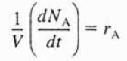
The mole balance for the constant volume batch reactor can be written in terms of concentration as following:
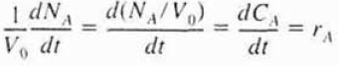
In order to calculate the time necessary to achieve a given conversion X for the following irreversible second-order reaction:
A → B
The mole balance for the given condition & the rate law:
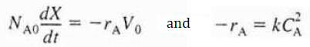
The mole balance and the rate law equation can be combined to obtain the following relation:
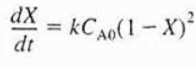
After integrating the given equation in differential form, we can obtain the relation to obtain the time duration of the reaction:
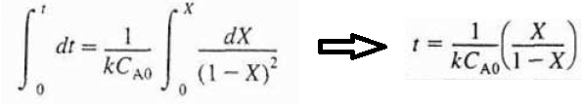
The total reaction time in any batch process is considerably longer than the reaction time.
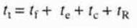
Where t_{f} is the time necessary to fill the reactor, t_{e} is the time necessary to heat the reactor and t_{c} is the time necessary to clean the reactor. Mostly, the reaction time calculated from the given equation may be only a small fraction of the total cycle time, t_{t}.

- Design of Continuous Stirred Tank Reactors (CSTRs): The continuous stirred tank reactor (CSTR) is a common model for a chemical reactor in engineering. All calculations performed with the continuous stirred tank reactor assume perfect mixing. In a perfectly mixed reactor, the output composition is identical to composition of the material inside the reactor, which is a function of residence time and rate of reaction. The continuous stirred tank reactors are typically used for liquid-phase reactions.
The volume V necessary to achieve a conversion X can be calculated using the following design equation:
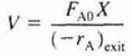
In order to calculate the space time to achieve a conversion X in the continuous stirred tank reactor (CSTR):
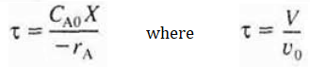
In order to calculate the volume or the space time for a first-order irreversible reaction for which the rate law is:
A → B
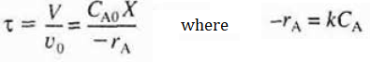
For liquid-phase reactions within the continuous stirred tank reactor (CSTR), there is no volume change during the chemical reaction. Hence, the given design equation can be written in terms of the conversion as following:
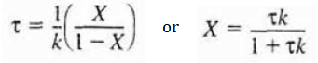
For two CSTRs in series, the effluent concentration of reactant A from the first CSTR can be calculated as following:
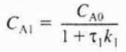
By using the design equation for the second reactor,
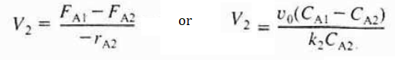
The effluent concentration of reactant A from the second CSTR can be calculated as following:
If we insert the effluent concentration of reactant A from the first reactor into the second reactor design equation:
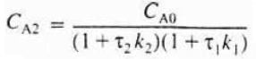
If both reactors have the same reaction constant value and the space time value, then the given design equation be written as following:
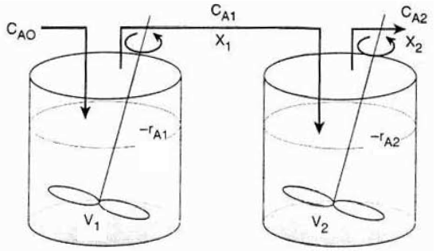
Figure 1. Two CSTRs in series
If we have n equal-sized CSTRs connected in series with the same space time and reaction rate constant values, the effluent concentration of reactant A from the last reactor will be:
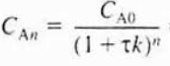
After arranging the given equation in terms of the conversion, we obtain:
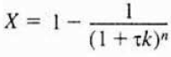
In addition, the rate law for n equal-sized CSTRs connected in series will be:

References:
- H. Scott Fogler, “Elements of Chemical Reaction Engineering”, Prentice Hall Professional Technical Reference, Fourth Edition.

