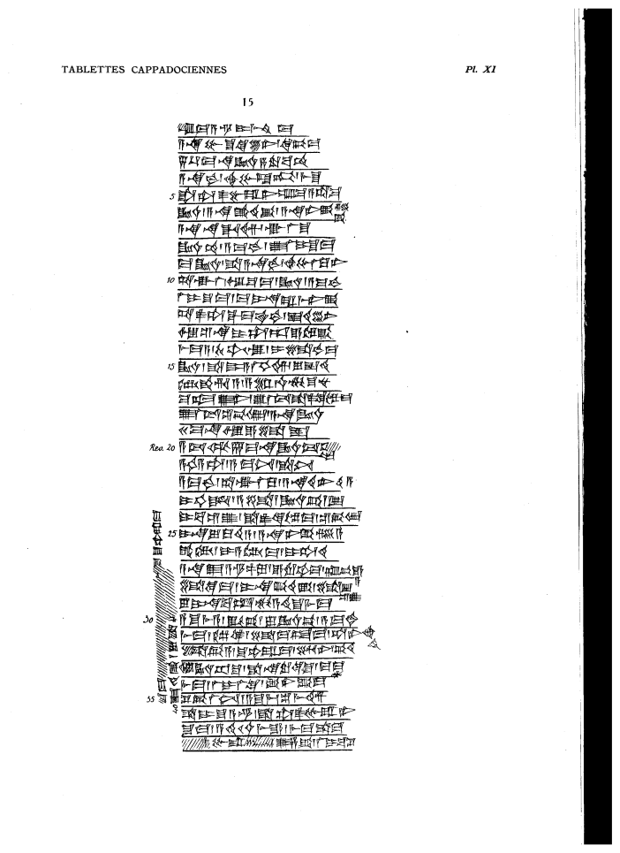

um-ma A-s^ur-i-mi3-ti2-ma
a-na Pu-s^u-ke-en6/qi2-bi-ma
5 1/3 ma-na KU3.BABBAR s,a-ru-pa2-am
a-na-kam ah-bu-la-kum / mi3-s^u
5 s^a ta-as^2-pu-ra-ni um-ma a-ta-ma
KU3.BABBAR / a-na qa2-ti2-ka3 / a-na ni-ka3-si2=ka3
a-na na-da-im / ak-la-s^u
KU3.BABBAR.am/ a-ma-kam / u2-la2 i-s^u-ma
ma KU3.BABBAR / s^a a-na-kam / ah-bu-la2-ku-ni
10 ta-ak-la2 / u3 s^u-ma / KU3.BABBAR / a-ma-kam
la2 i-s^u-ma / ma i-na ra-mi3-ni-ka3
ta-as^2-ta-qal-ma ITU.KAM / is^-te2-en6
u3 s^e2-na i-ta-ab-e-el-ka3
mi3-ma a-/-Kur-ub-Is^tar / i-li-kam-ma
15 KU3.BABBAR/ s^a DUMU A-la2-hi-im / lu is^-ti2
DAM.QAR.ri-a / a-s^ar / u4-mu-s^u-nu
ma-al-u2-ni / u2-la2 tu3-s^a-as^2-qi2-il5-ma
u2-la2 tu3-s^e2-bi4-lam / a-na KU3.BABBAR
20 ma-na u3 e-li-is^
20 a-t,u3-ul 7 ma-na KU3.BABBAR tu3-s^e2-[bi]=lam
a-hi a-ta / a-ma-nim / s^a-nim
a-ma-kam / ta-ak-la2-ku / a-na te2-er-ti2-a
i-hi-id / a-li KU3.BABBAR.pi2 1 GIN2
i-ba-s^i2-u2 / s^a-as^2-qi2-il5-ma/ s^e2-bi4-lam
25 i-na lu-qu2-ti2-a /a-na ni-ka3-si2-a
qa2-tam / i-a-tam2-ma / i-ta-di2
a-na E2 A-s^ur-SIPA / e-ru-ub-ma / t,up-pe2-e=a
li-qe2-ma / i-na qa2-ti2-ka3 / li-ib=s^i2-u2
lu i-na ba-ab mu-a-ti2-s^u mi3-ma
30 a-s^u-mi3-a / iq-bi / lu KU3.BABBAR.pi3 / a-ma-kam
mi3-ma / il5-qe2 / li-ma-ad-ma / ta-ne2-eh=ti2
li-bi-a / s^u-up-ra-ma / uz-ni / pi2-te2
u3 KU3.BABBAR.ap-s^u / s^a na-ru-qi2-s^u / ma-ma=an
mi3-ma / la2 i-la2-qe2 / ka3-ni-ka3-ma
35 s^e2-bi-la2-nim / a-s^u-mi3 / s^i2-mi3-im
s^a DUMU S^u-A-s^ur / s^a ta-as^2-pu-ra-ni
s^u-ma / a-di2 10 u4-me-e / mi3-ma-s^a-ma
[la2] as^2-pu-ra-[kum]~ / u2-za-ka3 / la2 i-ba-s^i2
s^u-ma [ ] x s^u-up-ra-ma
40 is^-ti2-ka3 / lu s^a x [ ]

