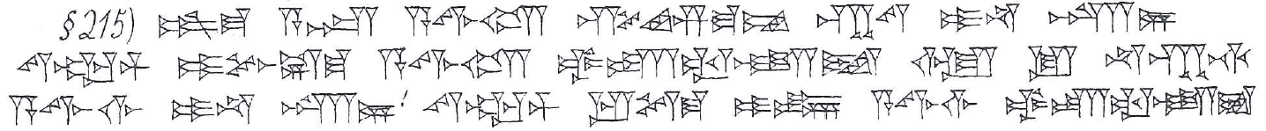
215. šum-ma asûm ( A.ZU) a-wi-lam sí-im-ma-am kab-tam i-na karz/ṣillim ( GÍR.Nİ/ZAL) siparrim ( ZABAR) i-pu-uš-ma a-wi-lam ub-ta-al-li-iṭ ù lu na-kap-ti a-wi-lim i-na karz/ṣillim ( GÍR.Nİ/ZAL) siparrim ( ZABAR) ip-te-ma i-in a-wi-lim ub-ta-al-li-iṭ 10 šiqil ( GÍN) kaspam ( KÙ.BABBAR) i-le-qé

