While children are expected to parrot the moral views they were taught, whether by parents or by society, adults need to think out moral issues for themselves.
To do philosophy is to reason about the ultimate questions of life—questions such as these:
- Is there a God?
- Are our actions free or determined?
- Are humans completely explainable in material terms?
- How and what can we know?
- What is the nature and methodology of moral judgments?
- What principles ought we to live by?
- To reason logically is to conclude something from something else. For example, we conclude that the butler committed the murder from the beliefs that (1) either the butler or the maid did it, and (2) the maid didn’t do it. If we put reasoning into words, we get an argument—a set of statements consisting of premises and a conclusion:
- Either the butler or the maid did it.
- The maid didn’t do it. Á The butler did it.
- B or M
- Not-M Á B
- (Here “Á” is short for “therefore.”) This argument is valid, which means that the conclusion follows logically from the premises. If the premises are true, then the conclusion must be true. So if we can be confident of the premises, then we can be confident that the butler did it.
- Calling an argument valid claims that the conclusion follows from the premises; it doesn’t say that the premises are true. To prove something, we also need true premises. If we give clearly true premises from which our conclusion logically follows, then we’ve proved our conclusion.
- Philosophy involves much logical reasoning. The most common form of logical reasoning in philosophy attacks a view P by arguing that it leads to an absurdity Q:
- 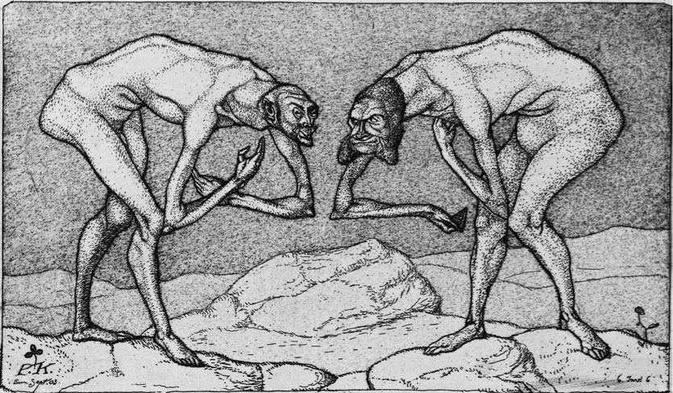
Ethics is disturbing. We are often vaguely uncomfortable when we think of such things as exploitation of the world’s resources, or the way our comforts are provided by the miserable labour conditions of the Third World. Sometimes, defensively, we get angry when such things are brought up. But to be entrenched in a culture, rather than merely belonging to the occasional rogue, exploitative attitudes will themselves need a story. So an ethical climate may allow talking of ‘the market’ as a justification for our high prices, and talking of ‘their selfishness’ and ‘our rights’ as a justification for anger at their high prices. Racists and sexists, like antebellum slave owners in America, always have to tell themselves a story that justifies their system. The ethical climate will sustain a conviction that we are civilized, and they are not, or that we deserve better fortune than them, or that we are intelligent, sensitive, rational, or progressive, or scientific, or authoritative, or blessed, or alone to be trusted with freedoms and rights, while they are not. An ethic gone wrong is an essential preliminary to the sweat-shop or the concentration camp and the death march.
1. The death of God
For many people, ethics is not only tied up with religion, but is completely settled by it. Such people do not need to think too much about ethics, because there is an authoritative code of instructions, a handbook of how to live. It is the word of Heaven, or the will of a Being greater than ourselves.
Is it true that, as Dostoevsky said, ‘If God is dead, everything is permitted’?

- 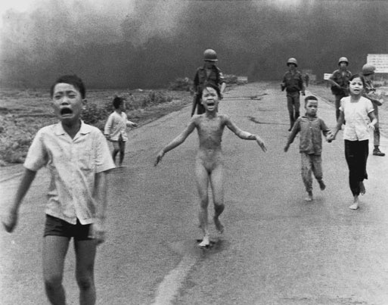
- Anyone reading the Bible might be troubled by some of its precepts. The Old Testament God is partial to some people above others, and above all jealous of his own pre-eminence, a strange moral obsession. He seems to have no problem with a slave-owning society, believes that birth control is a capital crime (Genesis 38: 9– 10), is keen on child abuse (Proverbs 22: 15, 23: 13–14, 29: 15), and, for good measure, approves of fool abuse (Proverbs 26: 3). Indeed, there is a letter going around the Internet, purporting to be written to ‘Doctor Laura’, a fundamentalist agony aunt:
- Dear Dr Laura,
- Thank you for doing so much to educate people regarding God’s Law. I have learned a great deal from you, and I try to share that knowledge with as many people as I can. When someone tries to defend the homosexual lifestyle, for example, I simply remind him that Leviticus 18: 22 clearly states it to be an abomination. End of debate. I do need some advice from you, however, regarding some of the specific laws and how to best follow them.
- a. When I burn a bull on the altar as a sacrifice, I know it creates a pleasing odor for the Lord (Lev. 1:9). The problem is my neighbors.
- 10
- Ethics
- They claim the odor is not pleasing to them. How should I deal with this?
- b. I would like to sell my daughter into slavery, as it suggests in Exodus 21: 7. In this day and age, what do you think would be a fair price for her?
- c. I know that I am allowed no contact with a woman while she is in her period of menstrual uncleanliness (Lev. 15: 19–24). The problem is, how do I tell? I have tried asking, but most women take offense.
- d. Leviticus 25: 44 states that I may buy slaves from the nations that are around us. A friend of mine claims that this applies to Mexicans, but not Canadians. Can you clarify?
- e. I have a neighbor who insists on working on the Sabbath. Exodus 35: 2 clearly states he should be put to death. Am I morally obligated to kill him myself?
- f. A friend of mine feels that even though eating shellfish is an abomination (Lev.10:10), it is a lesser abomination than homosexuality. I don’t agree. Can you settle this?
- g. Leviticus 21: 20 states that I may not approach the altar of God if I have a defect in my sight. I have to admit that I wear reading glasses. Does my vision have to be 20/20, or is there some wiggle room here?
- I know you have studied these things extensively, so I am confident you can help. Thank you again for reminding us that God’s word is eternal and unchanging.

- Things are usually supposed to get better in the New Testament, with its admirable emphasis on love, forgiveness, and meekness. Yet the overall story of ‘atonement’ and ‘redemption’ is morally dubious, suggesting as it does that justice can be satisfied by the sacrifice of an innocent for the sins of the guilty – the doctrine of the scapegoat.

Finally there are sins of omission as well as sins of commission. So we might wonder as well why he is not shown explicitly countermanding some of the rough bits of the Old Testament. Exodus 22: 18, ‘Thou shalt not suffer a witch to live’, helped to burn alive tens or hundreds of thousands of women in Europe and America between around 1450 and 1780. It would have been helpful to suffering humanity, one might think, had a supremely good and caring and knowledgeable person, foreseeing this, revoked the injunction.
Under Christianity the instincts of the subjugated and the oppressed come to the fore: it is only those who are at the bottom who seek their salvation in it. Here the prevailing pastime, the favourite remedy for boredom is the discussion of sin, self-criticism, the inquisition of conscience; here the emotion produced by power (called ‘God’) is pumped up (by prayer); here the highest good is regarded as unattainable, as a gift, as ‘grace’. Here, too, open dealing is lacking; concealment and the darkened room are Christian. Here body is despised and hygiene is denounced as sensual; the church even ranges itself against cleanliness ( – the first Christian order after the banishment of the Moors closed the public baths, of which there were 270 in Cordova alone). Christian, too, is a certain cruelty toward one’s self and toward others; hatred of unbelievers; the will to persecute . . . And Christian is all hatred of the intellect, of pride, of courage, of freedom, of intellectual libertinage; Christian is all hatred of the senses, of joy in the senses, of joy in general.
Obviously there have been, and will be, apologists who want to defend or explain away the embarrassing elements. Similarly, apologists for Hinduism defend or explain away its involvement with the caste system, and apologists for Islam defend or explain away its harsh penal code or its attitude to women and infidels. What is interesting, however, is that when we weigh up these attempts we are ourselves in the process of assessing moral standards. We are able to stand back from any text, however entrenched, far enough to ask whether it represents an admirable or acceptable morality, or whether we ought to accept some bits, but reject others. So again the question arises: where do these standards come from, if they have the authority to judge even our best religious traditions?
The detour through an external god, then, seems worse than irrelevant. It seems to distort the very idea of a standard of conduct. As the moral philosopher Immanuel Kant (1724–1824) put it, it encourages us to act in accordance with a rule, but only because of fear of punishment or some other incentive; whereas what we really want is for people to act out of respect for a rule. This is what true virtue requires. (I discuss these ideas of Kant’s more fully in Part Three.)

DİN AHLAKIN TEMELİ MİDİR, YOKSA DAVRANIŞLARIMIZIN YANSIMASI MIDIR?
Religion on this account is not the source of standards of behaviour, but a projection of them, made precisely in order to dress them up with an absolute authority. Religion serves to keep us apart from them, and no doubt it has other social and psychological functions as well.
It can certainly be the means whereby unjust political authority keeps its subjects docile: the opium of the people, as Marx put it. The words of the hymn – God made the rich man in his castle and the poor man at his gate – help to keep the lower orders resigned to their fates.
RÖLATİVİZM
Here it is natural to look to the language of justice and of ‘rights’. There are human rights, which these practices flout and deny. But the denial of rights is everybody’s concern. If young children are denied education but exploited for labour, or if, as in some North African countries, young girls are terrifyingly and painfully mutilated so that thereafter they cannot enjoy natural and pleasurable human sexuality, that is not OK, anywhere or any time. If they do it, then we have to be against them.
cemented in documents such as the United Nations’ Universal Declaration of Human Rights (Appendix; an extract is below).
Article 1
All human beings are born free and equal in dignity and rights. They are endowed with reason and conscience and should act towards one another in a spirit of brotherhood.
Article 2
Everyone is entitled to all the rights and freedoms set forth in this Declaration, without distinction of any kind, such as race, colour, sex, language, religion, political or other opinion, national or social origin, property, birth or other status.
Furthermore, no distinction shall be made on the basis of the political, jurisdictional or international status of the country or territory to which a person belongs, whether it be independent, trust, non-self-governing or under any other limitation of sovereignty.
Article 3
Everyone has the right to life, liberty and security of person.
Article 4
No one shall be held in slavery or servitude; slavery and the slave trade shall be prohibited in all their forms.
Article 5
No one shall be subjected to torture or to cruel, inhuman or degrading treatment or punishment.
Article 6
Everyone has the right to recognition everywhere as a person before the law.
Article 7
All are equal before the law and are entitled without any dis- crimination to equal protection of the law. All are entitled to equal protection against any discrimination in violation of this Declaration and against any incitement to such discrimination.
The United Nations’ Universal Declaration of Human Rights: The First Seven Articles
The first counteracts the idea that we are just ‘imposing’ parochial, Western standards when, in the name of universal human rights, we oppose oppressions of people on grounds of gender, caste, race, or religion. Partly, we can say that it is usually not a question of imposing anything. It is a question of cooperating with the oppressed and supporting their emancipation.
After all, it is typically only the oppressors who are spokespersons for their culture or their ways of doing it. It is not the slaves who value slavery, or the women who value the fact that they may not take employment, or the young girls who value disfigurement.
Just as victors write the history, so it is those on top who write their justification for the top being where it is. Those on the bottom don’t get to say anything.
We can have no senses (ears, eyes, touch) for responding to ethical facts, and no instruments for detecting their truth. We respond only to what is true, never to what ought to be true. Thus nihilism, or the doctrine that there are no values, grips us, as well as scepticism, the doctrine that even if there were, we would have no way of knowing about them.

