REFRACTOMETRY

It is called refraction when the intensity of light is shifted from one medium to another by a change of direction.
Refractometry is a method for making determinations such as concentration and amount of matter using the principle that the refractive index of each medium is different.
The refractive index is one of the physical properties of the material such as boiling point, melting point, density, and there is a refractive index specific to each material. For this reason, it can be used in qualitative and quantitative analysis.

Refractive Index:

The ratio of the speed of light in a vacuum to the speed of light in another substance is defined as the index of refraction ( refractive index or n) for the substance.

$$refractive index of substance\left(n\right)=\frac{c}{v}=\frac{Speed of light in a vacuum}{Speed of light in substance}$$

The refractive index is usually measured on transparent objects. For example, the refractive index of organic liquids ranges from 1.25 to 1.80, while for solids this value is between 1.3 and 2.5.

The incident angle of the beam is proportional to the velocity of the beam and the refractive index. If the angle of incidence and reflection of the beam is known, the ratios of the refractive indices of the two media can be found.

According to Snell's Law;

The relationship between light's speed in the two mediums (v₁ and v₂), the angles of incidence (θ₁) and refraction (θ₂) and the refractive indexes of the two mediums (n₁ and n₂) is shown below:

$$\frac{sinθ_{1}}{sinθ_{2}}=\frac{v_{1}}{v_{2}}=\frac{n_{2}}{n_{1}}$$

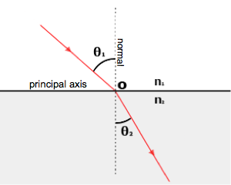
M₂ Intense medium
M₁ Light medium
Fig. Refraction of a light ray

In mediums with different refractive index, the movement of the light occurs in three ways:

- In the condition n₂ > n₁, the angles of incidence (θ₁) will be larger than the angles of refraction (θ₂). As the incidence angles increased, the refraction angle also increased.
- In n₁> n₂ condition, the reflection angle is larger than the incidence angle when passing from intense medium to light medium. As the incidence angle increases, the reflection angle approaches 90 °.
- In the case of M₁ vacuum medium, v₁ = c and n₁ = 1.

Critical Angle:

The critical angle (θ_{c}) is defined as the angle of incidence that provides an angle of refraction of 90-degrees.

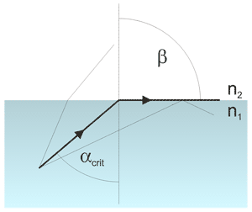
Fig. Representation of critical angle
If the light comes in a smaller angle from a critical angle, a bright zone forms. If the light comes in a larger angle from the critical angle, the light is reflected and the dark zone forms. The boundary of the dark and bright region corresponds to the critical angle.

According to Snell's Law;
$$sinθc=\frac{n_{2}}{n_{1}}$$

There are prisms in the refractometer. Light passes through the sample and comes to the prism in different directions. The refractive index of a material is dependent on the wavelength , the temperature, the concentration and the pressure.
As temperature increases, the refractive index decreases. The pressure increase causes an increase in density, the refractive index of a material increases with increasing pressure.
The wavelength affects the refractive index, so the wavelength of the light must also be known. The refractive index decreases as the wavelength increases in the wavelength at which the medium does not absorb.

Abbe’s Refractometer

The Abbe instrument is the most convenient and widely used refractometer. In Abbe refraktometer the sample whose refractive index will be determined is placed between two prisms as a liquid film. . The refractive index of the material is determined by the Abbe refractometer.
When the light is coming the prism as the smaller angle from the critical angle, the bright region formed. When the light is coming the prism as the larger angle from the critical angle, the darker region formed.

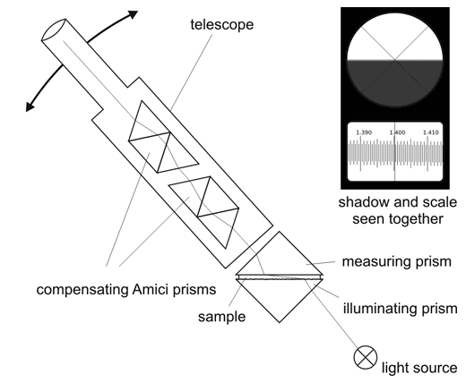
Fig. Scheme of Abbe refractometer

Qualitative Analysis: Refractometric qualitative analysis is performed by comparing the measured refractive index values with the refractive index values of pure materials.

Quantitative Analysis: Calibration equation is formed by plotting the concentration values against the measured refractive index values. With this equation,the concentration of the unknown solution can be calculated.

The fields where the Refraction Index measurement is used

• Refraction indexes are constants used in the identification of chemical substances, such as melting point and boiling point
• It is used for purity control in industry. Concentration can be determined with relation between refractive index and concentration.
• The refraction index is utilized in the determination of sugar, SiO₂ in glass, and analysis of aromatic hydrocarbons in petroleum.

Experimental Procedure:
- Refractometry is calibrated with pure water before starting the experiment.
- Then a few drops of 1% glucose solution are dropped onto the prism and the upper prism is closed. The same procedure is performed for the 2%, 3%, 4%, 5% glucose solutions.
- The glucose solution is viewed visible in dark and bright regions. The refraction index is read when it is brought right in the middle of the cross-hair mark which separates the dark and bright region.
- Before measuring the refractive indices of other solutions, prisms are thoroughly wiped with ethanol and 2% glucose solution is measured by dropping onto the prism. This process is repeated in the other solutions and refraction indexes are recorded.

