5.Hafta 14-16
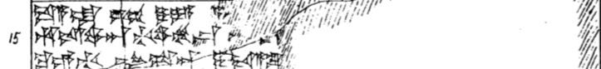
14 da-a-la Ú-UL DUMU-YA a-p[a-a-as an-na-as-si-is-ma GUD-us ma-a-an]
15 hu-is-wa-an-ti-wa-mu-kán ^{G}[^{UD}AMAR-un ÚR sar-ri-er har-ga-nu-er-wa-ra-an nu-wa-ra-an]
16 ku-e-ti LUGAL-sa-an i-da-a-lu [ku-it-ki i-ya-nu-un Ú-UL-an ^{LÚ}SANGA i-ya-nu-un]

