Ali b. Sahl Rabban al-Tabari

Abū'l-Hasan ‘Ali ibn Sahl Rabbān (or Raban) al-Tabarī, son of Sahl Rabbān al-Tabarī is a notable 9th-century Muslim physician, psychologist and one of the first scholars who studied the comparative history of religions. He also produced one of the first encyclopaedic works on medicine. He lived more than seventy years and met with important figures such as Muslim Caliphs, governors and eminent scholars. He is one of the most controversial of scholars due to his family's religious background and the books he composed on religious matters
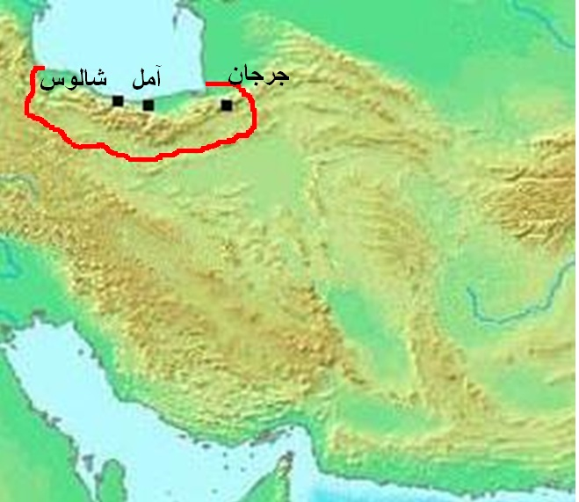
Taberistan, North of Iran

‘Alī b. Sahl Rabbān al-Tabarī was born into an intellectual Syriac Christian family in Marw in the region of Khurāsān (near present-day Tehran). We do not know the dates of his birth and death. His father, Sahl Rabbān al-Tabarī (d. c. 845-850), was a highly placed state official; he was an educated and respected member of the Christian Syriac community.

Sahl received the title of Rabbān because of his vast learning and knowledge of medicine and philosophy. Since the title "Rabbān (rabbi)" was given to the Jewish religious leaders, most historians thought that this family was Jewish in origin. Additionally, his title is given differently in several writings. For instance, one of the oldest books of Islamic history, The History of Tabarī of al- Tabarī (d. 922), while giving his name and family names as Ali b. Rabbān al-Nasrānī, Mas'ūdī mentions him as "Ali b. Zayd". In Ibn al-Nadīm, he is called "Ali b. Sahl b. Rabbal" , whilst Yāqūt writes about him as "Ali b. Zayn", and Ibn al-Qiftī as "Ali b. Rabbān".

On the other hand, Ali b. Rabbān very clearly described himself as a Christian in his book Kitāb al-Dīn wa al-Dawla. In Firdaws al-hikma, he also explains why his father got the title Rabbān and the meaning of it: "My father was one of scribes of Marw, noble, intelligent, kind, very good on the books of medicine and the philosophy. Medicine, as his family field has the priority. The aim of this was spiritual and religious satisfaction, not boasting and getting benefit from it. This is why he got the title Rabbān. The word Rabbān implies "our leader, our senior person and our teacher". In his other book Al-Radd ‘alā al-Nāsārā he says that he lived as a Christian until the age of seventy when converted to Islam. In spite of the fact that some scholars mention him as a Jewish physician who wrote in Arabic, and some of them as just a Jewish scholar, when his known treatises were published, all these claims became academically invalidated.

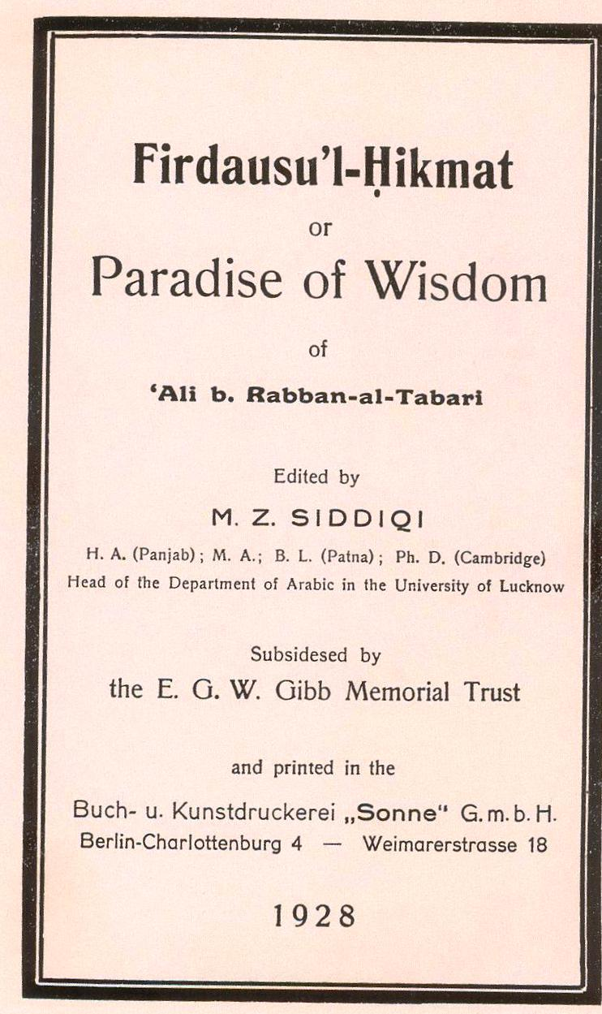
the cover page of al-Tabarī's book Firdausu'l-Hikmat with Latin letters, published in Berlin in 1928 by M. Z. Siddqi

Besides giving him a good education, his father, Sahl, taught him religion and philosophy. As one can understand through his works, in addition to Arabic, Persian and Syriac, he had also mastered the Hebrew and Greek languages to a high degree of proficiency. For example, he translated his own book Firdaws al-hikma written in Arabic into the Syriac language.
When he was ten years old, he was taken to Tabarīstān (henceforth al-Tabarī) by his father and he spent his early youth in Tabarīstān. The intellectual and pleasant atmosphere enabled him to devote his time to the study of a range of subjects including philosophy, medicine and religious, as well as various aspects of natural sciences. After he had completed his education in Tabarīstān, he moved to Iraq in 813 when he was thirty years old. Because he had lived in Tabarīstān, he became known as al-Tabarī.
Having been highly recommended to the caliph as a man of wisdom and intellectual and administrative ability, he was summoned by the ‘Abbasid Caliph al-Mu'tasim (833–842) to Baghdad to serve at the court. In a short time, Ali became one of the close friends of the Caliph, and became his diwān scribe. He continued in this job until the Caliph's death in 842 and upon his death.
He returned to Baghdad and continued in court service again as a private physician and courtier under the new Caliph al-Mutawakkil (847-861). It was in his reign; however, that al-Tabarī was promoted to that of companion to the caliph and lasting fame was assured. Caliph al-Mutawakkil urged and encouraged him to embrace Islam and confess his faith openly. Hence he converted to Islam around 849-850, and was given a title as "Mawlā amīr al-mu'minīn" by the caliph. He praises the Caliph at the end of his book Kitāb al-Dīn wa al-Dawla. When he converted to Islam, his cultured and highly respected uncle, Abū Zakkār Yahya b. al-Nu'man tried repeatedly, but in vain, to persuade al-Tabarī to renounce his new faith and return to Christianity.
The date of al-Tabarī's death is not cited. However, as he converted to Islam when he was seventy years old, during the reign of Caliph al-Mutawakkil, and he composed few books after that time, it can be deduced that he passed away after 864 in either Baghdad or Samarra.
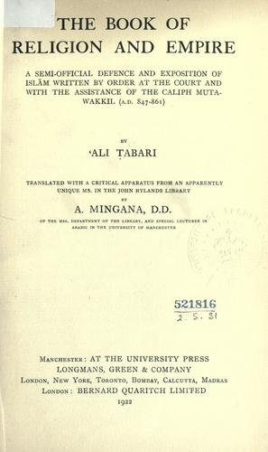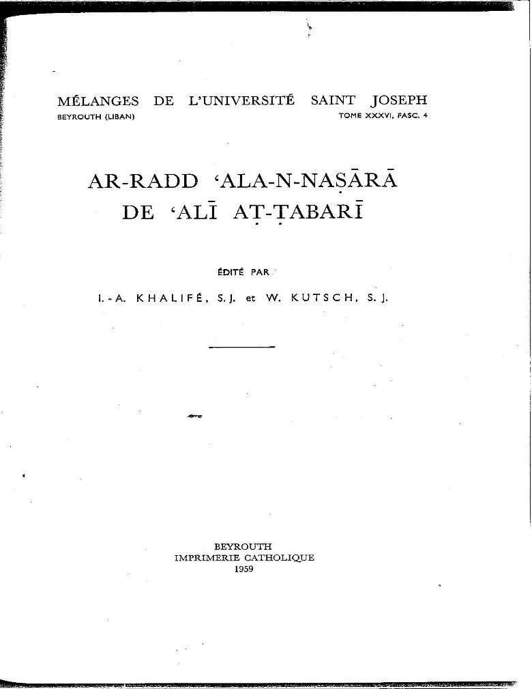
the cover page of the book Al-Rad ‘ala al-Nasara by al-Tabarī edited by Khalifa and Kutsch.

Al-Radd ‘alā al-Nāsārā (Refutation of Christians), known also as al-Radd ‘alā asnāf al-Nāsārā and as al-Nasāyikh). (Arabic) (Suleymaniye Library, Sehid Ali Pasa, MS 1628). In the prologue of the book, the author says that he was born and used to live as a Christian and converted to Islam when he was seventy. It was written between 850 and 855. He explains why he composed this book saying that his only aim was to gain Allah's consent and to warn the Christians. Because of his Christian roots, and as a Christian theologian , who can compare al-Qur'an and other divine books, his book has been accepted as the most successful of the books refuting the Christianity. This book was divided into five chapters.

Main objective:
Alī b. Sahl Rabbān al-Tabarī was born into an intellectual Syriac Christian family in Marw in the region of Khurāsān (near present-day Tehran). We do not know the dates of his birth and death. His father, Sahl Rabbān al-Tabarī (d. c. 845-850), was a highly placed state official; he was an educated and respected member of the Christian Syriac community.
The main objective of his work was a forthright critique of what ʿAlī al-Ṭabarī believed to be contrived and falsified Christian doctrines.
Although he was convinced of the unquestionable utility and clarity of his refutation, he nevertheless anticipated a disheartening Christian response. ʿAlī al-Ṭabarī believed Christians would “turn away their faces and their ears” from his warnings, an expression alluding to Sūrat al-Aʿrāf (7:179):
We have created for Gehenna many jinn and men; they have hearts, but understand not with them; they have eyes, but perceive not with them; they have ears, but they hear not with them. They are like cattle; nay, rather they are
further astray. Those–they are the heedless.

In the opening lines of his al-Radd ʿalā l-Nāṣārā, ʿAlī al-Ṭabarī details the primary goals of his work. Here, he emphasizes that his intention in writing such a refutation was not to refute Christ or the people of truth, but to refute contemporary Christians who oppose and distort the words of Christ and the Gospels.177 The phrase “people of truth” can be understood as Christians who have understood the true message of the Bible, i.e., Muslims.
The “people of the truth” are contrasted with “the sects of the Christians” who have altered the words of the Bible, that is to say, contemporary Christians: Melkites, Jacobites, and Nestorians. Much like earlier Islamic literature and the various works of his contemporaries, ʿAlī al-Ṭabarī drew a sharp distinction between “true Christians” and trinitarian Christians. After establishing the intended recipients of his polemic, ʿAlī al- Ṭabarī begins with a declaration of faith, a short, but quite important, definition of Islam. In this regard, the purpose in writing his al-Radd ʿalā l-Nāṣārā was not solely to refute Christianity but also to defend Islam

Alī al-Ṭabarī calls this summary of Islamic belief sharīʿat ahl al-Islām whereas he calls the Nicene Creed sharīʿat īmānihim. In his credo, he emphasizes the oneness of God as well as the continuity of God’s message and messengers.
Alī al-Ṭabarī posed seven hypophoric questions, which he called al-muskitāt (the silencers), in hopes to place Christians in an inescapable theological quagmire. He explains, “And the Christians, if they are of my opinion,
then they are outside of this religion which they profess (Christianity); and if they contradict me, then they contradict the Torah and the Gospel.”

For ʿAlī al-Ṭabarī, trinitarian Christianity could not be reconciled with the teachings of the Bible, a stance that he would elaborate upon in his Kitāb al-dīn wa-l-dawla as well. A significant portion of ʿAlī al-Ṭabarī’s refutation revolves around the following seven questions:

(1) We ask Christians about this monotheism (Islam) which we have explained and this faith which we have described: Is it the truth or is it error?

(2) We ask them about that which Christ said about himself: Is it, in part, truth, and, in part, false?

(3) We ask them about the Eternal Creator: Is the state of His eternality and his substance (jawhar) changeable? Is He, or is He not, susceptible to accidents (ʾamrāḍ) and death?

(4) We ask them about this creed (sharīʿa) of which there is no distinction between them regarding it. They do not complete a mass without it. Is it true from beginning to end? Is it entirely false? Or is some of it true
and some of it false?

(5) We ask about the Messiah: Is he the Eternal Creator as in their creed (sharīʿat īmānihim)? Is he a chosen man as in our creed (sharīʿat īmāninā)? Or is he god and man as certain sects of them say?

(6) We ask about the Messiah: Did he live in a specific country and during a
specific time? Yes or no? Surely I have found that the disciple John says in chapter five of his Gospel that ‘the Father was life in his essence, so therefore He gave the son life by means of his power.’

Alī al-Ṭabarī continues his discussion of Christ’s personhood by mentioning Luke 2:40, “And the child grew and became strong, filled with wisdom. And the favor of God was upon him.”225 If Christ were God (again discounting any duality in his nature), this would create multiple deficiencies in God’s nature. But how can God grow in stature or wisdom, wonders ʿAlī al-Ṭabarī? Moreover, how can the Holy Spirit strengthen him (Luke 2:52). If God grew, then he was immature; if he was filled with wisdom, then he was not eternally omniscient; if he was strengthened by the Holy Spirit, then he was not
omnipotent.

