5.Hafta 13-15
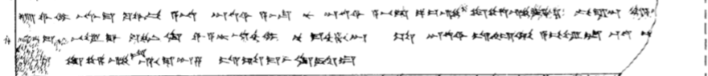
13 u-wa-mi na-as-ma ku-wa-pi A-NA ^{D}UTU^{SI} a-as-su nu ^{D}UTU^{SI} a-pid-da pa-iz-zi tu-uz-zi-ya-ma pi-ra-an ma-a-a[(n D)UMU LUGAL]
14 [n]a-as-ma BE-EL GAL ku-in-ki wa-a-tar-na-ah-mi nu ma-ah-ha-an SA ^{D}UTU^{SI} is-hi-u-ul a-pe-el-la QA-TAM-<MA> i[s-sa-at-ten]
15 n[a-a]n tu-uz-zi-is hu-u-ma-an-za is-ta-ma-as-ki-id-du

