LEOK-3 OPTICS EXPERIMENT KIT (LAMBDA SCIENTIFIC INC.)

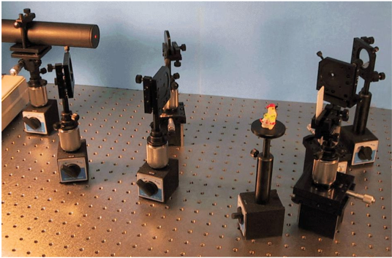

The following experiments are going to performed with LEOK-3 Optics Experiment Kit:

Experiment 3.1: Building a Kepler Telescope
Eperiment 3.2: Building a Slide Projector
Experiment 3.3: Analysing Polarization Status of Light Beams

Introduction

This kit provides a complete set of optical and mechanical components as well as light sources, which can be conveniently assembled to construct experimental setups. Almost all optics experiments required in general physics education (e.g. geometrical, physical, and modern optics) can be constructed in sequence using these components. Through selecting and assembling the corresponding components into experimental setups, students can enhance their experimental skills and problem solving ability.

LEOK-3 can be used to construct a total of 26 different experiments that can be grouped in six categories:

• Lens Measurements: Understanding and verifying lens equation and optical rays transform.

• Optical Instruments: Understanding the working principle and operation method of commonlab optical instruments.

• Interference Phenomena: Understanding interference theory, observing various interference patterns generated by different sources, and learning one precise measurement method based on optical interference.

• Diffraction Phenomena: Understanding diffraction effects, observing diffraction patterns generated by various different apertures.

• Analysis of Polarization: Understanding polarization and verifying polarization of light.

• Fourier Optics and Holography: Understanding principles of advanced optics and their applications.

Parts Included in the Kit

Light Sources
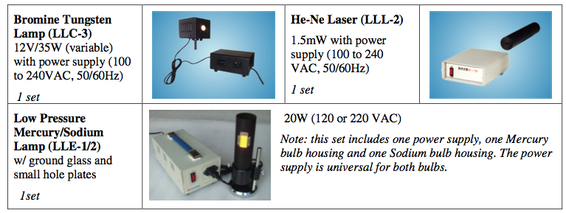

Mechanical Hardware
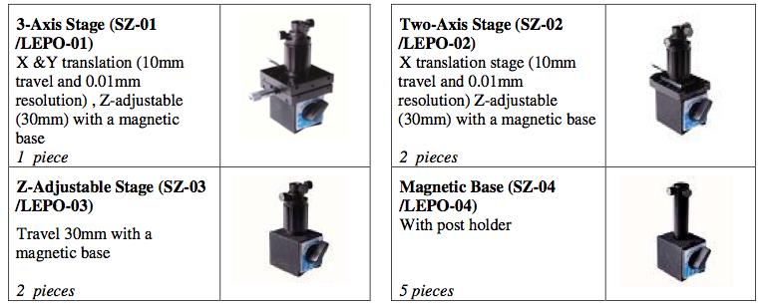
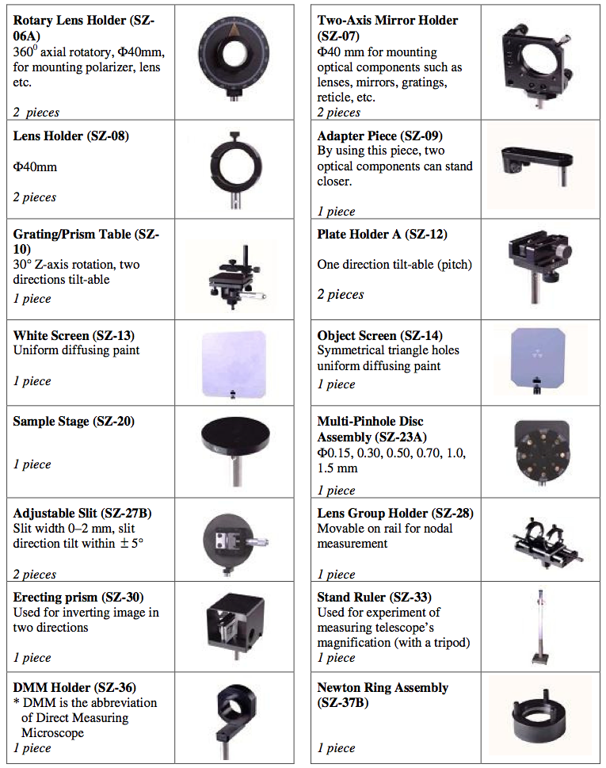
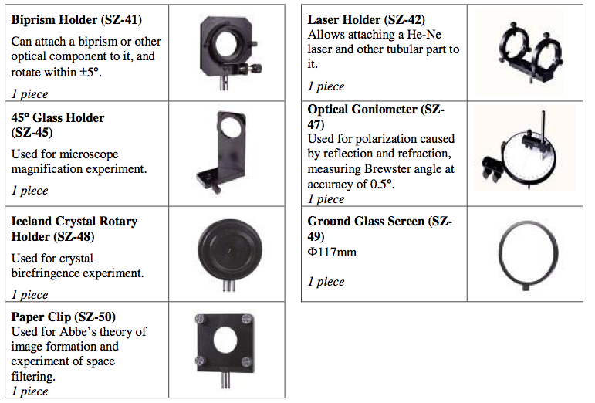

Optical components
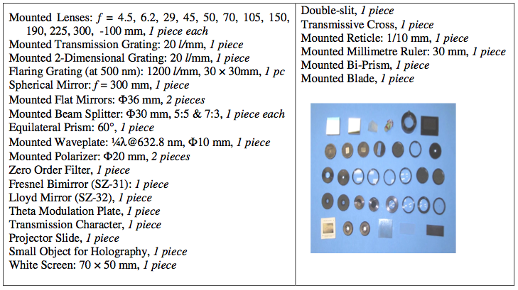

Other parts
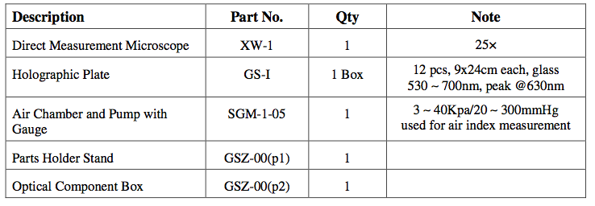

* Notes:
1. All parts are subject to change without notice.
2. For easy alignment of optical components, a metal straight ruler should be placed on the optical table and magnetic bases (stages) are positioned along the ruler.
3. Configuration of the direct measurement microscope:
The objective lens focuses an object located on the bottom plane of the tube at the reticle plate in the eyepiece with a ratio of 1:1. Refer the following picture to dismount the objective.
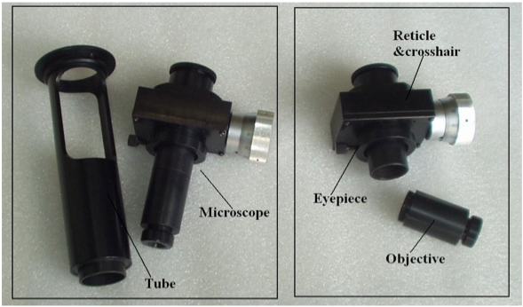

EXPERIMENT 3.1: BUILDING A KEPLER TELESCOPE

Objective:
Understand the principle, the construction, and the adjustment of a Kepler telescope; measure the system magnification.

Experimental Setup
￼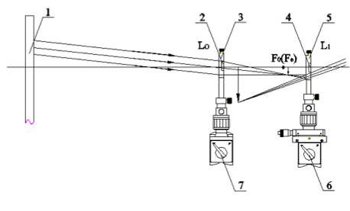
Figure 3.1: Schematic of experimental setup

As seen in Figure 3.2, the magnifying power of a telescope used for observing objects at infinity is defined as the angular magnification at the pupils because the angles are very small:
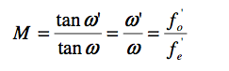
Where f_{o}’ and f_{e}’ are the focal lengths of the objective and eyepiece lenses, respectively, and w’ and w are the object and image angles at the eyepiece and objective lenses, respectively.
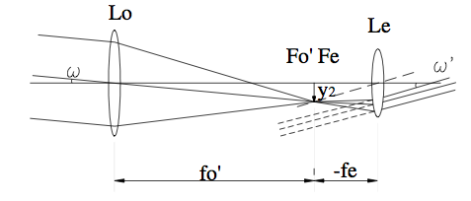
Figure 3.2: Schematic of telescope imaging at infinity

As shown in Figure 3.3, when observing an object at quasi-infinity, the power of magnification is:
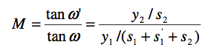
Since y₂/y₁=s₁’/s₁, therefore,
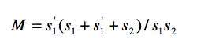
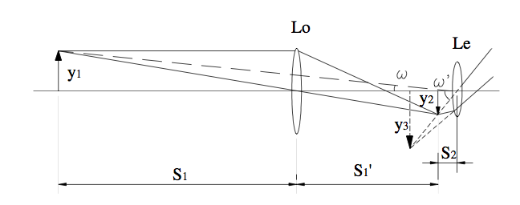
Figure 3.3: Schematic of telescope imaging at quasi-infinity

Experimental Procedure:
- Refer to Figure 3.1, align all components in same height along a straight line, set the distance between object (the stand ruler) and eyepiece lens L_{e} about 3 meters;
- Move objective lens Lo back and forth, behind L_{e}, use one eye to observe the image of the ruler till it is clear;
- Use another eye to directly observe the scale marks (each “E” pattern is 5 cm) on the ruler, count how many scale marks (amount m0 ) on the ruler image directly to the eye are covered by one mark in the telescope image;
- Use a white screen H (SZ-13) to find the image of the ruler through Lo, write down the locations of the ruler, L_{o}, H, and L_{e} as a, b, c, and d, respectively;
- Calculate measured magnification of the assembled telescope and compare it with the theoretical value:

Measured Magnification: M = m0
Theoretical Magnification: M = s₁' (s₁ + s₁’ + s₂ ) / s₁ s₂

Where s₁ =b−a, s₁' =c−b, s₂ =d−c

EXPERIMENT 3.2: BUILDING A SLIDE PROJECTOR

Objective:

Understand the principle of a slide projector and the function of its condenser, learn how to adjust a projection optical system, and understand illuminating condition for achieving a uniform light field on the screen (Kohler illumination).

Experimental Setup

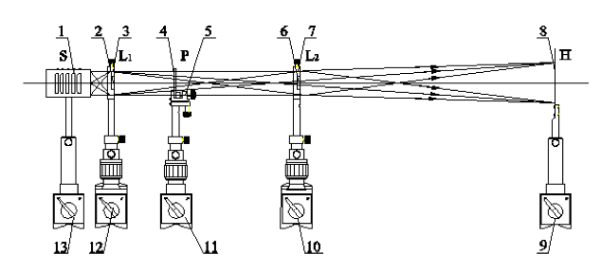

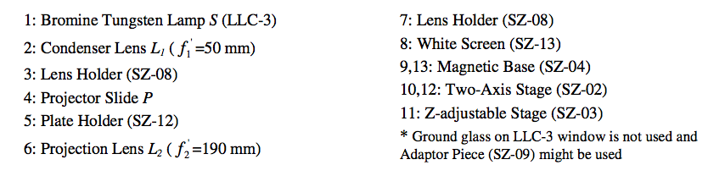
Figure 3.4: Schematic of experimental setup

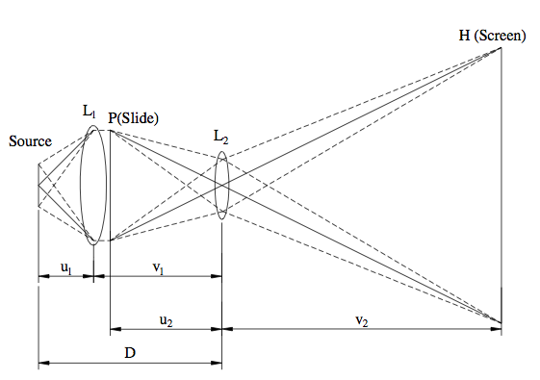
Figure 3.5: Schematic of slide projector imaging

Principle

As shown in Figure 3.5, L₁ is a condenser, and L₂ is a projection lens. A slide is just behind L₁ (we can assume v₁ = u₂). If the magnification of a slide projector is M, the length of slide projector is D, and the focal length of L₁ and L₂ are f₁ and f₂, respectively, by taking M = v₂ / u₂ , 1/f₂ =1/u₂ +1/v₂, we can get
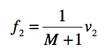

By taking D=u₁+v₁, v₁ =u₂, 1/f₁ =1/u₁+1/v₁, we can get

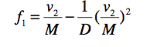

Experiment Procedure:
- Refer to Figure 3.4, align all components in same height along a straight line, set the distance between L₂ and screen H about 1.2 m;
- Move slide P back and forth, till a clear image (imaged by L₂) is observed on H;
- Fix condenser as close as possible to P (the adaptor piece can be used), remove P, move light source S back and forth, till the image of S formed by L₁ is clear on L₂ aperture plane;
- Put back slide P at its pervious location, observe the brightness and uniformity of the projected image on the screen;
- Remove L₁, observe the brightness and uniformity of the projected image again, and recognize the function of L₁.

EXPERIMENT 3.3: ANALYSING POLARIZATION STATUS OF LIGHT BEAMS

Objective:

Observe polarization phenomena, analyze polarization status of an input beam, generate the desired polarization status, and determine the axis direction of a polarizer

Experimental Setup

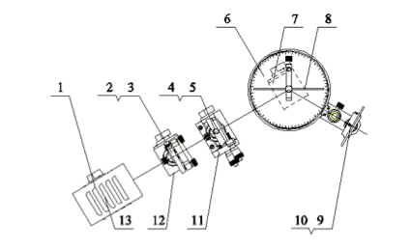

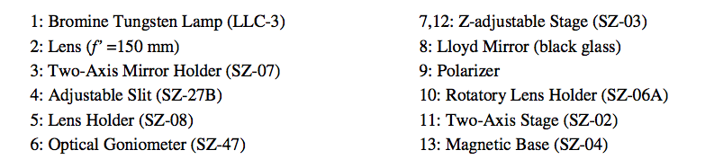
Other parts needed: low-pressure sodium lamp (LLE-2), He-Ne laser (LLL-2), quarter-wave plate, iceland crystal w/rotary holder (SZ-48), beam expander (f’ = 4.5 mm), and two-axis mirror holder (SZ-07).

Figure 3.6: Schematic of experimental setup

Principle

a) Brewster’s Angle

When unpolarized light travels from a transparent medium with a refractive index n_{i} to another one with a higher refraction index n_{t}, part of the light is refracted into the second medium while the other part of the light is reflected back into the first medium, as shown in Figure 3.7.

If the angles of incidence and refraction are θ_{i} and θ_{t}, respectively, the following condition exists, known as Snell's law

n_{i}sinθ_{i} =n_{t}sinθt

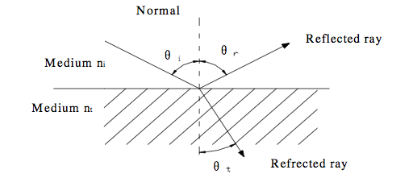
Figure 3.7: Reflection and refraction of light between two media

According to Sir David Brewster, at a specific angle of incidence, θ_{b}, called Brewster’s angle, the reflected ray and the refracted ray are perpendicular to each other, so the sum of the incident angle and the refractive angle is 90° as

θ_{b} +θ_{t}=90°, namely θ_{t} =90°−θ_{b}

By substituting this equation into Snell’s law, we get

n_{i} sinθ_{b} = n_{t} sin(90° −θ_{b} ) = n_{t} cosθ_{b}

tanθ_{b} = n_{t}/n_{i}

Then the Brewster’s angle is:

θ_{b} = arctan n_{t} /n_{i}

b) Birefringence

Put an iceland spar on a piece of printed paper, and we will see two distinct images of words. One image will remain fixed as the crystal is rotated, and the light ray through the crystal is called "ordinary ray" since it behaves just as a ray through glass. However, the other image will rotate with the crystal, tracing out a small circle around the ordinary image. This light ray is called "extraordinary ray". This is the phenomenon of birefringence.

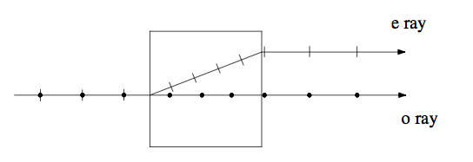
Figure 3.8: Schematic of birefringence

c) Malus’ s Law

When a light ray passes through a polarizer, then another polarizer, called analyzer, the transmitted light intensity I(θ) leaving out of the second polarizer, is given by Malus’s Law

I(θ)=I₀ cos²θ

Where I₀ is light intensity incident on the first polarizer, θ is the angle of two polarizer axes.

Experimental Procedure:

- Measure Brewster’s angle and determine the polarization direction of a polarizer Let the filament of the Tungsten light source locating on the front focal plane of the lens to create a collimated beam (the distance between the two magnetic bases is about 162 mm). After passing through the slit, the beam is incident onto the black glass at the center of the goniometer disk and light leaves a track along the radial direction on the disk. Rotate the goniometer disk, let the beam have a specific angle incident on the black glass. Then rotate the polarizer one full turn, observe the beam behind the polarizer and let the polarizer stop at the darkest angle position. Then rotate the goniometer disk and the polarizer alternatively, let the observed light becoming dark and dark till the darkest (finely adjust the polarizer angle at the same time). Finally, the polarizer axis lays in the plane of incident and reflection beams of the black glass, and the angle of the incident beam on the surface of the black glass plate is the Brewster’s angle (for this black glass, n=1.51, so i_{B}≈57ο);

- Analyze linear polarized light Let sodium light beam sequentially pass two polarizers, rotate one polarizer, observe light intensity change with the variation of angle, and qualitatively demonstrate Malus’s law.

- Analyze elliptical polarized beam: Use the He-Ne laser as light source, insert the 1⁄4 λ wave plate between two orthogonal polarizers with known axis directions (axis direction can be determined in Step 1), let the axis of the 1⁄4 λ wave plate at an arbitrary angle, rotate the analyzer in a full turn (360°), the transmitted light will present dark and bright twice alternatively (use a white screen to receive the transmitted light), at the dark position, the transmission direction of the analyzer is the direction of the short axis of the ellipse.

- Analyze circularly polarized light and determine the axis of 1⁄4 λ wave plate Use the He-Ne laser as light source, insert the 1⁄4 λ wave plate between two orthogonal polarizers with known axis directions, when the angle between polarizer and 1⁄4 λ wave plate is 45° or 135°, rotate the analyser and output light intensity doesn’t change (use a white screen to receive the transmitted light), therefore the axis of 1⁄4 λ wave plate will be at 45° or 135° with respect to the polarizer axis; the transmitted light from the analyzer is therefore circularly polarized.

- Observe birefringence phenomenon illuminate a He-Ne laser beam into the input aperture of the Iceland crystal (SZ-48), the transmitted beam will be split into two beams, rotate the crystal, o beam and e beam can be determined, further use a polarizer to determine their polarization directions.

