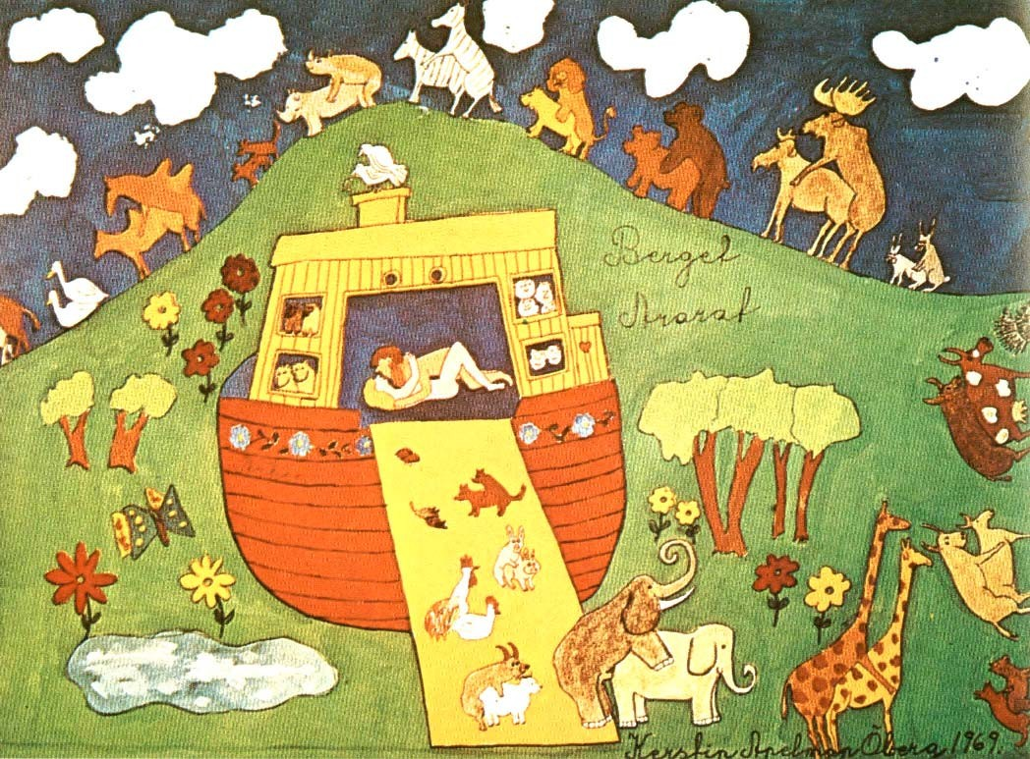
Sex & Reproduction
Reproduction is a fundamental property of life. In most multicellular eukaryotes, reproduction is sexual reproduction.
1

Sex: the combination of genetic information from two different sources.
In most eukaryotes, sex involves the fusion of two cells, egg and
sperm. Their fusion is called syngamy.
Egg cells and sperm cells are gametes. Their production is called gametogenesis. Oogenesis produces egg cells.
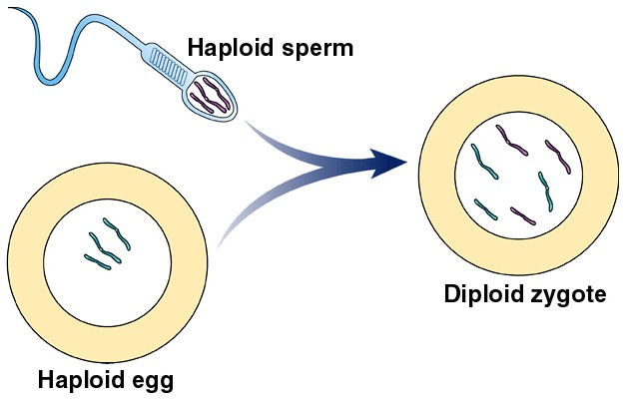
Spermatogenesis produces sperm cells.

In both spermatogenesis and oogenesis the amount of genetic information in cells is halved. Syngamy restores the amount of genetic information to the normal amount.
2

Definitions:
- diploid - a cell with two complete copies of genetic information
- haploid- a cell with one complete copy of genetic information
- N is the number of chromosomes of a haploid cell,
- 2N is the number of chromosomes of a diploid cell.

3
N
N
2N

Most eukaryotes are diploid (2N) and their gametes are haploid (N). Gametogenesis makes haploid cells from diploid cells:
2N → N
Syngamy combines two haploid cells to make a diploid cell:
N + N → 2N

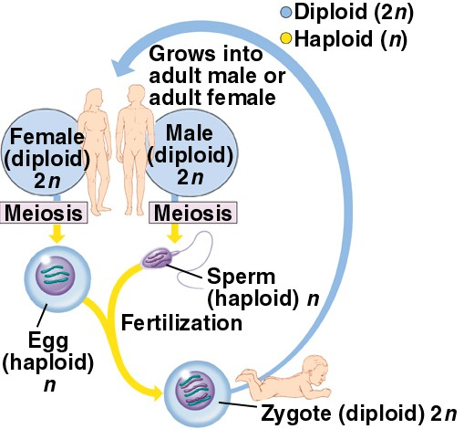
The new diploid organism commonly goes through many mitoses to become a large multicellular diploid organism. A few cells of that organism are devoted to producing egg cells or sperm cells for the sexual reproduction.

4

In Humans:
Most cells are diploid with 46 chromosomes in their nucleus (2N =46). 23 chromosomes came from the mother and were contained in the haploid egg (N=23). 23 chromosomes came from the father and were contained in the sperm (N=23). The newly fertilized egg, the zygote, has 46 chromosomes (2N=46).
The two sets of chromosomes from the mother and the father look exactly the same (with one exception that will be covered later), and each set has the same types of genes on them. The genes from the mother and father are often slightly different, different varieties of the same gene.
If the chromosomes are numbered 1 through 23 in the set that came from the mother, there will be a corresponding chromosome in the set that came from the father. Chromosome number 1 in the mother’s set and chromosome number 1 in the father’s set are called homologous chromosomes or homologs.
5

The process that arranges and assorts chromosomes during gamete formation is called meiosis.
Meiosis has two purposes:
- To produce haploid cells from diploid cells
- To produce genetically diverse cells

Meiosis has consists of 2 rounds of chromosome organization and division, Meiosis I and Meiosis II. Each has 4 named phases
- with names identical to those of mitosis - but there are some important differences between meiosis and mitosis.

Meiosis I consists of prophase I, metaphase I, anaphase I, and telophase I.
Meiosis II consists of prophase II, metaphase II, anaphase II, and telophase II.
6

Before meiosis begins, all DNA is replicated, in an S phase. Chromosomes begin meiosis in a replicated state.
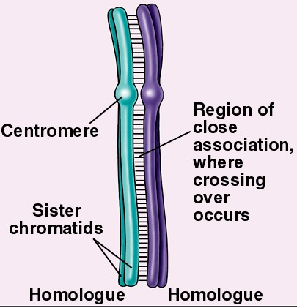
Meiosis I Prophase I:
Homologous chromosomes pair along their entire length. This is called synapsis.
Chromosomes condense Nuclear membrane disintegrates Spindle fibers form
Spindle fibers attach to each centromere of a homologous pair

7

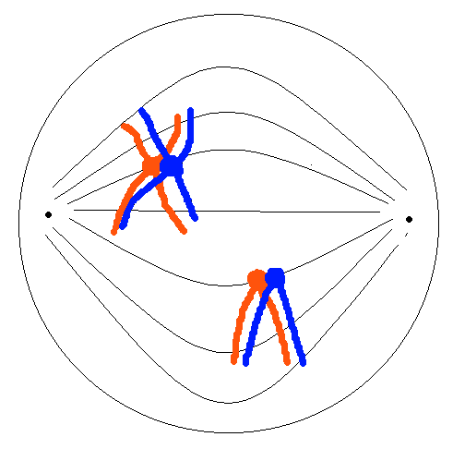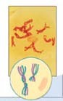
Pairing of homologues serves two purposes
- It prepares the chromosomes for an exchange called crossing-over
- It ensures that homologues will be pulled to opposite poles later in Anaphase I

8

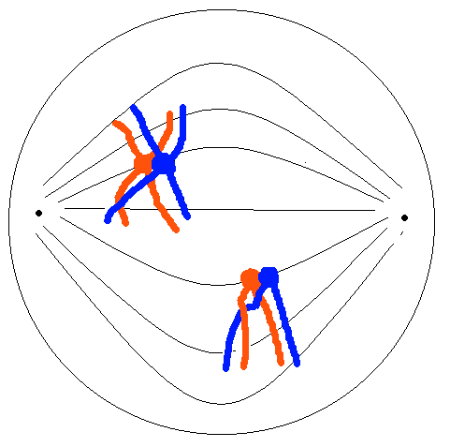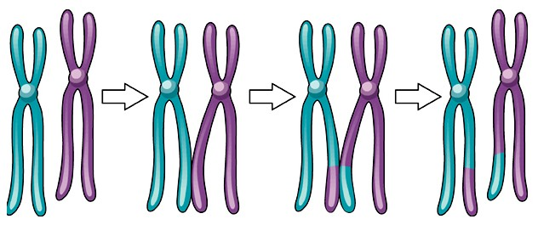When chromosomes undergo crossing-over there is a physical exchange of genetic material.

9

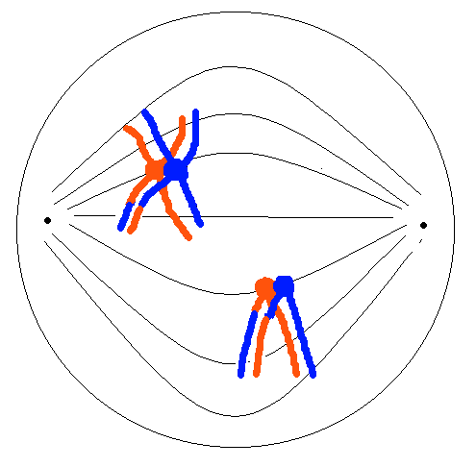
Crossing-over results in a reciprocal exchange of genes. Homlogues carry the same genes, some in different versions, and the exchange is a 1 for 1 exchange of the same genes.

During prophase I, the chromosomes migrate toward the center of the cell, pulled by shortening spindle fibers.

10

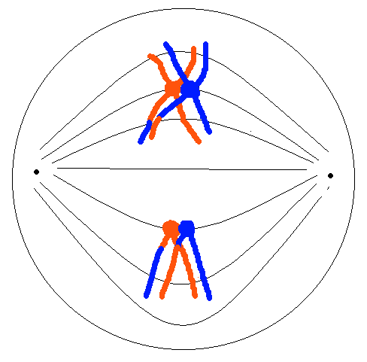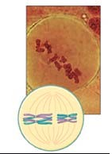Metaphase I:
The chromosomes are aligned at the center of the cell.

11

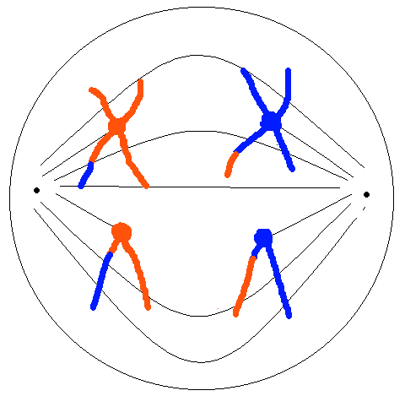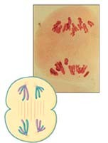Anaphase I:
Homologous chromosomes separate and migrate to opposite poles of the cell.

12

Telophase I:
The chromosomes arrive at the poles
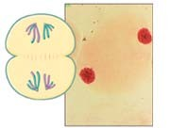
A nuclear membrane forms around the chromosomes The chromosomes decondense

Cytokinesis partitions the chromosomes into two cells
Interkinesis - a resting stage between Meiosis I and Meiosis II - No DNA replication occurs. Centrioles replicate and form spindle fibers.

13

Meiosis II Prophase II:
chromosomes condense, spindle fibers form, the nuclear membrane disintegrates, and the spindle fibers attach to either side of each centromere.

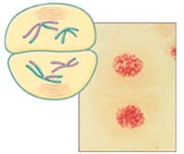

14

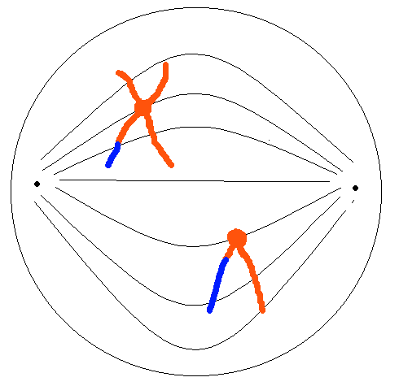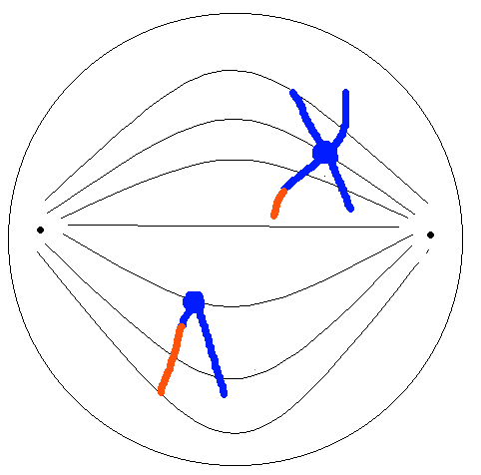

Prophase II

15

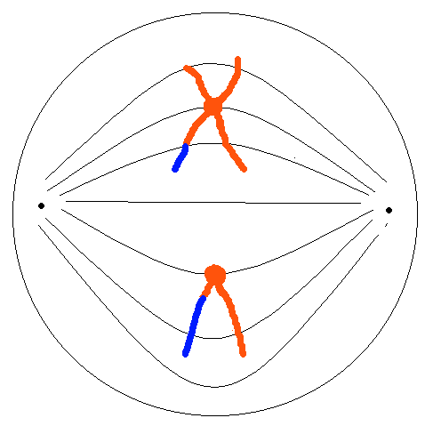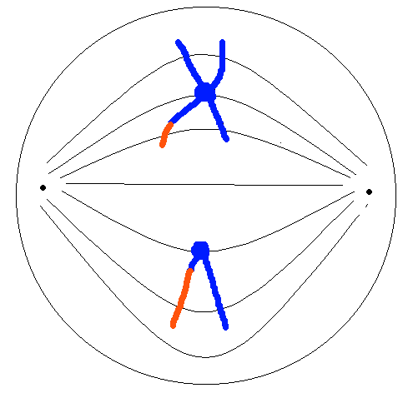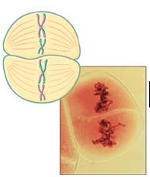Metaphase II:

Chromosomes align at the center of the cell.

16

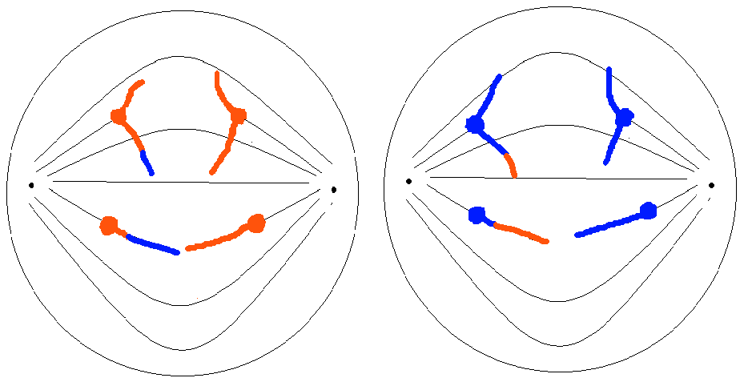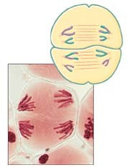Anaphase II:

Centromeres divide and chromatids migrate to opposite poles.

17

Telophase II:
The chromosomes arrive at the poles
A nuclear membrane forms around the chromosomes The chromosomes decondense

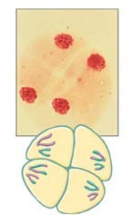
Cytokinesis partitions the nuclei into two cells

18

The products of meiosis are all genetically different.

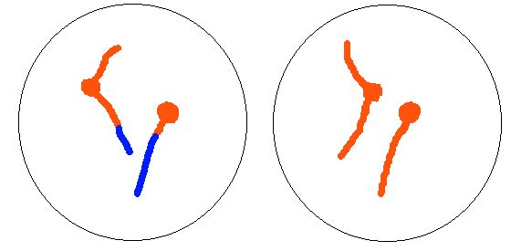
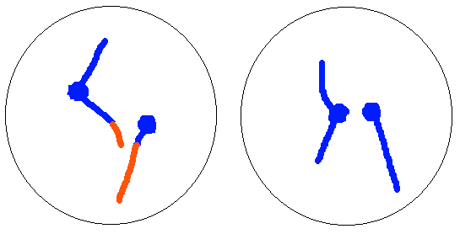

19

Meiosis produces genetically diverse cells in two ways
  - Independent Assortment of Chromosomes
  - Crossing-over between homologous chromosomes.

The two mechanisms can result in an immense variety of genetic combinations in the cells that result from meiosis.
Humans have approximately 40,000 genes. Here we’ll consider just 2.

20

A brief introduction to genetics:
Genes influence the characteristics of an organism, and genes come in alternate varieties called alleles.
Assume gene 1 controls the ability to roll your tongue and there at two varieties: T and t. Every individual has two copies of every gene. So an individual can have two copies of the same variety TT, or tt, or two different varieties of the same gene, Tt.
Individuals that are TT and Tt have the ability to do tongue- rolling. Individuals that are tt can’t.
Assume gene 2 controls the appearance of earlobes and there are two varieties of this gene, U, and u.
Individuals that are UU or Uu have large (unattached) earlobes. Individuals that are uu have small (attached) earlobes.

21

Assuming the gene for tongue-rolling and the gene for earlobe type are on different chromosomes, an individual with both alleles for both genes would have two chromosomes of each type (diploid) and have a different form of each gene on each homologue.
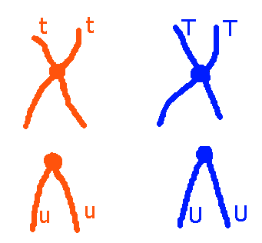
During prophase I the homologous chromosome pair and then during metaphase I they line up in the center of the cell.
22

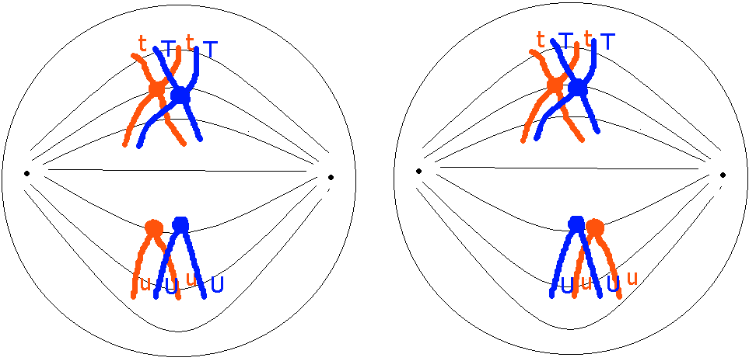
Assuming there has been no crossing-over, there are two possible arrangements of chromosomes at metaphase I for an individual that is Tt and Uu.
The arrangement on the left will occur 1/2 the time and the arrangement on the right will occur 1/2 the time. The chromosomes show independent assortment. 23

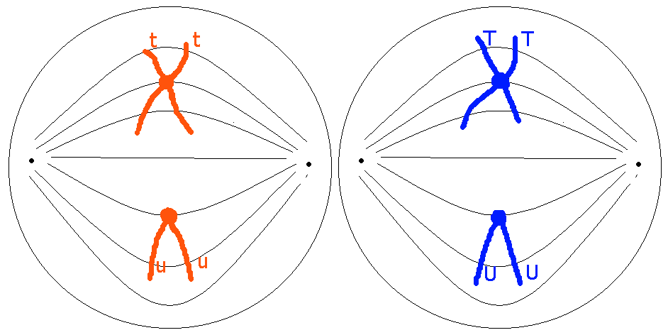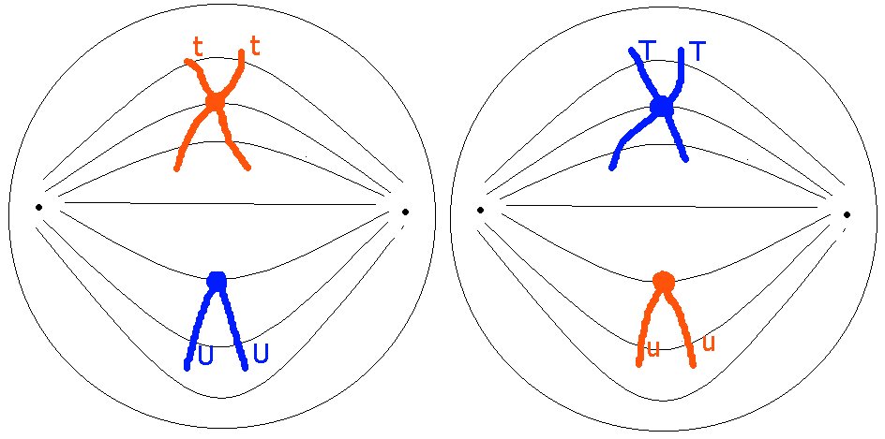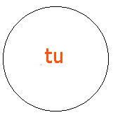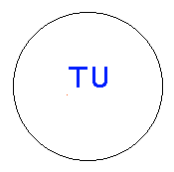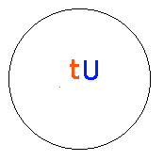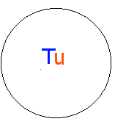Four different genetic combina- tions are produced

24

If we assume the two genes are on the same chromosome then the genes can be labeled as:
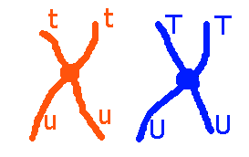

Without crossing-over, the four chromatids are preserved and only 2 combinations of genes are seen in the gametes produced.

25

With crossing-over somewhere between the two genes:
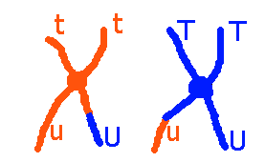

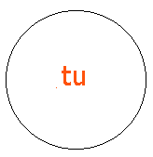
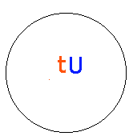
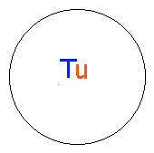
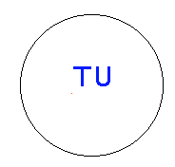
The 4 different chromatids result in 4 different combinations of genes in the gametes:
26

Meiosis produces haploid cells from diploid cells.
Haploid: one complete copy of the genetic information, or having a haploid (N) number of chromosomes in the cell.

At the beginning of meiosis the cells are diploid (2N)
2N=4

At the first division the number of chromosomes is reduced to the haploid number

N=2

27

The second division does not reduce the number of chromosomes

N=2

The second division just divides the replicated halves of a single chromosome. In each cell N=2.

28

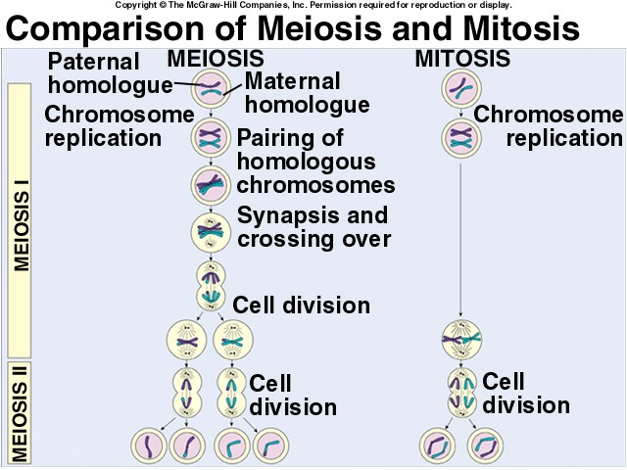
29

Schultz Notation for understanding the differences between mitosis and meiosis:
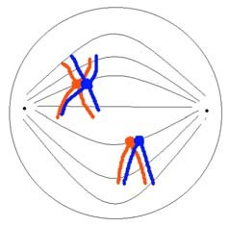
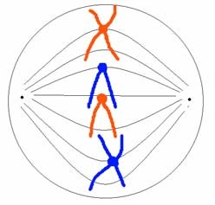
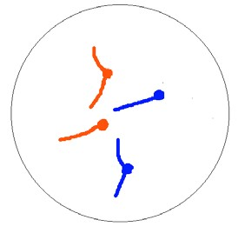2(2N) : the cell is diploid and all chromosomes are replicated

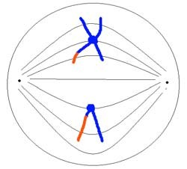
2N : the cell is diploid and chromosomes are not replicated
2(1N) : the cell is haploid and all the chromosomes are replicated
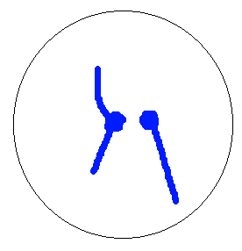1N : the cell is haploid and the chromosomes are not replicated

30

Mitosis: 2(2N=4) → 2 cells both 2N=4
Meiosis: 2(2N=4) → 2 cells both 2(1N=2) → 4 cells all 1N=2
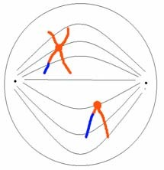
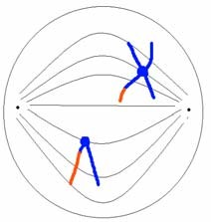 31

Meiosis is a part of gametogenesis
Spermatogenesis occurs in the seminiferous tubules of the testes:
Germ cell line cells (2N) multiply by mitosis to produce spermatogonia (2N)

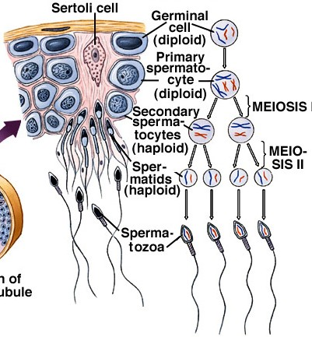
Spermatogonia (2N) go through mitosis to produce primary spermatocytes (2N)
Primary spermatocytes go through meiosis I to produce secondary spermatocytes (1N)
Secondary spermatocytes go through meiosis II to spermatids
Spermatids mature to become spermatozoa (sperm cells)

32

Oogenesis occurs on the surface of the ovary
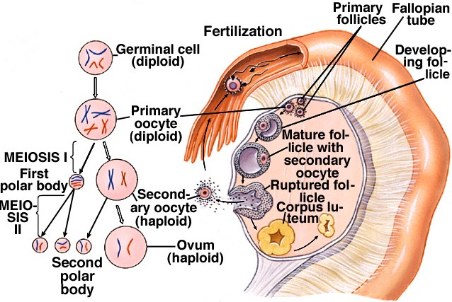
Germ cell line cells produce oogonia by mitosis.
Oogonia produce primary oocytes by mitosis.
Primary oocytes produce go through meiosis

I to produce one secondary oocyte and a polar body.
The primary oocyte keeps the nutrients stored in the egg. The polar body does not become a gamete.
33

The secondary oocyte goes through meiosis II to produce an ovum and a second polar body.
The ovum may go through additional growth and maturation to become a mature egg.

34

There are many modes of reproduction used by eukaryotes, both sexual and asexual reproduction.
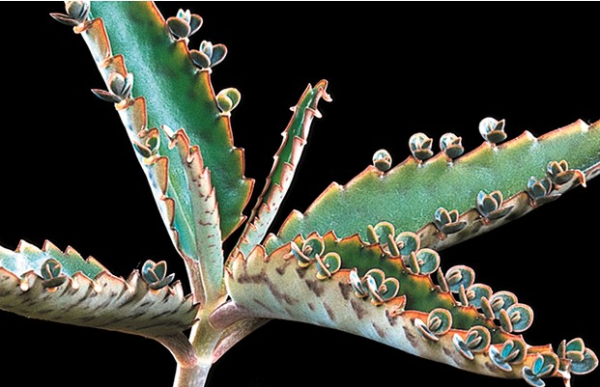
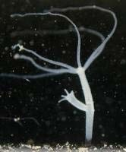
Asexual reproduction is common in plants and some animal groups.

Budding - growth of a new individual on the body of the parent

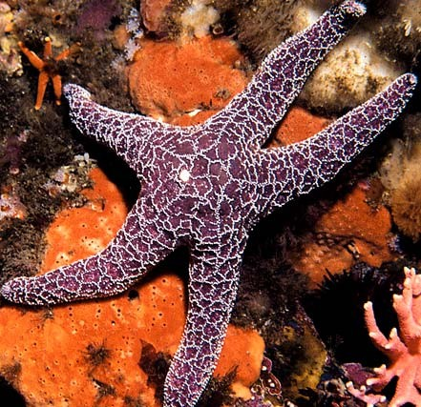
Fragmentation - in starfish, an arm and part of the central disk can regenerate a complete multi-armed body. Fragmentation is common in plants and some worms.
35

Parthenogenesis - the development of eggs that have not been fertilized -- exhibited by many insects, many lizard species and some fish species. Parthenogenesis can be induced in some birds by heat-shocking eggs.
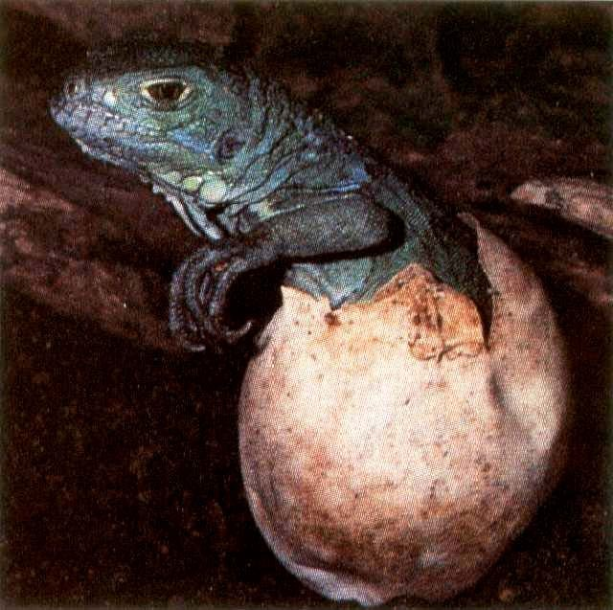 36

There is extreme variety in modes of sexual reproduction
The male and female sex organs can be found in the same body. This is known as monoecy or hermaphroditism.
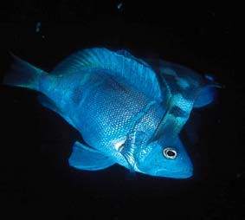
Hermaphroditism is very common in plants and found in many animal groups.

37

There is variety in the types of hermaphroditism
A simultaneous hermaphrodite has both male and female sexual functions at the same time.
A sequential hermaphrodite is a male during one part of its life and a female during another part.
Protandrous hermaphrodites are males first and then later become females
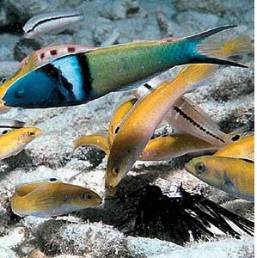
Protogynous hermaphrodites are females first and then later become males.

Alternation of Generation

In plants, sexual and asexual reproduction unite in a single cycle called alternation of generations. During alternation of generations, a gametophyte, (a haploid gamete-producing plant), alternates with a sporophyte (a diploid spore-producing plant). In Ectocarpus, a brown aquatic alga, the two generations are equally prominent, whereas in mosses, the gametophyte generation dominates. In ferns and seed plants, the sporophyte dominate, because the sporophyte generation is better adapted to survive on land.
Read more: Sexual Reproduction - Alternation Of Generations - Sporophyte, Haploid, Gametophyte, and Cells - JRank Articles http://science.jrank.org/pages/6099/Sexual-Reproduction-Alternation-generations.html#ixzz5ZqgXRT8w

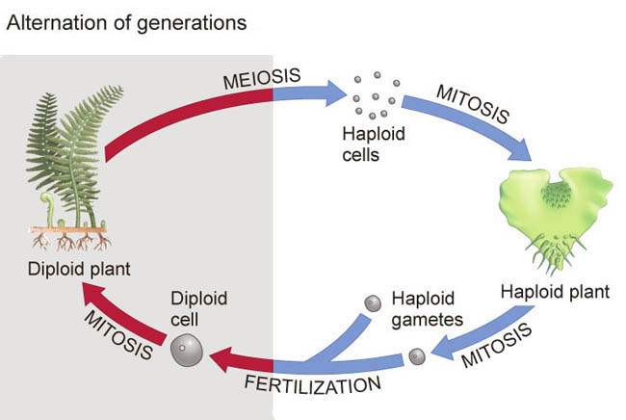

38

Asexual reproduction has many advantages over sexual reproduction:
- No effort is spent searching for a mate
- There is no risk of choosing a sterile mate
- There is no risk of genetic mixing from a bad mating
- The multiplication rate can be much higher Every asexual individual can produce offspring
In a sexual species, only the females produce offspring So, if all else is equal, an asexual should be able to multiply twice a fast as a sexual organism.

39

Although asexual reproduction has advantages, sexual reproduction is, by far, the more common mode of reproduction in eukaryotes.
Why? What allows sexual reproduction to be common in spite of the advantages of asexuality?
Potential advantages of sexual reproduction:
- Sex allows bad mutations to be removed from the population. Because of sex, in every generation some individuals get a double dose of the mutation and die, or fail to reproduce. This removes 2 copies of the bad gene from the population.
An asexual organism accumulates mutations with each successive generation and they have no way to repair them. Crossing-over during meiosis allows the creation of combinations of genes that contain fewer mutant forms.
40

- Sex allows for some errors in DNA replication to be repaired. Synapsis of homologous chromosomes allows one chromosome to serve as a model for repair of a damaged chromosome.
- Sexual reproduction produces variety in offspring and variety has advantages:
Variety allows more rapid adaptation to changing environmental conditions
Variety allows greater frequency of resistance to catastrophic diseases
In both cases, variety produced through meiosis and sex allows some individuals to do better than others in adverse conditions.

41

Although sex does have advantages, it is unclear if the advantages of sexual reproduction outweigh the advantages of asexual reproduction. Why sex is so common is one of the major unsolved questions of evolutionary biology.

42

Many groups can reproduce both sexually and asexually. Such groups illustrate the conditions that may favor sexuality and asexuality.

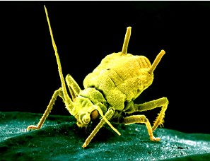
Aphids - suck juices from plants
In the Spring, they hatch from eggs. All hatchlings are females, and they reproduce parthenogenetically. They contain in their bodies identical female offspring. They don’t fly and don’t crawl far. They can be found in large numbers on the underside of leaves throughout the summer.

43

In the late Fall, the females produce both males and females with wings.
The winged aphids disperse and find other, unrelated aphids to mate with. The fertilized females lay a eggs on many plants over a wide area. The following Spring, the eggs hatch and the cycle begins again.
The aphid pattern is similar to many other species. The general pattern is:
When the future is uncertain or unpredictable, sex is the preferred mode of reproduction. Produce diversity when conditions are changing or about to change.
When the future is fairly certain, and conditions are good, asexual reproduction is preferred. Good conditions can be utilized for
rapid multiplication. 44

Reference: https://www.nicholls.edu/biol-ds/biol155/Lectures/Sex%20&%20Reproduction.pdf

