Langston Hughes Briefly
(1902-1967)

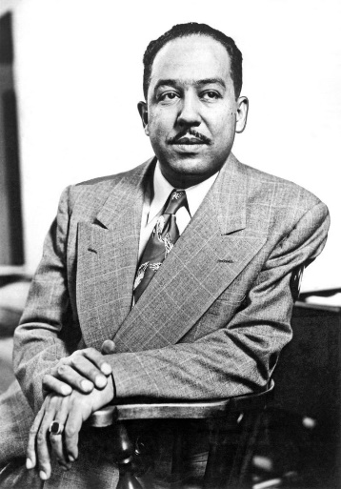

The most prominent figure of The Harlem Renaissance or the New Negro Movement.
Productive in different genres, he is best known for his poems.
His formal education was not great but he travelled extensively and lived in different countries for long periods.
Coming back to New York, Harlem, he felt himself at an environment that enhanced his creative forces and political convictions.
The myth of “the Elevator boy” discovered by a white writer by chance is not correct since he started his literary career quite early. So he was already discovered.

He relied on traditional jazz and black blues rhythms for his poetry.
His work is obviously socio-political but his lyrical quality is also remarkable.
His friends say “No one enjoys being a negro as much as Langston does”.
For further biographic info https://www.britannica.com/biography/Langston-Hughes

