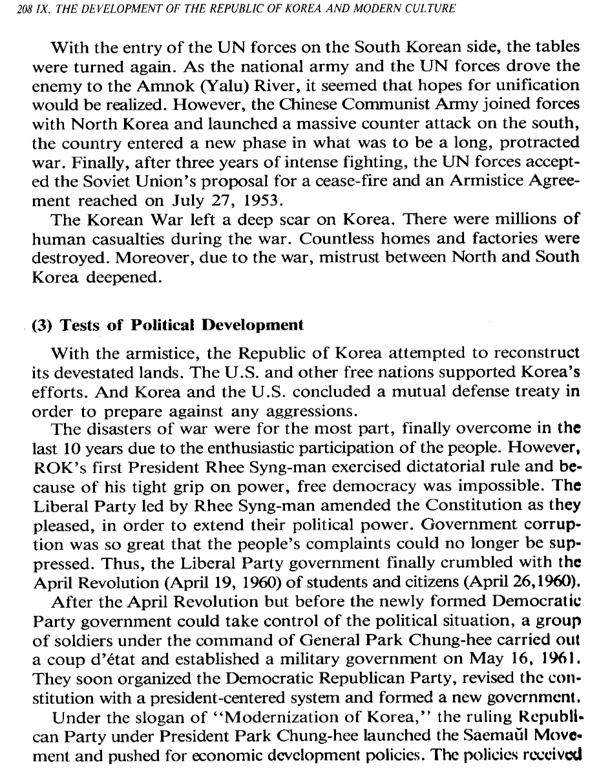
Resim 1 Radio Korea International Korean Broadcasting System. 1995. The History of Korea. Seoul
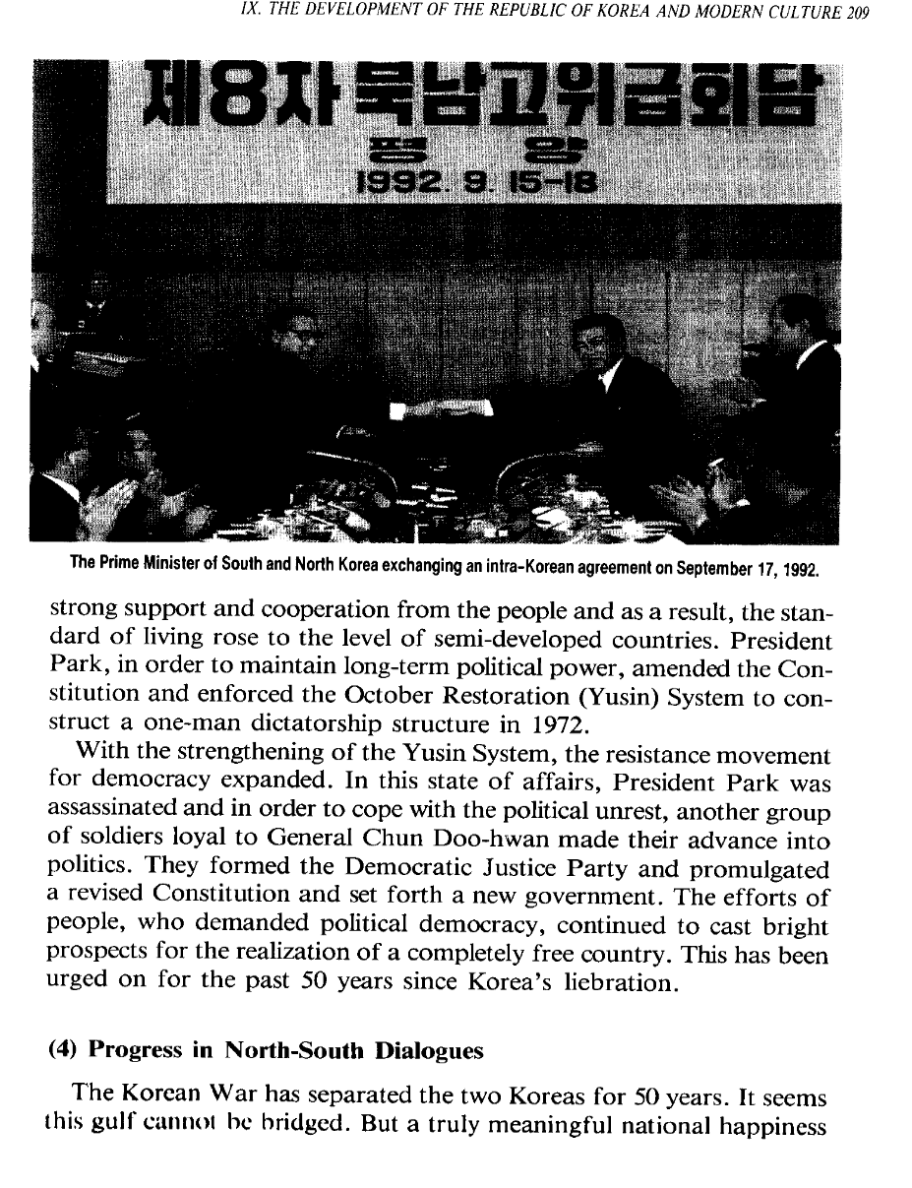
Resim 2 Radio Korea International Korean Broadcasting System. 1995. The History of Korea. Seoul
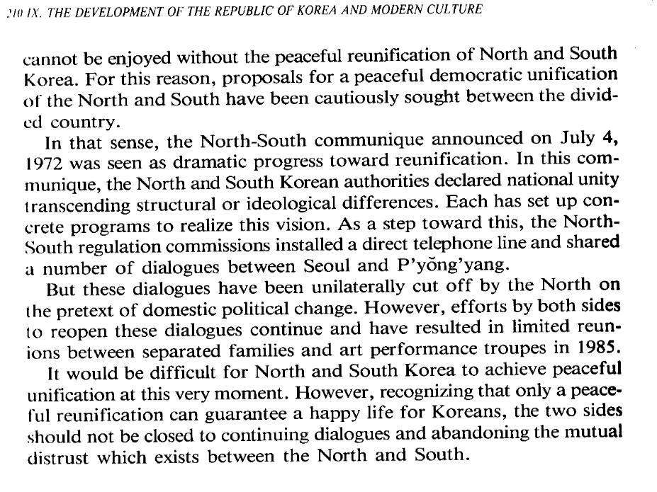
Resim 3 Radio Korea International Korean Broadcasting System. 1995. The History of Korea. Seoul

