9.Hafta 25-27
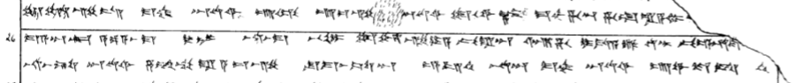
25 tu-uz-zi-is MA-HAR ^{D}UTU^{SI} U-UL u-iz-zi [nu?] ^{D}UTU^{SI} tu-u-wa-az ma-ah-ha-an ha-at-ra-a-mi Q[A-TAM-MA is-sa-at-ten]
26 ma-a-an-kan a-pa-a-as-ma DUMU LUGAL na-as-ma BE-LUM tu-uz-zi-ya pi-ra-an ar-ha i-da-a-lu ut-tar pe-e-hu-te-[iz-zi]
27 na-as-ta ^{D}UTU^{SI} za-am-mu-ra a-iz-zi su-ma-as-sa-an e-ep-ten na-an MA-HAR ^{D}UTU^{SI} u-wa-te-et-ten

