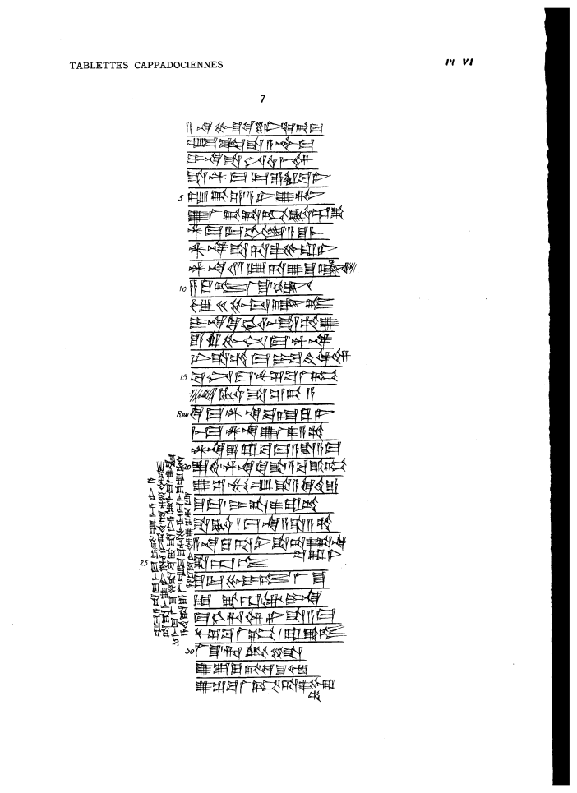

a-na Pu-s^u-ke-en6 qi2-bi-ma
um-ma Puzur4-A-s^ur-ma
i-na s^a-nim u4-mi3-im
s^a DINGIR-ma-lik e-ru-ba-ni
5 t,up-pe2-e / a-ni-u2-tim
u2-la2-pi2-ta-kum KU3.BABBAR.ap-ka3
DINGIR-ma-lik ub-lam / a-s^u-mi3
AN.NA s^a ta-as^2-pu-ra-ni
AN.NA 13 GIN2.TA u2 s^u-uq-lum2
10 za-ku-tum la2-s^u / ANS^E
u3 20 bu-tu3-uq-tum
i-na ki-kam-lim s^a-am-u2
e-ru-bu-nim-ma / AN.NA
ni-s^a-am-ma i-ba-ti2-qi2-im
15 pa2-nim-ma nu-s^e2-ba-la2-kum
a-na KU3.BABBAR s^a s^e2-pi2-a
ki-ma AN.NA ba-at-qu2-ni
mi3-ma u2-la2 as^2-a-am
AN.NA e-ra-ba-ma a-s^a-a-ma
20 is^-ti2 / AN.NA.ki-ka3 / a-ba-ka3-kum
u2 s^i2-mu-um s^a a-ki-di2-e
s^u-ma / i-ta-as^2-ra-am
s^a KU3.BABBAR 1 ma-na a-s^a-a-am
a-na ku-ta-ni s^a ta-as^2-ta-na=pa2-ra-ni
25 s^a-ap-tum
s^u-ur-bu-i-tum / la2-s^u
1 TUG2 ka3-ab-tam2 i-na
ma-hi-ri-im ni-s^a-a-ma
nu-s^e2-ba-la2-kum / ra-qa2-tum
30 la2-s^u / ri-ig-li
u2 su2-lu-pi2 KI S^u-Is^tar
u2-s^e2-ba-la2-kum / ta-as^2-pu-ra=am
um-ma a-ta-ma mi3-ma i-pi2 / um-mi3-a-ni-a
ta-s^a-me-u2-ni uz-ni pi2-te2 / ta-zi-im-tum
35 mi3-ma la2-s^u li-ba-ka3 s^a-ni-a-tam2 / mi3-ma la2 u2-ba-lam
a-di2 s^a E-la2 / um-ma S^u-Hu-bu-ur-ma mi3-s^u-um KU3.BABBAR
a-s^ar s^a-ni-im u2-s^e2-ri-ib

