Interphase Transport and Transfer Coefficients
In many engineering problems, we are interested in the calculation of the rate of momentum transfer, heat transfer and mass transfer from one phase to another across the phase interface. This can be performed by integrating the total interface flux expression over the interfacial area. The total interface flux is equal to molecular flux plus the convective flux.
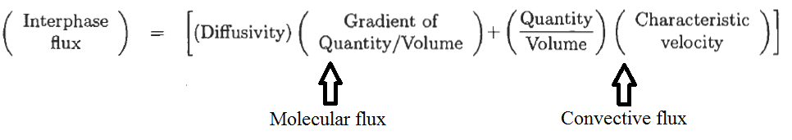
To determine the interphase flux, gradient of “quantity/volume” term needs to known at the interface. It is not easy to determine the gradient of velocity, temperature and concentration at the interface. Hence, we resort to experimental data and correlate the results by the transfer coefficients, namely, the friction factor, the heat transfer coefficient, and the mass transfer coefficient.

- FRICTION FACTOR
Let’s consider a flat plate with a length of L and width of W. This plate is suspended in a uniform stream with an approach velocity V, as shown in Figure 1, below.
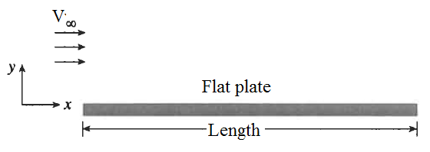
Figure 1. Flow on a flat plate with a length of L and width of W

In order to calculate the total drag force of the flowing stream applied on the plate, the total momentum flux needs to be integrated over the plate surface area.
The total momentum flux at the wall is:
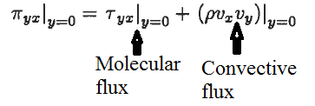
The total drag force over the plate can be calculated by integrating the total flux over the plate as given below:
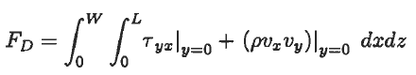
Since the plate is stationary, the fluid which is in contact with the plate is also stagnant (no-slip boundary condition). Hence, Vx and Vy are both equal to zero. It means that the convective flux terms needs to be equal to zero.
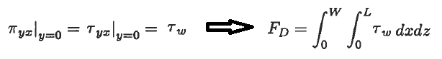
In order to evaluate the integral of the iven expression, the velocity gradient needs to be known at the interface. If it is not known or if there is no model expressing the velocity gradient at the interface, it is customary in engineering problems to replace Tw by a dimensionless term called the friction factor as shown below:
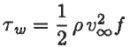
The total drag force over the plate can be calculated by integrating the shear stess “Tw” over the plate as given below:
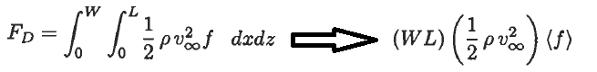
Power, which is the rate of work, can be calculated using the following relation given below:
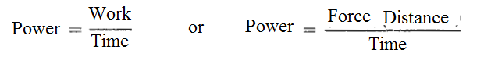

- Physical Interpretation of Friction Factor
Newton’s law of viscosity can be expressed as following:
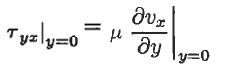
The givne equation equation can be rearranged into the following form of equation as given shown beow:
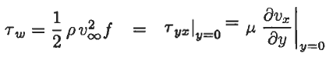
Since most of the times the velocity gradent is unkown, the actual case of resistance can idealized as shown below in Figure 2:
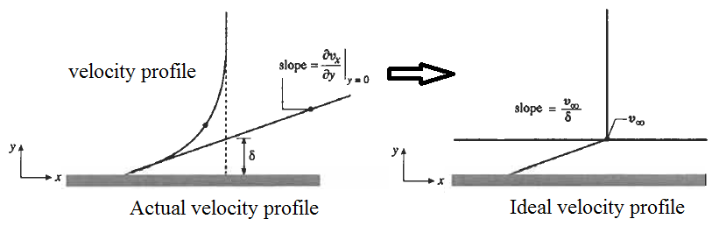
Figure 2. The film model idealized for momentum transfer

In idealized condition, the velocity gradient in the film is constant and is equal to:
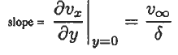
The given equation can be converted into the form including dimensionless number, Reynolds number “N_{RE}”.
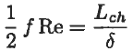
Where Reynolds number is equal to the following experssion given below:
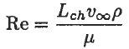
Expression given above indicates that the product of the friction factor with the Reynolds number is directly proportional to the characteristic length “ Lch” and inversely proportional to the thickness of the momentum boundary layer.

References:
İ. Tosun, “MODELLING IN TRANSPORT PHENOMENA A Conceptual Approach”, Elsevier, 2002.

