Wallace Stevens Briefly
(1879-1955)

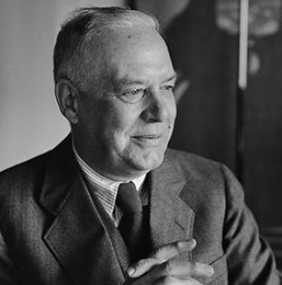

- One of the major poets of American modernism who seems to have written his poems in his free time.
- He published his first poem at the age 35, spent most of his life as an office worker (after a while, he was the vice president of a company).
- He was 44 when his first book was published and he became famous when his Collected Poems were published just one year before his death.
- For more biographic info https://poets.org/poet/wallace-stevens

