II. POLARIZING LIGHT MICROSCOPE AND GEOLOGICAL THIN SECTIONS

Many different models of polarizing light microscopes (PLMs) exist, ranging in price from a few hundred dollars to several tens of thousands of dollars. However, the basic design of a PLM is fairly simple and has remained unchanged for many years. Figure 2 shows a schematic and 3 a microscope illustration of a PLM with the minimal number of components for routine optical mineralogical work. A mineral sample is placed on the rotatable stage for observation in plane polarized light. The sample may be rotated so polarized light will vibrate along different directions within the crystal. Another polarizer, at right angles to the lower polarizer, can be inserted and withdrawn from the microscope. When the upper polarizer is inserted, the mineral sample is being viewed between crossed polarizers. With no sample or an isotropic sample present, no light will be visible because the polars are crossed. However, if a randomly oriented anisotropic mineral is inserted, the crystal will appear and will go extinct (dark) every 90⁰ of stage rotation.

Basically, the PLM is nothing more than two pieces of polarizer whose vibration directions are perpendicular with the added ability to magnify the image. Also shown in Figure 2 is an accessory that is made of different types of anisotropic plates that can be inserted into the light train. Observations made before and after insertion of these plates provide valuable information on the optical characteristics of the mineral under study.

The substage lens system delivers two basic types of light to the sample. For orhtoscopic illumination, the light rays leaving the substage lens system are parallel to the optic axis of the microscope. This is the "normal" viewing condition. In conoscopic illumination, the rays leaving the substage system are no longer parallel but form an inverted cone whose point (focus) is at the sample. Conoscopic illumination is used to observe interference figures of minerals. From these figures the crystal system of the mineral can usually be established; thus, these figures greatly aid in mineral identification.
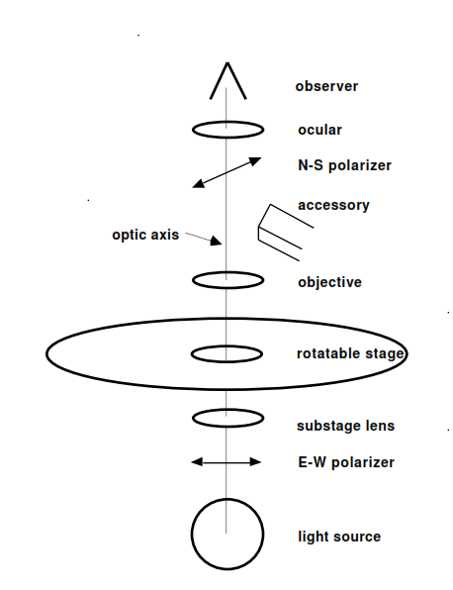

Figure 2. Schematic view of a polarizing light microscope (PLM). Light travels along the optic axis from the light source into the substage lens system, in which either orthoscopic or conoscopic light rays exit onto the sample placed on the rotatable stage. There is an E-W polarizer below the stage and a removable N-S polarizer above.

Figure 3. View of a polarizing light microscope (PLM) and their parts.

There are three types of samples commonly studied on the PLM in geology. (1) Powders of minerals in the size range of 0.07 to 0.15 mm for use in the immersion method. (2) Single crystals of minerals approximately 0.03 to 3.0 mm for use on the spindle stage. (3) Rock thin sections, prepared by cutting, grinding, and polishing a slab of rock mounted on a microscope slide to a thickness of 0.03 mm. Thin sections are by far the most common use of optical mineralogy in geology. They are used by petrologists to identify the minerals present, their textural relationships, to classify the rocks, and to locate minerals for microprobe analysis.

