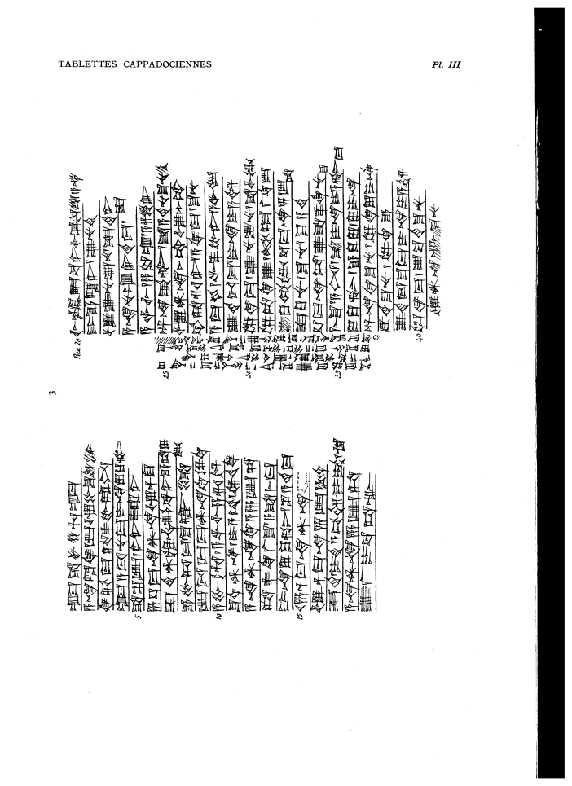

um-ma S^a-lim-a-hu-um-ma
a-na La-qe2-ep u3 Pu-s^u-ke-en6
qi2-bi-ma ta-as^2-pu-ra-nim
um-ma a-tu3-nu-ma i-na lu-qu2-tim
5 s^a s^e2-ep / I3-li2-as^2-ra-ni
6 1/3 ma-na AN.NA u3 1/2 TUG2
is^-ti2 d.NIN.S^UBUR-ba-ni e-ta-lu-tam2
e-pu-us^-ma / s^u-uq-li
ip-t,u3-ur-ma AN.NA.ki il5-qe2
10 a-pu-uh3 / a-wi-lim sa3-ri-im
s^u-ut AN.NA / i-a-am il5-te2-qe2
a-na AN.NA.ki-a 6 GIN.TA
s^a-as^2-qi2-la2-s^u / a-s^a-me-ma
i-na lu-qu2-tim / s^i2-a-ti2-ma
15 16 1/2 ma-na AN.NA
u3 1/2 ma-na 7 GIN2 KU3.BABBAR
is^-ti2 I-di2-a-bi-im DUMU I-di2-Is^tar
a-na AN.NA 6 GIN2.TA
u2-la2 i-ba-ta-aq
20 IGI d.En-lil2-ba-ni IGI Puzur4-A-s^ur
DUMU E-la-li2 / u2-nu-ti2
u3 u2-nu-su2-nu / is^-te2-ni=is^
a-na-nu-um ir-de8-ma /
a-wi-lum2 / sa3-ru-um / a-s,e2-er
25 AN.NA qa2-tim / s^a a-di2-nu-s^u-nu-ti2
u3 AN.NA 1 GU2 u3 GU2
up-ta-re-er / a-ki-ma / s^u-nu
a-ma-kam wa-as^2-bu-ni / a-wi-lam
u2-di2-du-ma i-na i-a-im
30 il5-qe2-ma / u2-nu-su2-nu s^a-lim-tam2
il5-ta-qe2-u2 / ELLAT.at La2-qe2-ep
u2-ku-ul-tam2 2/3 ma-na 5 GIN2.TA
is^-ku-nu / s^u-nu / s^u-a-ti2
1/3 ma-na.TA / u2-s^a-as^2-ki-nu-s^u
35 mi3-s^u/ a-num / s^a i-na i-a-tim-ma
lu-qu2-tim / e-ku-lu / lu i-na
AN.NA-hi-s^u-nu il5-qe2 lu-i-na
TUG2.ti2-s^u-nu / il5-qe2-e
u2-di2-du-s^u-ma i-na i-a-im
40 il-qe2-ma / s,u2-ba-ti2-s^u-nu
u3 an-na-ak-s^u-nu
s^al2-ma-am-ma u2-ta-er / a-pu-ti2-a-ma a-na-ku
la2 a-ha-li-iq / is^-ti2-in u3 s^e2-na
lu-us^-bu-ma / a-s^ar / us-ma-at-ni le-pu-s^u
45 s^u-ma da-nu-tam2 / e-ta-wu-u2 a-na ka3-ri-im [ ]

