CHAPTER-2

INTRODUCTION TO CONDUCTION

Recall that conduction is the transport of energy in a medium of a temperature gradient and the physical medium has molecular activity.

- What form does the Fourier’s Law take in different geometries ?
- How does k depend on the nature of the medium (k=constant, general assumption)
- How do we develop the heat equation ? [Heat equation means the energy balance]

Suppose that the cylindrical rod below is open to heat transfer at its two ends. But the lateral surface is insulated.
x-direction

T₁ is bigger than T₂. Only end surfaces transfer heat.

T₁ T₂
L

Assumptions: Steady -state conduction
Fourier’s law: ${q_{x}}^{''}=-k \frac{dT}{dx}$ = $-k\frac{T2-T1}{L}=k\frac{∆T}{L}$

${q_{x}}^{''}$ is the heat transfer rate per unit area by conduction in x-direction (Heat flux)

Where $∆T$ = T₁-T₂

${q_{x}}^{''}$varies directly with k and $∆T\text{ but inversely with L}.$

Thermal conductivity, k (W/m.K) is generally assumed constant and given to you in the questions.

k is a transport property and provides an indication of the rate at which energy is transferred by the diffusion process.

k may change according to the coordinates and with respect to temperature.

So k_{x}$≠$ k_{y}$≠$k_{z} , but for an isotropic material k is identical in all directions.

k_{solid}>k_{liquid}>k_{gas} ; this difference is mainly due to the intermolecular spacing for the states of the matter.

In our analysis of heat transfer problems, it will be necessary to use several properties of matter.

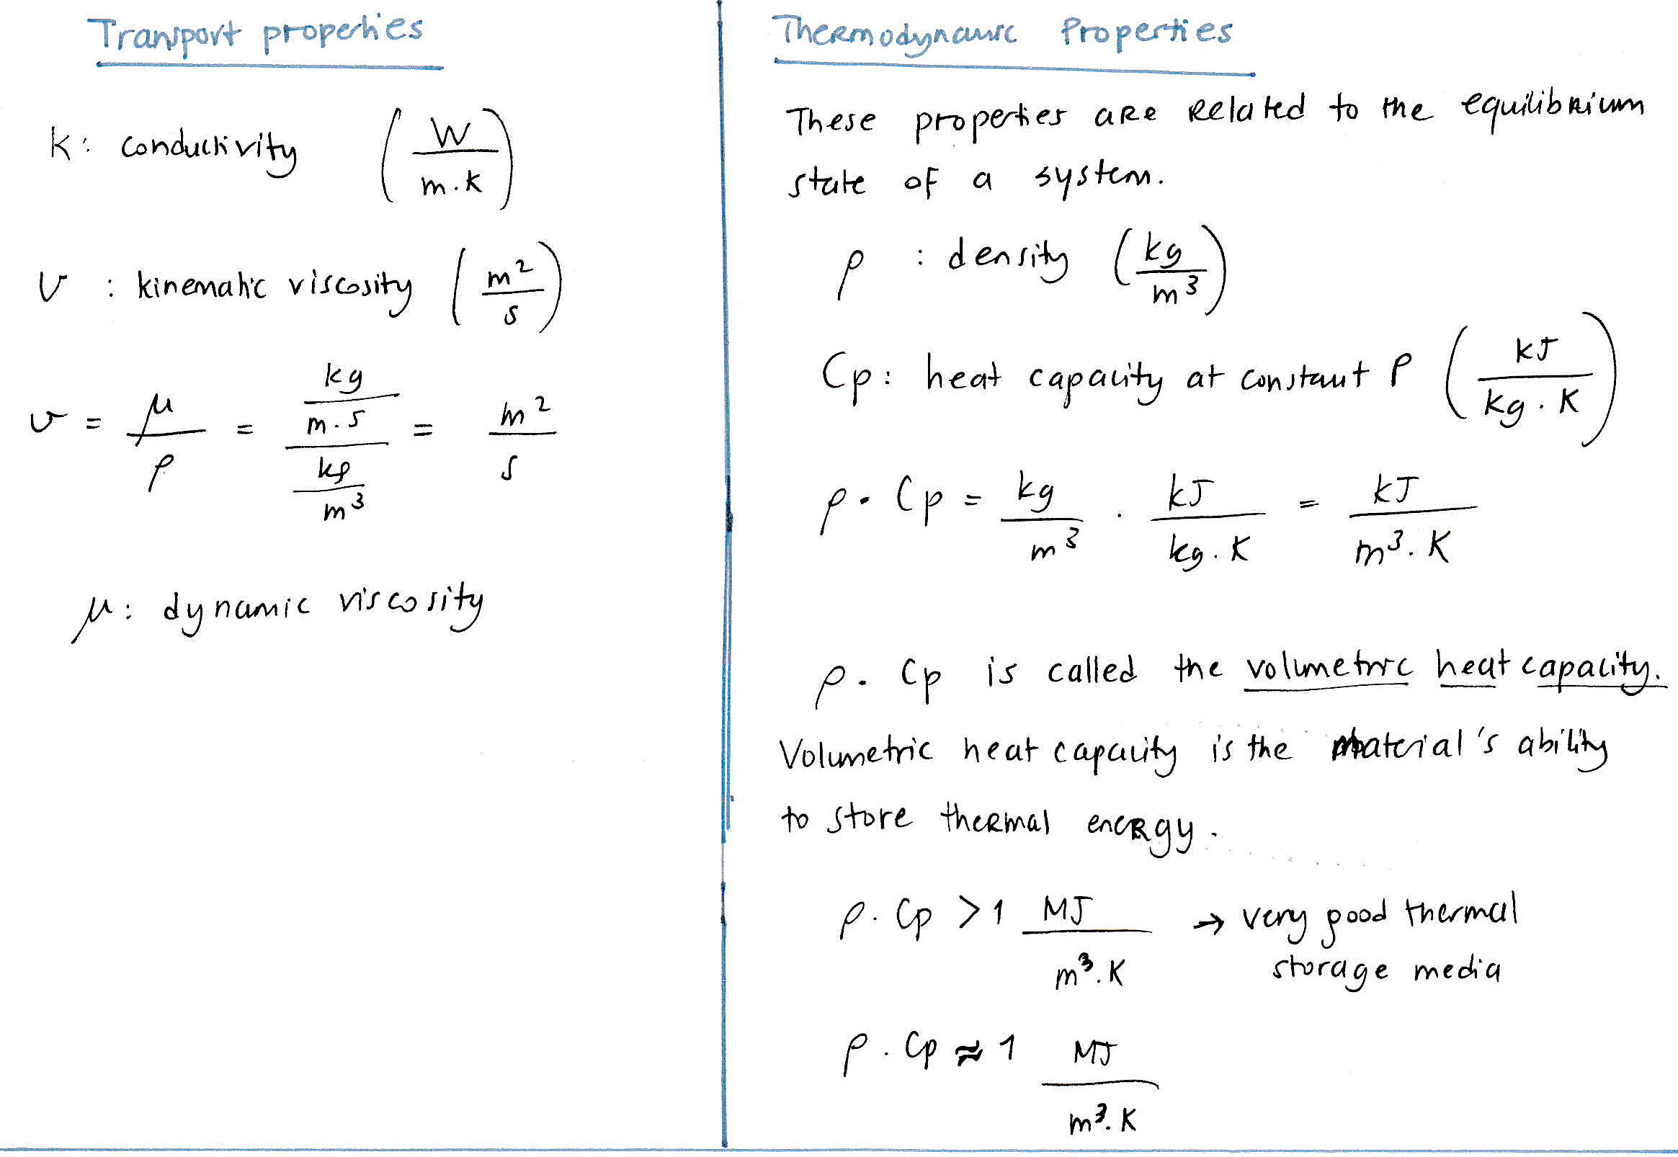

In heat transfer problems, the ratio of thermal conductivity to the volumetric heat capacity is an important property called $α$, thermal diffusivity (m²/s)

$α$= $\frac{k}{ρ∙C_{p}}$

$α$ measures the material to conduct thermal energy relative to its ability to store thermal energy.

