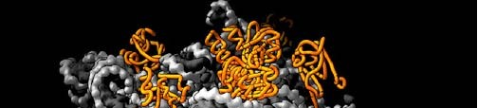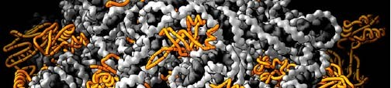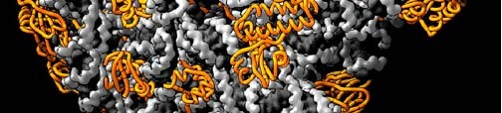Molecular Genetics II Information Flow

DNA is a code for proteins. Information in DNA is carried from DNA by RNA to the machinery that synthesizes protein. The RNA code is used to order and assemble the amino acids of a
protein. 1

Proteins are synthesized using the DNA code in a two step process:

Transcription - making an RNA molecule that is complementary to the DNA code. The RNA molecule is called messenger RNA, or mRNA.
Translation - using the mRNA code as instructions for assembling a protein.
The “Central Dogma” of
Molecular Biology

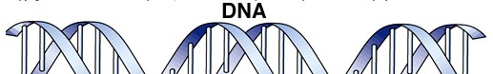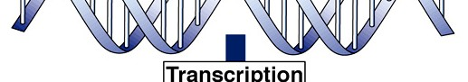2

Transcription
RNA polymerase uses one of the two strands as the template strand and makes a complementary RNA transcript. The other strand of the DNA molecule is called the coding strand.
If the DNA reads ATCG on the template strand it will read TAGC on the coding strand
the mRNA will read UAGC - a complement to the template.
The two strands of the DNA molecule are sometimes called the “Watson strand” and the “Crick strand.”
Along the length of the DNA molecule there are many genes. For some genes the Watson strand is the template. For other genes the Crick strand is the template.
The template strand is sometimes called the anti-sense strand.
The coding strand can be called the sense strand. 3

RNA polymerase associates with the DNA at a site adjacent to the gene called the promoter. The promoter is not part of the gene.
It is upstream from the gene. It is commonly rich in A and T bases: TATAAA A protein called sigma (σ) associates with the promoter and marks the site for RNA polymerase to associate.
RNA polymerase, unwinds and reads the DNA as it synthesizes

RNA. RNA synthesis is from 5’ to 3’.
As mRNA is synthesized, it peels off the DNA and the DNA duplex rewinds behind RNA
polymerase.

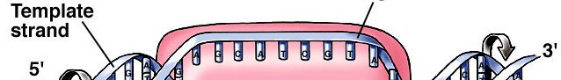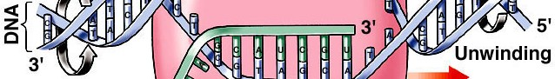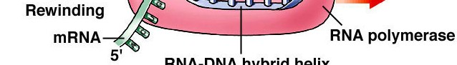4

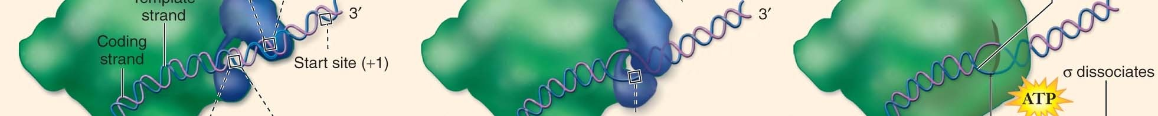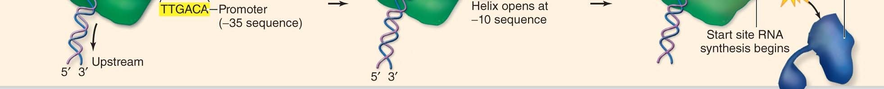More detail on the promoter, sigma and binding of RNA polymerase:

5

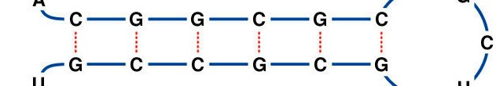Transcription stops after RNA polymerase transcribes the

terminator sequence
The terminator sequence, is rich in G and C bases, and when it peels off can form a “hairpin loop.” The hairpin structure is recognized by RNA polymerase and this causes it to dissociate from the DNA.

(Other details of transcription will be covered later.) 6

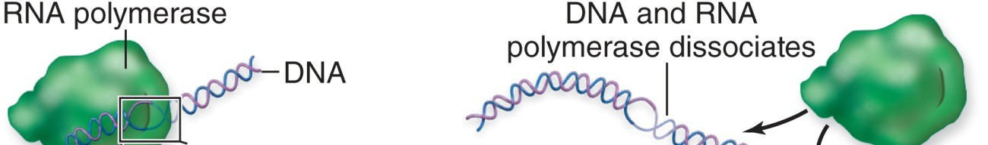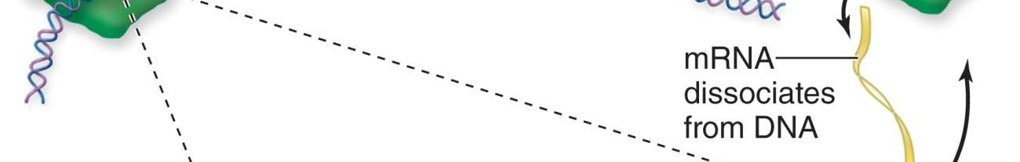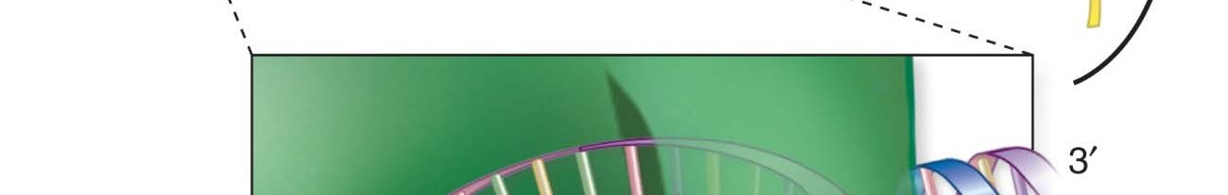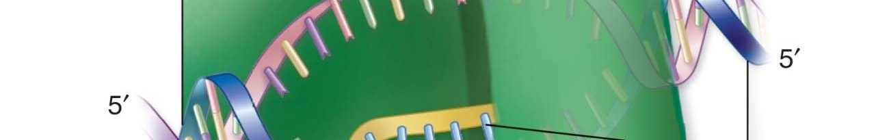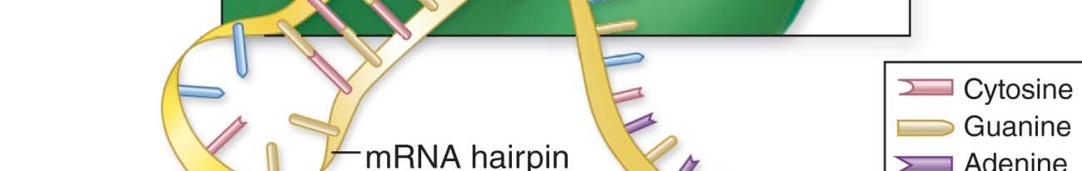More detail on termination:

7

Translation - the synthesis of protein using an mRNA code. Recall:
Proteins consist of a sequence of amino acids. There are 20 different amino that can be used in the construction of proteins. The sequence of amino acids gives a protein its properties.
How do nucleotides code for amino acids?

8

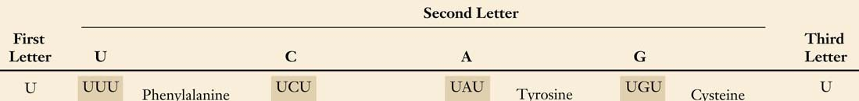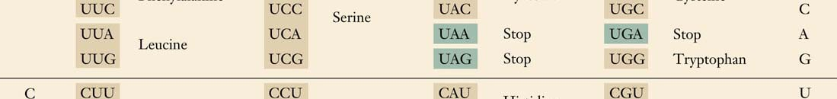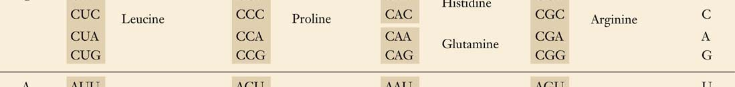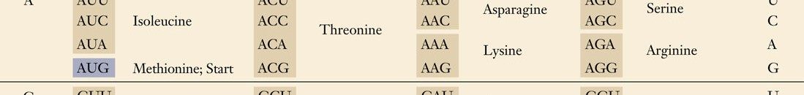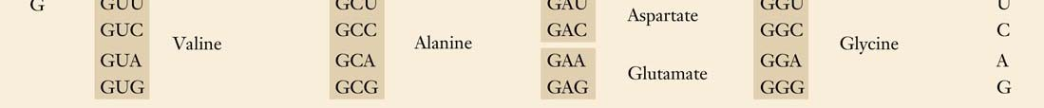The code consists of nucleotide triplets, these are codons. Codons specify either an amino acid or are a signal to terminate translation.

61 codons code for 20 amino acids - a code with this type of redundancy is called degenerate. 9

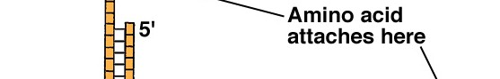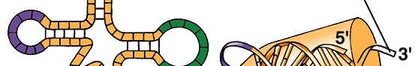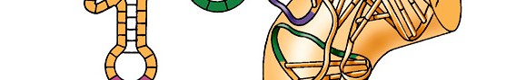How does a codon like GGG specify glycine?
Another RNA molecule, transfer RNA (tRNA), carries amino acids. There are many tRNAs. Each has an anticodon that is complementary to one of the the codons.
tRNA-gly carries Glycine and has the anticodon CCC.
The anticodon CCC base-pairs with the codon GGG and positions the amino acid for polymer
formation. 10

Four different depictions of tRNA:

11

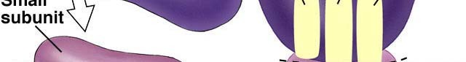There is one more component needed for translation: the ribosome. Ribosomes have two subunits - a small subunit and a large subunit The two subunits only associate with each other during protein
synthesis

The subunits are composed of both RNA and protein

12

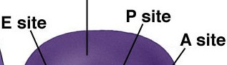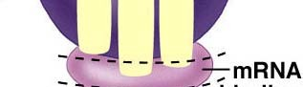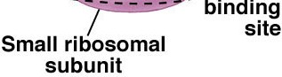
When the subunits associate they form three sites where tRNAs can associate and reside
A site - Amino-acyl site - tRNAs carrying amino acids enter at this site during protein synthesis
P site - Peptidyl site - tRNAs that hold the growing polypeptide chain reside at this site.
E site - Exit site - tRNAs stripped of their amino acids reside here and then leave the ribosome.

13

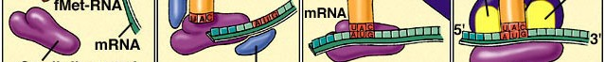Translation begins with the formation of an initiation complex:

Initiation factors, the small ribosome subunit, and tRNA-fmet associate with the mRNA at the leader sequence.
fMet-tRNA has the anticodon UAC.
The small ribosome subunit moves along the mRNA until an AUG
codon is found. Then the large subunit associates. 14

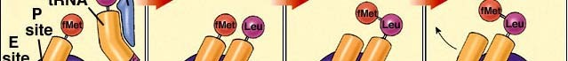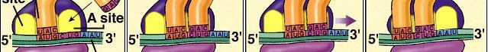With the assistance of elongation factors a new tRNA bearing an anticodon that matches the codon enters at the A site.

The ribosome catalyzes the removal of the amino acid from the tRNA at the P site and the formation of a peptide bond between that amino acid and the amino acid attached to the tRNA at the A site. The enzyme that is part of the ribosome is peptidyl transferase.
The ribosome then translocates along the mRNA by one codon.
The former P-site tRNA now resides at the E site. It leaves. 15

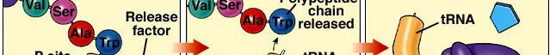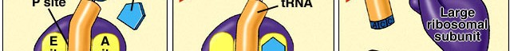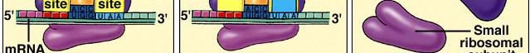New tRNAs bearing matching codons enter at the A site and new peptide bonds are formed to produce a polypeptide.

Eventually, a stop codon is found at the A site. A release factor (stop protein) enters the A site. The ribosome cleaves the polypeptide from the tRNA at the P site and then the ribosome dissociates.

16

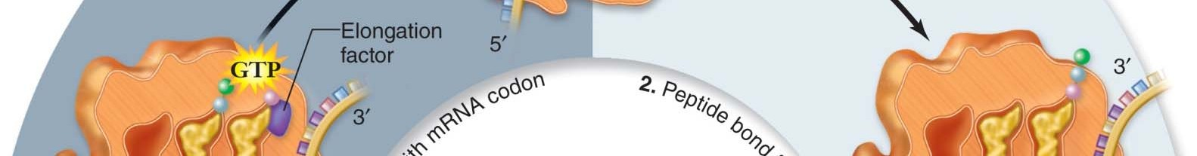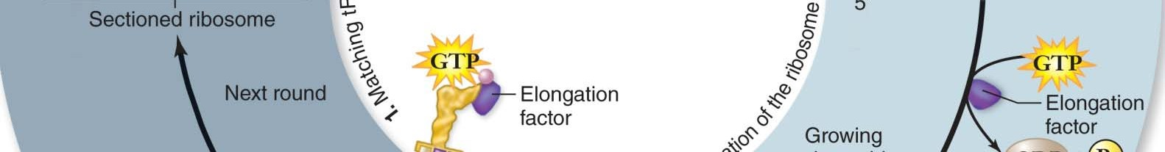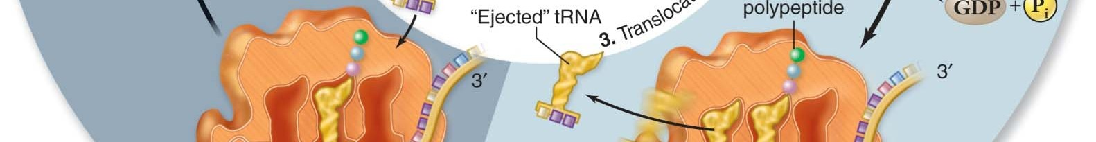
17

Ribosomal translocation and polypeptide elongation

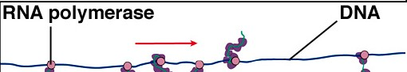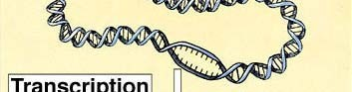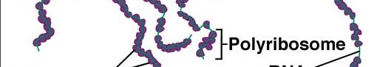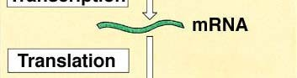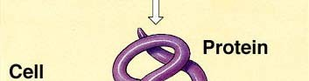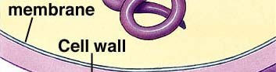In prokaryotes, translation begins as soon as the leader sequence is transcribed.
.

Ribosomes begin translation before transcription is completed.
Many ribosomes can be seen translating proteins from the same
mRNA 18

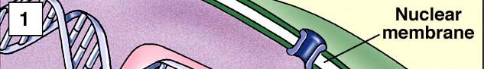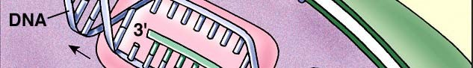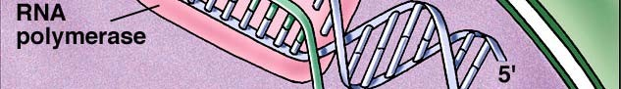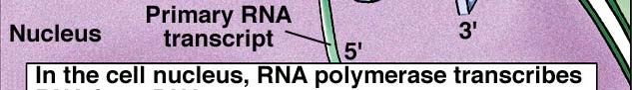In eukaryotes, transcription occurs in the nucleus, and translation occurs in the cytoplasm and there are several other additional complications.

19

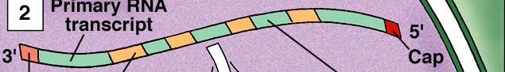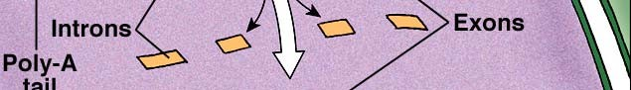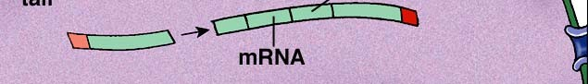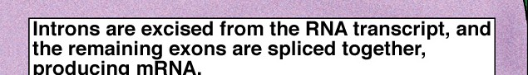The mRNA that is first transcribed is much longer than the mRNA that will eventually be translated. Eukaryotic genes commonly have intervening sequences that must be removed before an mRNA that codes for the proper sequence of amino acids can be created.

The intervening sequences that must be removed are called introns.
The coding sequences are called exons.

20

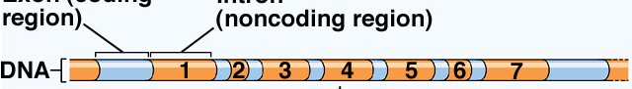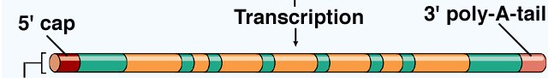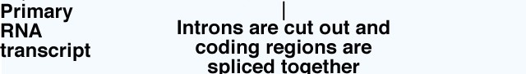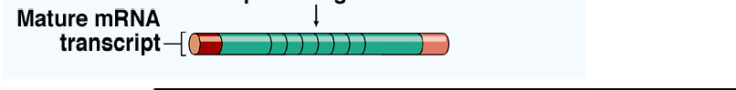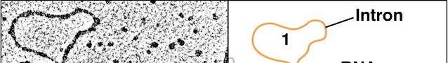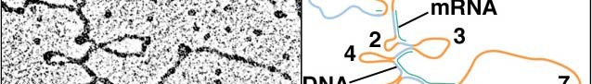Along with intron removal, the mRNA is also modified through the addition of a 5’ cap and a 3’ poly A tail.
This creates a mature mRNA.

21

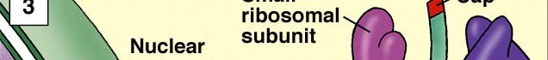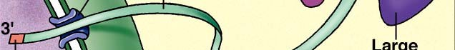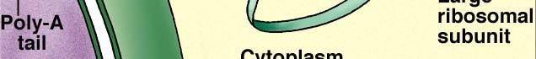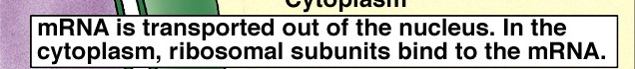The 5’cap and the 3’ poly-A tail are required for mRNA to leave the nucleus through a nuclear pore.

22

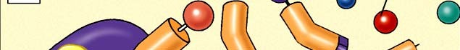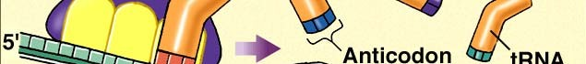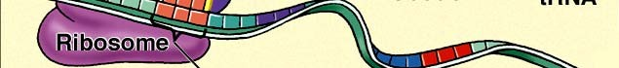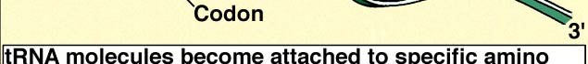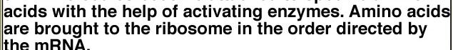Translation is very similar to that seen in prokaryotes

23

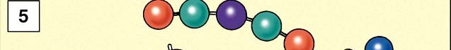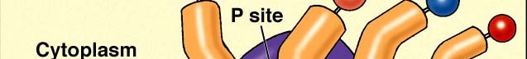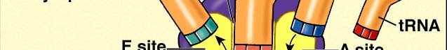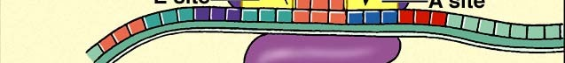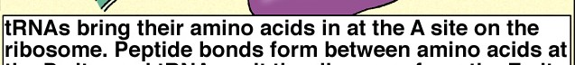

24

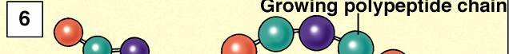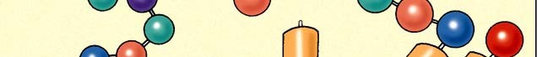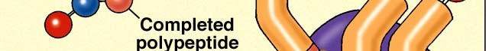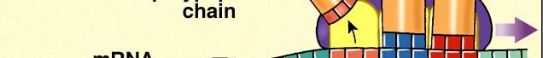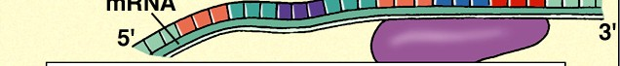

25

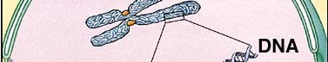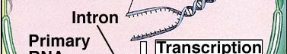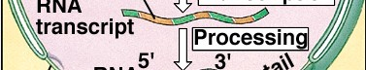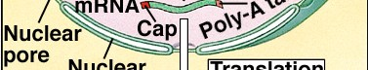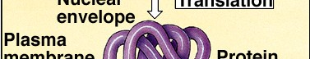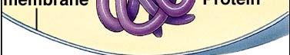A summary of information flow:
Transcription
Post-transcriptional modifications: intron removal, exon splicing, addition of 5’cap and poly- A tail
Transport out of the nucleus Translation in the cytoplasm

26

Reference: https://www.nicholls.edu/biol-ds/biol155/Lectures/Information%20Flow.pdf

