İKİ FAKTÖRLÜ ANOVA

İki faktörlü varyans analizinde iki bağımsız değişkenin bir bağımlı değişkenle ilişkisinin analiz edilmesidir.

Bu analizde bağımsız değişkenlerin bağımlı değişkenlere tekil olarak etkilerinin yanısıra birlikte etkilerinin de olup olmadığının incelenmesi mümkündür.

İki faktörlü varyans analizinin diğer analizlere göre avantajı birlikte etkiyi incelemeyi olanaklı kılmasıdır. Değişkenlerin tekil etkilerinin farklı analizlerle (örneğin, t-test ya da tek faktörlü ANOVA) ile incelenmesi söz konusudur. İki faktörlü ANOVA’da ise bağımsız değişkenlerin etkileşimi analiz edilebilir.

Test Sonuçlarının Yorumlanması

Descriptives tablosu sürekli değişkenin farklı gruplar içerisinde hangi örneklem büyüklükleri, ortalamaları ve standart sapmalara sahip olduğunu belirten, betimleyici istatistiksel bilgiler içerir.

Tests of Between-Subjects-Effects tablosu, varyans analizinde test edilen hipotezin reddedilip reddedilmeyeceğine işaret eden istatistiksel göstergeler içerir.

Bu tabloda her bir bağımsız değişken için p-değeri bulunur. Bu gösterge ile bağımsız değişkenlerin tekil etkilerinin sınanması olanaklıdır.

Ayrıca, aynı tabloda bağımsız değişkenlerin birlikte etkileri için de bir p-değeri hesaplanmıştır. Bu değer ile birlikte etkinin olmadığı hipotezinin reddedilip reddedilemeyeceği kararlaştırılır.

Birlikte etkinin bulunduğu durumlarda, söz konusu etkileşimin yorumlanması grafikler yardımıyla yapılır. Grafikler değişkenler arasındaki ilişkilerin görselleştirilmesidir.

ÖRNEK 1

Descriptive Statistics
Dependent Variable: Satisfaction with your life
Religious person | Sex | Mean | Std. Deviation | N
A religious person | Male | 6.89 | 2.313 | 24351
 | Female | 6.91 | 2.316 | 29483
 | Total | 6.90 | 2.314 | 53834
Not a religious person | Male | 6.81 | 2.149 | 11915
 | Female | 6.92 | 2.112 | 10527
 | Total | 6.86 | 2.132 | 22442
An atheist | Male | 6.80 | 2.133 | 2768
 | Female | 6.93 | 1.974 | 1951
 | Total | 6.85 | 2.069 | 4719
Total | Male | 6.86 | 2.252 | 39034
 | Female | 6.91 | 2.251 | 41961
 | Total | 6.89 | 2.252 | 80995

Tests of Between-Subjects Effects
Dependent Variable: Satisfaction with your life
Source | Type III Sum of Squares | df | Mean Square | F | Sig.
Corrected Model | 125.823ª | 5 | 25.165 | 4.965 | .000
Intercept | 1509497.986 | 1 | 1509497.986 | 297831.259 | .000
V147 | 25.137 | 2 | 12.568 | 2.480 | .084
V240 | 58.699 | 1 | 58.699 | 11.582 | .001
V147 * V240 | 44.906 | 2 | 22.453 | 4.430 | .012
Error | 410476.498 | 80989 | 5.068
Total | 4253393.000 | 80995
Corrected Total | 410602.321 | 80994
a. R Squared = .000 (Adjusted R Squared = .000)

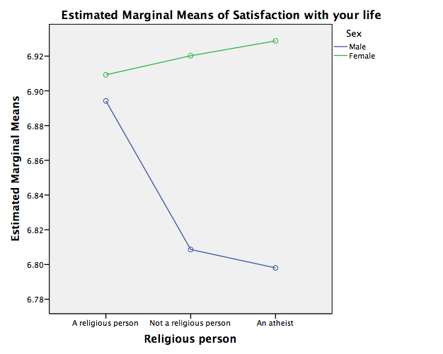
İKİ FAKTÖRLÜ ANOVA – 2

Descriptive Statistics
Dependent Variable: Age
Religious person | Sex | Mean | Std. Deviation | N
A religious person | Male | 41.18 | 16.662 | 24428
 | Female | 42.63 | 16.772 | 29600
 | Total | 41.98 | 16.738 | 54028
Not a religious person | Male | 41.50 | 16.489 | 11964
 | Female | 41.41 | 16.127 | 10604
 | Total | 41.45 | 16.320 | 22568
An atheist | Male | 42.47 | 17.072 | 2778
 | Female | 42.21 | 16.089 | 1968
 | Total | 42.36 | 16.670 | 4746
Total | Male | 41.37 | 16.642 | 39170
 | Female | 42.30 | 16.589 | 42172
 | Total | 41.85 | 16.621 | 81342

Tests of Between-Subjects Effects
Dependent Variable: Age
Source | Type III Sum of Squares | df | Mean Square | F | Sig.
Corrected Model | 33854.168ª | 5 | 6770.834 | 24.545 | .000
Intercept | 56391677.431 | 1 | 56391677.431 | 204428.148 | .000
V147 | 4666.067 | 2 | 2333.034 | 8.458 | .000
V240 | 1068.042 | 1 | 1068.042 | 3.872 | .089
V147 * V240 | 11101.317 | 2 | 5550.659 | 20.122 | .000
Error | 22436604.386 | 81336 | 275.851
Total | 164962315.000 | 81342
Corrected Total | 22470458.554 | 81341
a. R Squared = .002 (Adjusted R Squared = .001)

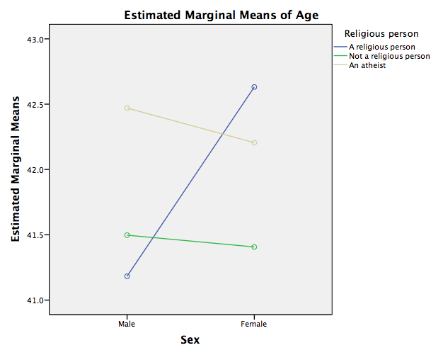

İKİ FAKTÖRLÜ ANOVA – 3

Descriptive Statistics
Dependent Variable: What age did you complete your education
Religious person | Sex | Mean | Std. Deviation | N
A religious person | Male | 20.25 | 10.177 | 21745
 | Female | 20.33 | 11.727 | 26128
 | Total | 20.30 | 11.050 | 47873
Not a religious person | Male | 20.09 | 8.164 | 11143
 | Female | 19.79 | 7.975 | 9874
 | Total | 19.95 | 8.077 | 21017
An atheist | Male | 20.68 | 7.588 | 2574
 | Female | 20.09 | 6.907 | 1805
 | Total | 20.44 | 7.320 | 4379
Total | Male | 20.23 | 9.415 | 35462
 | Female | 20.18 | 10.676 | 37807
 | Total | 20.20 | 10.085 | 73269

Tests of Between-Subjects Effects
Dependent Variable: What age did you complete your education
Source | Type III Sum of Squares | df | Mean Square | F | Sig.
Corrected Model | 2895.518ª | 5 | 579.104 | 5.695 | .000
Intercept | 12068560.229 | 1 | 12068560.229 | 118687.191 | .000
V147 | 1959.020 | 2 | 979.510 | 9.633 | .000
V240 | 535.990 | 1 | 535.990 | 5.271 | .022
V147 * V240 | 804.498 | 2 | 402.249 | 3.956 | .019
Error | 7449657.558 | 73263 | 101.684
Total | 37361870.250 | 73269
Corrected Total | 7452553.075 | 73268
a. R Squared = .000 (Adjusted R Squared = .000)

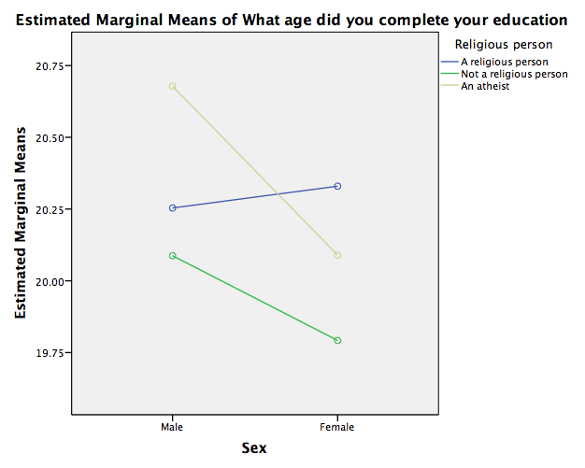

İKİ FAKTÖRLÜ ANOVA – 4

Descriptive Statistics
Dependent Variable: Self positioning in political scale
Religious person | Sex | Mean | Std. Deviation | N
A religious person | Male | 5.98 | 2.358 | 19369
 | Female | 5.87 | 2.305 | 22016
 | Total | 5.92 | 2.331 | 41385
Not a religious person | Male | 5.50 | 2.196 | 9212
 | Female | 5.45 | 2.166 | 7597
 | Total | 5.48 | 2.182 | 16809
An atheist | Male | 4.94 | 2.250 | 2188
 | Female | 4.94 | 2.099 | 1419
 | Total | 4.94 | 2.192 | 3607
Total | Male | 5.77 | 2.324 | 30769
 | Female | 5.72 | 2.276 | 31032
 | Total | 5.75 | 2.300 | 61801

Tests of Between-Subjects Effects
Dependent Variable: Self positioning in political scale
Source | Type III Sum of Squares | df | Mean Square | F | Sig.
Corrected Model | 5002.335ª | 5 | 1000.467 | 191.990 | .000
Intercept | 712699.651 | 1 | 712699.651 | 136766.981 | .000
V147 | 4815.589 | 2 | 2407.794 | 462.055 | .000
V240 | 19.887 | 1 | 19.887 | 3.816 | .081
V147 * V240 | 16.841 | 2 | 8.421 | 1.616 | .199
Error | 322016.869 | 61795 | 5.211
Total | 2366984.000 | 61801
Corrected Total | 327019.204 | 61800
a. R Squared = .015 (Adjusted R Squared = .015)

