3. Canning of Fruits and Vegetables
Canning; It is the process of filling suitable qualified raw materials into cans, glass jars or similar containers suitable for the purpose, after some preliminary processes such as washing, sorting and de-stalking, sealing the containers in an airtight way (hermetic) and killing microorganisms, that can deteriorate, food by heat treatment (pasteurization and sterilization).
Although the quality of canned foods are lower than in frozen foods, the consumption amount is approximately 4 times that of dried and frozen foods^{[7]}.

The factor that determines whether a can is pasteurized or sterilized is the pH of the food. Clostridium botulinum (its spores are very resistant to heat, pathogen, anaerobe) cannot both reproduce and excrete toxins in foods below pH 4.5^{[8,9]}.

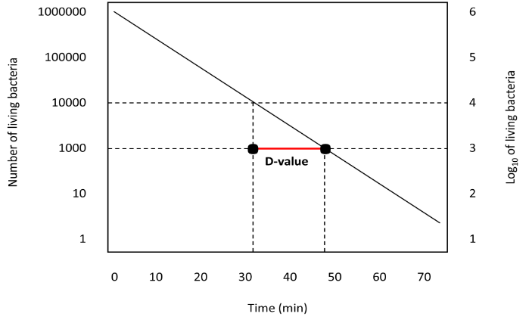
Figure 1 Graphical representation of D value

Bacteria reproduce in a geometrical order. D and z values are used to determine the sterilization time^{[8,9]}:
- D value (Decimal reduction): It is the time in minutes required for 1 logarithmic value reduction of the number of microorganisms at constant temperature (Figure 1).
- Z value (Dependence on Temperature): It is the value in degrees of the temperature increase required for 1 logarithmic value decrease of the D value (Figure 2).

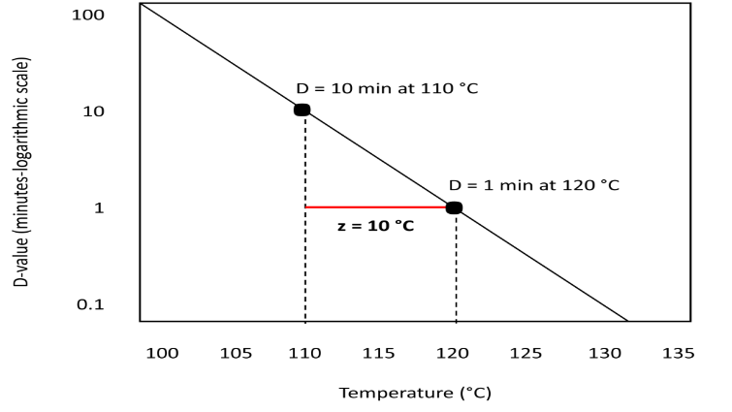
Figure 2 Graphical representation of the z value

3.1. Pre-processes
3.1.1. Harvest
The first rule to obtain a quality product is to use a quality and fresh raw material suitable for the purpose. In general, vegetables should be harvested when they are very young, while fruits should be harvested when they are fully ripe and their color and aroma are fully developed but not softened. Following the harvest, fruits and vegetables should be transported to the factory properly without being injured or crushed^{[10-12]}.

3.1.2. Washing
Fruits and vegetables received into the process line should be washed effectively to remove dust, soil, pesticides and similar foreign substances and to reduce the microorganism load. The washing process is carried out in three stages: pre-washing (softening), washing and rinsing. On average, 3-5 kg of washing water is used for 1 kg of product^{[10-12]}.

3.1.3. Cleaning and Sorting
The cleaned fruits and vegetables must be sorted before being canned. The damaged, dented, moldy and rotten ones are either completely discarded or only the damaged parts are cut off and discarded. After sorting, fruits and vegetables are classified according to their quality and properties. Classification of fruits and vegetables can be made according to size, color, maturity and shape. Classification according to maturity, color and shape can be done by experienced people. However, flat sieve type or cylinder type classification machines are used for classification according to size. With the classification process, it is ensured that the vegetables and fruits in the package have the same characteristics and size, that the necessary requirements in terms of standards are applied and that the heat treatment can be done at an adequate level^{[10-12]}.
3.1.4. Dehulling, Trimming and Slicing-dicing
Before applying any preservation method to vegetables and fruits, the purposes of removing the stem, head and ends are as follows^{[7]}:
- To remove the inedible parts of vegetables and fruits.
- To increase the visual quality of the product to be produced.
- To facilitate the packaging of products.
- Getting the most efficiency from the preservation method to be applied.
- To make products completely consumable.
- To alleviate the microorganism load that can be found on the stems.

This processes are not used in all products, it is done when necessary. For example, dehulling is applied in peas and end-cutting and chopping is applied in beans.

3.1.5. Peeling and Core Removal
In the food industry, peeling can be done to remove the unwanted and inedible parts of fruits and vegetables and to improve the appearance of the product. In the peeling process, it is desired that the amount of material removed from the foodstuff is as low as possible, the cost is low, the energy spent, laboratory and material costs are minimal. Fruits and vegetables such as apples, peaches, potatoes, carrots, celery need to be peeled. Peeling is done in 4 different ways^{[7,13]};
- Manual peeling (artichoke, asparagus, orange, grapefruit): In addition to its advantages such as less wastewater, no chemicals that may cause environmental pollution, possible use of wastes in the feed industry, there are disadvantages such as the risk of microbial contamination of the peeled raw material, increased waste rate and decreased efficiency.
- Peeling with heat treatment (tomato, peach, red pepper, eggplant): It can be applied in 4 different ways. Steam peeling is the most preferred method. In this method, the raw material is kept under 7-10 atm pressure steam for less than 1 minute in steam peeling machines. The most important advantages are low water consumption, minimum product loss, good appearance to the product, high efficiency and easy removal of wastes. In the flame peeling process, the raw material (e.g. onion, garlic) is taken to the furnace with a very high temperature by a conveyor belt and the product is passed in front of the flame. Since the flame provides rapid heating, the skin is immediately separated and there is a loss of product as the outer skins of the vegetables are burned. In the process of peeling with hot water, the product is dipped into the containers with boiling water with a net or wire basket and the skins are peeled by keeping them for an appropriate time. In the freeze peeling process, which has a very limited use as it is an expensive application, liquid nitrogen is brought to an environment of -79 °C and the product immersed in it freezes at this temperature and the shell is separated when thawed.
- Mechanically peeling (apple, pear, potato, celery): Special peelers equipped with rotating blades or rasping (abrasion) system are used according to raw material properties.
- Peeling with chemical compounds (tomato, peach, orange, grapefruit): The raw material, which is kept by being immersed in sodium hydroxide (NaOH), potassium hydroxide (KOH), calcium chloride (CaCl₂) and sodium carbonate (Na₂CO₃) solutions, is washed with plenty of water after the process. The peels are removed by using mechanical scrubbers. Since the surface texture of many fruits and vegetables is not smooth, it is a very preferred method due to its advantages such as being able to peel very well with this method, removing the damaged and crushed parts from the raw material, high-capacity operation, and cheap and simple equipment. However, there are also disadvantages such as the need for a lot of water to remove the peels and alkali solution, the environmental pollution of chemical wastes and the loss of tissue in careless application.

During the processing of stone fruits, seeds and cores must be removed by hand (apple, pear, quince, peach, apricot) or by special machines (sour cherry, cherry, plum).

