CARBOHYDRATES

Carbohydrates are the most widely distributed and abundant organic compounds on earth. Basically, carbohydrates get their name from their chemical makeup—containing carbon, hydrogen, and oxygen. Carbohydrates, all coming from the process of photosynthesis, by the help of light green plants producing carbohydrates from oxygen and carbon dioxide.
Carbohydrates defined as aldehydic or ketonic compounds with some number of oxydrilic groups, so they are polyhydroxy aldehydes or polyhydroxy ketones, as well as their derives. They have a general formula (CH₂O)_{n}. In aldehydes, the carbonyl is bonded to one carbon and one hydrogen and located at the end of the carbon chain. In ketones, carbonyl group is bonded to two carbons with a carbon skeleton.
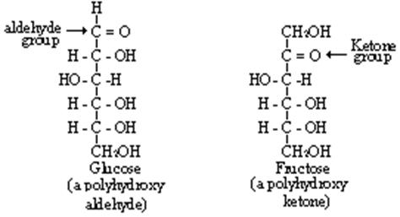
The main function of carbohydrates is to provide energy especially for the nervous system. Glucose is the main energy source of the brain. Eating carbohydrates is a quick way to increases blood sugar and stimulate insulin production. Healthy blood sugar and insulin levels are key to maintaining a healthy body. Carbohydrates increased the brain’s production of serotonin more than other food groups. Serotonin is known as the “feel good hormone”. Once activated in the brain, it works to stimulate sleep, regulate blood pressure, control your mood, appetite and your sensitivity to pain. Some of the carbohydrates known as the bulk material, that moves everything through our digestive tracks—because, unlike proteins and fats, they are indigestible and passes through our systems mostly intact—adding roughage to your bowels while keeping body full, regular, and satisfied after eating. Trigger appetite, hunger and fullness, high fiber diets have a slower digestion. Prebiotics are nondigestible carbohydrates that stimulate the growth or activity of bacteria in the colon. This ultimately improves digestive health. Their presence is necessary for the normal lipid metabolism. More than 100 years ago Pasteur said: “Fats burn in the fire of carbohydrates’.
Classification of Carbohydrates
On the basis of the number of forming units, three major classes of carbohydrates can be defined: monosaccharides, disaccharides and polysaccharides. Saccharon implies sugar in Greek.
Monosaccharides, are the simplest group of carbohydrates and serve as the building blocks of larger molecules. They contain a single polyhydroxy aldehyde or polyhydroxy ketone unit. Monosaccharides cannot be broken down into simpler units by hydrolysis reactions. Naturally occurring monosaccharides have from three to seven carbon atoms. Monosaccharides are water-soluble because of their hydroxyl groups and they are sweet.
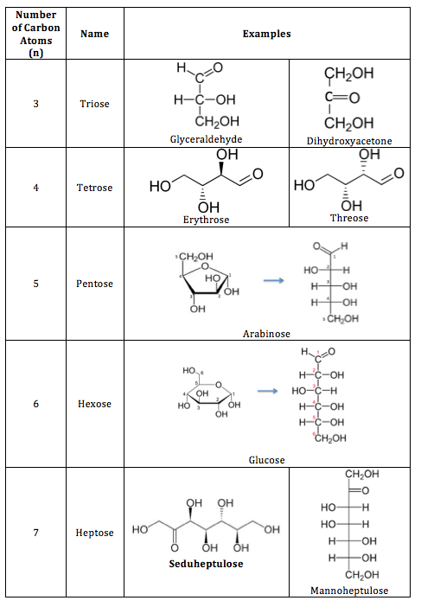
Five and six-carbon species are especially common. Glucose, fructose and galactose share the same molecular formula: C₆H₁₂O₆. Because of their six carbon atoms, each is a hexose. Although all three share the same molecular formula the arrangement of atoms differs in each case. Substances such as these three, which have identical molecular formulas but different structural formulas, are known as structural isomers.
Monosaccharides are divided into two families; D form and L form sugars. A monosaccharide is given D configuration if the hydroxyl group is on the right of the last stereocenter carbon, whereas L configuration is given if the OH is on the left. D or L is usually put in the beginning of the carbohydrate when naming the molecule eg; D-glucose.
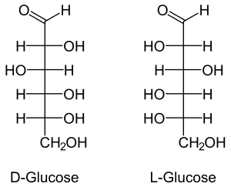
Common monosaccharides;
- Glucose, also called dextrose is the blood sugar. It is the immediate source of energy for cellular respiration, it is an aldose sugar.
- Galactose, is the sugar in milk products. It is an aldose sugar.
- Fructose, is known as fruit sugar, it is also found in honey. It is a ketose sugar.
Disaccharides, are carbohydrates composed of two monosaccharide units covalently bonded to each other. Like monosaccharides, disaccharides are water-soluble substances. Especially in the human diet the most important ones are sucrose (common table sugar), lactose and maltose. Although the process of linking the two monomers is rather complex, the end result in each case is one mole of water. The resulting linkage between the sugars is called a glycosidic bond. An aldehyde or a ketone group on the sugar can react with a hydroxyl group on another sugar, this called maltose type glycosidic bond. In a different type, an aldehyde or a ketone group of one sugar can react with the aldehyde or a ketone group of the other sugar. This bond is called trehalose type glycosid bond. The different types of this bonds effect the reduction property of the sugar. Reducing sugars have free aldehyde or ketone groups. Sucrose is the non-reducing sugar, while lactose and maltose are reducing.
Disaccharides;
- Sucrose is one of the oldest sweetening agents and the most used caloric sweetener, both for home and commercial use. glucose + fructose Also known as table sugar. Sugar beet is the common source for sucrose. It is sweetness accepted as 100.
- Maltose, is a seldom disaccharide present naturally in foods, while it is added to many products: it is often present in products commercialized as sugar free, in which it is referred as malt. It is a product of starch digestion. It is consisting of two units of glucose.
- Lactose, is the specific sugar of the milk. It consists of one unit of galactose and one unit of glucose. It accounts respectively for 7.5% and 4.5% of the composition of woman and cow’s milk. It is the least sweet sugar.
Polysaccharides, are carbohydrates made up of many monosaccharide units. Polysaccharides, which are polymers, often consist of more than 20 monosaccharide units. They differ each other for the monosaccharides recurring in the structure, for the length and the degree of branching of chains or for the type of links between units. They are not sweet. Whereas in the plant kingdom several types of polysaccharides are present, in vertebrates there are only a small number. Polysaccharides are defined as homopolysaccharides if they contain only one type of monosaccharide as starch, glycogen and chitin; heteropolysaccharides, instead, contain two or more different kinds (e.g. hyaluronic acid). The primary functions of polysaccharides are to provide structure and store energy.
Polysaccharides;
- Cellulose, is the major structural material of which plants are made. Wood is largely cellulose while cotton and paper are almost pure cellulose. It has glucose as its monomer. Because of the orientation of the glyosidic bonds linking the glucose residues, it is arranged as a long, straight, rigid molecule. There are no side chains in cellulose. Because of the many -OH groups, as well as the oxygen atom in the ring, there are many opportunities for hydrogen bonds to form between adjacent chains. The result is a series of stiff, elongated fibrils, the perfect material for building the cell walls of plants. Because of the beta bonds, it is very hard to digest this molecule with our enzymes. Humans cannot digest cellulose, but also we need to take it in our diet because of its bulk material properties. Hydroxy-methyl cellulose used in industry as a thickener agent.
- Starch, formed by units of glucose and plants convert excess glucose into starch for storage. It is present in vegetable cells and contains two types of homopolysaccharides, amylose and amylopectin. Amylose consists of linear, unbranched chains of several hundred glucose residues. Amylopectin differs from amylose in being highly branched. Amylopectin is not soluble, it swollen in water and get stinky. Rice, wheat, and corn are also major sources of starch in the human diet.
- Glycogen, animals store excess glucose by polymerizing it to form glycogen. The structure of glycogen is similar to that of amylopectin, although the branches in glycogen tend to be shorter and more frequent. The liver and skeletal muscle are major depots of glycogen.
On the basis of their degree of polymerization, carbohydrates can be classified as; simple carbohydrates which are mono and disaccharides and complex carbohydrates the polysaccharides.
Sweetness Grades of Sugars
The most important characteristic of carbohydrates is that they are sweet, because of the OH groups in their structure. Sugars have different levels of sweetness. Fructose is the sweetest sugar, where lactose is the least sweet one. Sucrose sweetness accepted as 100 and the others scored according to it as shown in the table.
Sugar | Sweetness
Sucrose | 100
Glucose | 74
Fructose | 174
Invert sugar | 126
Lactose | 16
Maltose | 32
Galactose | 32

Digestion of Carbohydrates
In human diet, both simple and complex carbohydrates are present. 60 % of the food we take is carbohydrates. In order to absorb carbohydrates from intestines we should break down them into monosaccharides. Both simple and complex carbohydrates break down into glucose. Digestion begins in mouth by salivary alpha-amylase and goes on in the stomach with the pancreatic amylase. When carbohydrates pass through the intestines, the wall of the small intestine begins to make lactase, sucrose, and maltase. These enzymes break down the sugars even further into monosaccharides or single sugars. These sugars are the ones that are finally absorbed into the small intestine. Once they’re absorbed, they’re processed even more by the liver and stored as glycogen. Other glucose is moved through the body by the bloodstream. Anything that’s left over after these digestive processes goes to the colon. It’s then broken down by intestinal bacteria. Fiber is contained in many carbohydrates and cannot be digested by the body. It reaches the colon and is then eliminated with your stools.
Lactose Intolerance
Lactose intolerance is a digestive disorder caused by the inability to digest lactose because the lack or absence of lactase enzyme. The undigested lactose moves into the large intestine. The bacteria that are normally present in the large intestine interact with the undigested lactose, ferment them and cause symptoms such as bloating, gas, and diarrhea. Lactose intolerance is very common in adults, particularly those with Asian, African, Native American, or Mediterranean ancestry.
Lactose intolerance usually causes gastrointestinal symptoms, such as gas, bloating, and diarrhea, about 30 minutes to two hours after ingesting milk or other dairy products containing lactose. People who are lactose intolerant may need to avoid eating these products or take medicines containing the lactase enzyme. The another option is that consuming, lactose free products or milk products like yogurt, cheese in which lactose break down by the starter cultures instead of milk.

