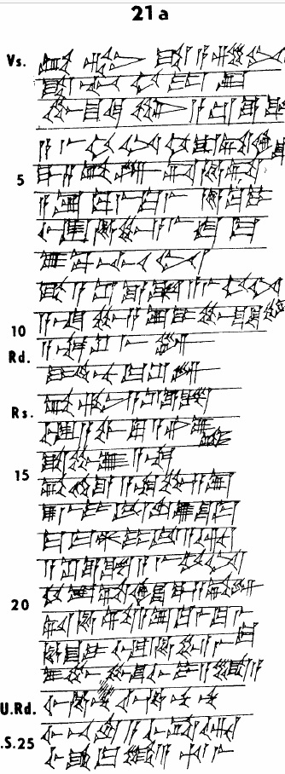
KKS 21a
{Vs.} 1 be2-tum8 s^a A-si2-nim
s^a t,e6-hi-i E2
Pu-s^u-ke-en6 A-s^i2-e-et
a-la2-hi-num Hi-is^-ta-ah-s^u
5 GAL s,a-bi-im Us^-ha-ta
A-zu Ku-la2-ku-la2 Ha-s^u!-i
u3 Ha-pu-a-la2 ki-ma
u3-pa2-ti-nim
s^a A-s^i2-e-et a-la2-hi-num
10 a-na Bu-za-zu DUMU Pu-s^u-ke-en6
{u.K.} a-na s^i2-mi3-im
i-di2-nu-ma s^i2-im
{Rs.} be2-tim A-s^i2-e-et
u3 a-wi-lu a-ni-u2=tum
15 s^a-bu-u2 a-na
be2-te2-e a-na Bu-za-zu
u2-la2 i-tu3-ru-u2 s^u-ma
ma-ma-an i-tu3-a-ar
A-s^i2-e-et a-la2-hi-num
20 Hi-is^-ta-ah-s^u GAL s,a-bi-im
Us^-ha-ta A-su2 Ku-la2-ku-la2
Ha-s^u-i u3 Ha-pu-a-la2-ma
u2-bu-bu-s^u IGI I-sa3-li-a
{o.K.} IGI Ha-nu IGI Ha-nu-nu
{l.S.}
25 IGI Pe3-ru-a IGI Ta-ar-hu-la2
IGI Ka3-ma-li-a

