10.Hafta 29-31
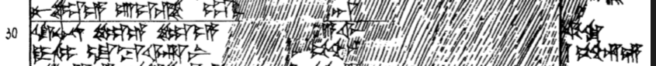
29 nu le-e ú-iz-zi ap-p[í-iz-zi-ya-]an [KUR-e-me-et har-nam-ni-y]a-zi
30 ki-nu-na le-e le-e [ku-wa-at-ka₄] kar-si k[at-ta pa-iz-zi ka-a-sa]
31 DUMU-mi la-ba-ar-ni [É-e]r pé-eh-hu-[un A.SÀ^{HI.A}-se me-e]k-ki

